LESSON 8
Expressing thoughts, feelings, processes, actions, and enumeration
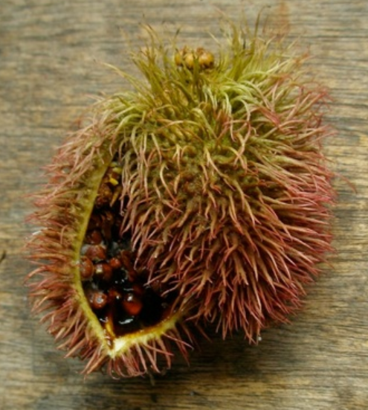
manduru pod and seeds

The polyfunctional suffix –ri

The suffix –ri- has several interrelated meanings. The first two sentences below illustrate the verb aspina ‘to scratch, scrape’:

1. T: Imata aspingi masha?: ‘What are you scraping, masha?’
aspina ‘to scrape’
2. M: Ayawaskata aspini kumari, tuta upingaw. ‘I’m scraping the ayawaska (root),
kumari, in order to drink (it)’. Tonight’

1.Reflexive -ri

In the next two sentences, by contrast, the verb aspina is suffixed with –ri, to describe the reflexive action of scratching oneself:

3. A: Ima rayguta kasna aspiringi wawa? ‘Why, child, are you scratching
aspirina ‘to scratch oneself’ yourself like that?’
4. S: Karami yapa shikshiwan ‘My skin itches me a lot’.
shikshina ‘to itch’
There are several other verb pairs which feature this reflexivizing –ri-. Some of the more commonly used verbs are listed below:
apana ‘to take something’
aparina ‘to carry something on one’s body’
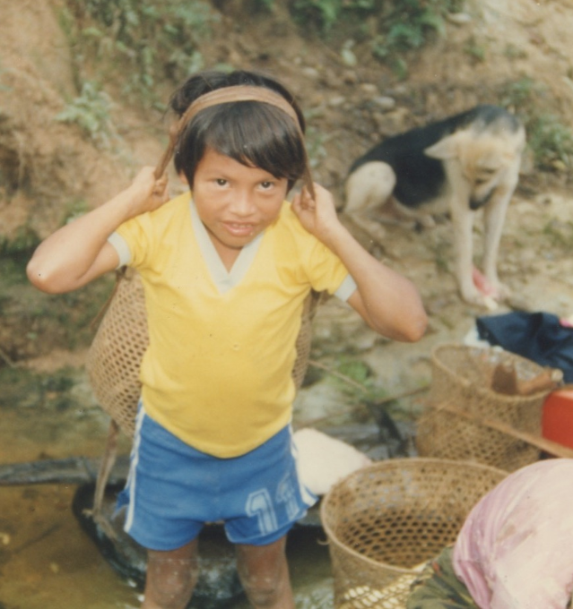
ashanga aparina ‘to carry a basket’
pakana ‘to hide or store something away’
pakarina ‘to hide oneself’

allsana ‘to pull or lift something’
allsarina ‘to pull oneself, e.g., to lift one’s foot out of a muddy hole’

Some reflexive –ri-verbs have no corresponding non-ri-derived verb. For example:
awirina ‘to paint oneself, e.g., with wituk (genipa Americana) juice or with cosmetics’
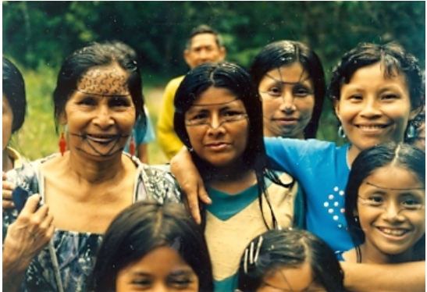
wituk awirina ‘to paint with wituk’

Cognitive –ri-
In another of its functions, -ri- indicates that a verb refers to inwardly directed cognitive processes. Consider the difference between examples 5 and 6 below,which feature the verbs yuyana “to pay attention to”, and yuyarina PQ and iyarina NQ ‘to think, consider, remember’:
5. F: Sachay purisha, pumata yuyangichi! ‘When walking in the forest, watch
puma ‘jaguar’ out for jaguars (you-all)’
yuyana ‘pay attention be heedful of something’

6. D: Yuyaringi! Ima shinata upichisha tukwi “Think! How will I give all the people
runata? Mana charinichu aswata. something to drink? I have no aswa.
yuyarina ‘to consider, remember, realize’
In sentence 5, the verb yuyana has an implied object of attention or consideration, namely the jaguar. However, in sentence 6, yuyarina focusses on an inwardly directed process of thought, namely the problem of how to make a small amount of aswa serve a large number of people. The following pairs of verbs further illustrate this inwardly directed –ri-.
yachana ‘to know, be familiar with something’
yacharina ‘to become accustomed to something, i.e., to know inwardly ’

mandzhana ‘to be afraid of something’
mandzharina ‘to be frightened or surprised’

piñana ‘to speak, or act angrily toward someone’
piñarina ‘to feel angry’

kungarina ‘to forget’

- The –ri of bodily configuration
The next meaning of the –ri suffix specifies bodily movements which may happen suddenly, or may be marked by a distinctive bodily configuration. In examples 7 and 8, the verb tiyana “to settle, be in a place”, contrasts with its –ri suffixed form tiyarina “to sit down”:

7. Ñukanchi Puka Yaku llaktay tiyanchi “We live (dwell) in Puka Yaku town”
8.Kanguna tiyaringichi! Samangichi! “You-all sit down, rest!”

Many bodily configurational verbs exist only in –ri forms:
sirina ‘to lie down’
hatarina ‘to get up’
kungurina ‘to kneel down’
kumurina ‘to bend over’
kushparina ‘to shake, thrash, move back and forth’
llushkarina ‘to slip, slide’
4.The –ri- of low animacy actions
The final group of –ri- verbs is exemplified by models 9 and 10:
9. T: Kay wawaga wiñangami! ‘This baby will grow!’
wiñana “to grow, thrive”
10. G: Kay papa dzas wiñarin; chimanda ‘This potato sprouts quickly,
kuti wañurin. Then again it withers’.
wiñarina ‘to sprout, e.g. plants, hair’
wañurina ‘to wither, die out, e.g., plant, fire’
In this function, the –ri suffix is used to refer to processes where agentivity, or animacy, is relatively low. This means that it is often difficult to identify a specific animate agent or actor that is responsible for the verb’s action. In example 9, the baby is doing the growing, but in example 10, it is a potato plant, which is a less active, volitional, capable being than a human. Animacy is a very important feature of many grammatical categories and processes, not just in Quichua, but in all languages. This function of –ri- is quite important, as is evident by the numerous other pairs which rely on –ri- for this distinction:
wañuna ‘to die, e.g., people, animals’
wañurina ‘to wither, die out, e.g., a fire; to wither or lie dormant, e.g., a plant, or vine’

samana ‘to rest, to breathe’
samarina ‘to subside, e.g., any pain, sore, illness, or infection’

hambina ‘to cure, to treat a river or pond with venom’
hambirina ‘to heal, e.g., an infection or illness’

allsana ‘to pull or lift something’
allsarina ‘to be pulled, lifted, or configured in a certain way; e.g., the way the tips of a crescent moon appear to be pulled in different direction’s.

rikuna ‘to look at someone, something’
rikurina ‘to appear’

uyana ‘to listen to something
uyarina ‘to be heard, to sound’

chakichina ‘to dry something’
chakirina ‘to dry up’

tukuna ‘to become’
tukurina ‘to be used up, finished, or deleted’

Although these four functions of –ri- have been presented as fairly distinct, there are cases of overlap. For example, allsarina can be both a reflexive –ri- and also, in another use, an inanimate –ri- verb:
Reflexive –ri-: allsarina ‘to lift oneself, e.g., a foot from a muddy hole’
Low animacy –ri: allsarina ‘to be lifted, e.g., the tips of a crescent moon’
In other words, be aware of these different functions, but do not be too concerned if you are unable to pick out precisely which function is being used in a particular context.

Written exercise 1.
Match the pairs by drawing a line to the best translation:

Ñambi rikurin He shows the path
Ñambira rikuchin She looks at the path.
Ñambira rikun The path appears.

Chi sisa wañurin That flower wilts.
Chi sisata wañuchin That flower dies.
Chi sisa wañun She kills the flower.

Sikura tukuchin She becomes an agouti.
Siku tukun He kills the agouti.
siku tukurin The agouti meat is finished.

Practice 1
Make up simple sentences for each of the following verbs, using kinship terms, pronouns, or any basic vocabulary.
Example: llakina ‘to love’: Pay wawata llakin. ‘He/she loves the baby’

llakina ‘to love’
llakirina ‘to be sad’

churana ‘to put something somewhere, to impregnate someone’
churarina ‘to put on clothes’

aysana ‘to pull’
aysarina ‘to go down (a swelling) or recede (a cresting river)’

hapina ‘to take; to grab something’
hapirina ‘to light or turn ‘on
hapichina ‘to light or turn something on’

takana ‘to pound’
takarina ‘to bump into something without meaning to’

kawsana ‘to live’
kawsarina ‘to revive’
kawsachina ‘to cause someone to revive’

pitina ‘to cut’
pitirina ‘to cut oneself’

rikuna ‘to see’
rikurina ‘to appear, to look-like’
rikuchina ‘to show’

sakina ‘to leave something or someone behind’
sakirina ‘to stay’

tukuna to become; to be transformed into something else
tukurina to run out
tukuchina to finish

Written exercise 2
Choose the best verb to complete each sentence, and add the correct ending for the present tense.
1.(chakichina, chakirina)
Ñalla allpa __________________ .
Kamba llachapagunata __________________
2.(samana, samarina)
Kunan ñuka maki nanay __________________
Tarabangichu o __________________ -chu?
3.(rikuna, rikurina)
Yaku haway __________________ wagraga.
Ñuka payta__________________ .
4.(pakana, pakarina)
Ñuka __________________ kanoy
Alita kulkita __________________.
Written exercise 3
Choose from among two possible verbs to correctly complete the following sentences.
1. (llakina, llakirina)
____________________ Kamba wawata?
2. (aspina, aspirina)
Ñuka karata shikshiwan. Chi raygu _________________.
3. (samana, samarina)
Payguna sindzhita tarabanawn chagray. Chi raygun kunan __________________
4. (piñana, piñarina)
Ñuka wawki saman. Chi raygumi payba chaki nanay __________________ .
5. (hambina, hambirina)
Ñukanchi yakuta__________________ .
6. (yachana, yacharina)
Ñuka tukwita ____________________.
7. (hapina, hapirina)
Pay lomokuchita __________________ .
8. (tukuna, tukurina)
Ñukanchi aswa ña _________________.
9. (allsana, allsarina)
Ñuka chaki turuy pambarin. Amarun shamun! Ukta __________________ ! [+-wa-]
10. (wiñana, wiñarina)
Ñawpaga ñuka akcha urman. Kunan kuti __________________.
Culture Focus: Forest Resources: red and black dyes
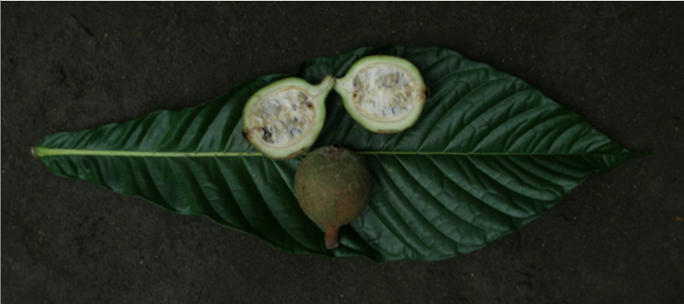
Genipa Americana; Quichua: wituk

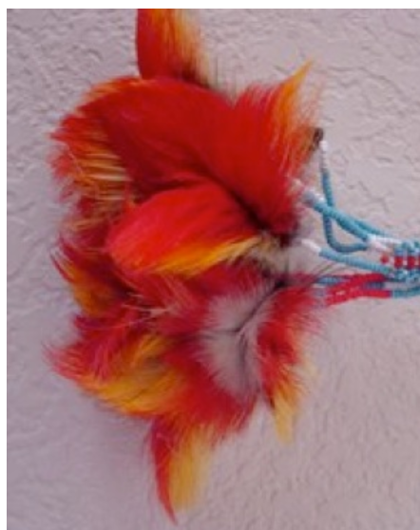
Shuar Toucan Feather earrings, circa 1965, dyed with manduru

Wituk and manduru are primary agents of beauty in the traditions of the Runa and Shuar communities of eastern Ecuador. Their fruits produce vivid black and red dyes that are used to beautify one’s body and hair. According to tradition toucans owe the red color of their feathers to manduru. Elderly people tell about blackening their teeth with wituk to beautify and protect teeth from decay. So beautiful and mysterious are these colors that they are integral to creation stories. In Amazonian Quichua, Zaparo and Shuar origin stories wituk (Genipa) was once a sensuous human girl. After wituk and her sister manduru mature through a series of amorous misadventures they turn into the trees that impart beauty and mystery to other species: Bixis orellana, the source of red face paint and Genipa americana, the source of black face paint. The two sisters then transform the various beginning times people into different species of plants and animals by painting each of them with their own distinctive red, reddish brown, and black designs.
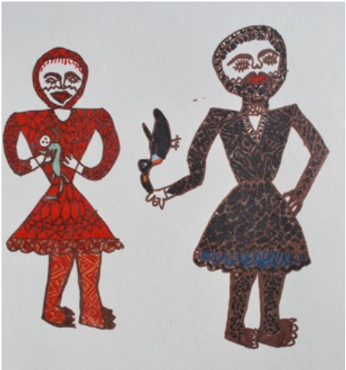
Manduru Warmi/Bixis Orellana Woman (left) paints the Amazonian red squirrel with her red fruit. Wituk Warmi/ Genipa Woman (right) painting the toucan black with wituk.
By Estela Dagua, Andes and Amazon Field School, Artists Workshop 2009

Numbers
Although Quichua speakers are increasingly using the Spanish number system for economic transactions, there is a set of numbers from 1 through10, and a unique number for 1,000 as well. Every quantity that a person would need to express in practical everyday life is expressed with some combination of the following:
1 shuk
2 ishkay PQ/ishki (T)
3 kimsa PQ/kinsa (T)
4 chusku
5 pichka
6 sukta
7 kanchis
8 pusak
9 iskun
10 chunga
11 chunga shuk
20 ishkay chunga
100 patsak
1,0000 waranga
From these numbers, all other quantities up to ninety-nine can be expressed through compounding. For example:
eleven chunga shuk
twenty ishkay chunga
twenty-one ishaky chunga shuk
twenty-two ishkay chunga ishkay
one hundred patsak
one hundred one patsak shuk
one hundred eleven patsak chunga shuk
one hundred twenty-one patsak ishkay chunga shuk
nine hundred ninety-nine iskun patsak iskun chunga iskun
one thousand waranga

Information about numerical quantities may be asked with the information question masna ‘how much, how many?’ plus the information question suffix -ta. For example:
Masnata shamunawn? ‘How many have come?’
If a specific quantitative question is being asked, the information marking -ta suffix is added to whatever masna modifies. For example:
Masna wawata shamunawn? ‘How many children have come?’
If masna modifies a word that is a direct object, then that direct object may receive both the –ta interrogative as well as the –ta direct object marker:
Masna wawatata charingi? ‘How many children do you have?’
Or, more commonly, speakers will simply drop one of the –ta’s, allowing context to make clear what the question means:
Masna wawata charingi? ‘How many children do you have?’
Written exercise 4
Answer the following questions using Quichua numbers.
1. Masna rukugunata paktamunawn? ________________________________________________
2. Masna ñawi luluntata charin, kanba allku? /Masna ñawi lulunyuk tan kanba allku? _________________________________________
3. Masna pundzhata tiyan shuk semanay (7) ? __________________________________________
4. Masna pundzhata tiyan, shuk watay (365) ? __________________________________________
5. Masna watayukta an kanba mama? ____________________________________________________
6. Masna watayukta an kanba yaya? _______________________________________________
7. Masna watatata charin kanba mama? ______________________________________________
8. Masna killata puringi?
_________________________________________________
9. Masna wangutata rangi?
_____________________________________________
10. Masna kullkitata munangi?
______________________________________________

Written exercise 5

Translate the following into Quichua numbers:
      - 455

      - 1,001

3 67

- 789

5. 19
6. 345
7. 1,056
8. 2,000
9. 611
10. 20,000

