LESSON 4
Information questions, polite directives and open-ended questions
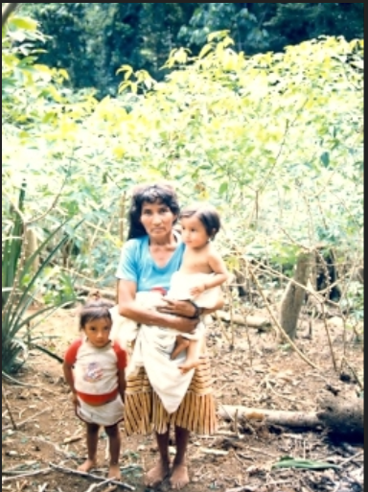
lumu chagray ‘in the manioc garden’

Information questions, polite directives and open-ended questions
Asking information questions
Dialogue

Speaker 1: May-ta ringi kumpari? ‘Where are you going kumpari?’

may ‘where’
-ta information question marker

Speaker 2: Chagra-ma rini kumari ‘I’m going to the chagra kumari’

Kan-ga? ‘And what about you?’
-ga topicalizing suffix

Speaker 1: Wasi-ma rini ‘I’m going home’

wasi ‘house’
-ma case marking suffix meaning ‘toward’, ‘to’

Speaker 2: Yuyangi! Pita lala ruku ñambi-y sirin. ‘Watch out! There’s a big old pit

viper lying on the path’

yuyana ‘to be aware, think, reflect’ (PQ)
iyana ‘to be aware, think, reflect’ (NQ)
pita lala ‘pit viper’
ruku adjective for ‘big’
ñambi ‘road, path’
-y location suffix meaning ‘in, on, near’

Speaker 1 : May-ta? ‘Where?’

Speaker 2: Chay-ma! Chunda ruya laro-y ‘Over there! Beside the peach palm tree’
chunda ‘peach palm’
ruya ‘tree’ (PQ)
yura ‘tree’ (NQ))
laro ‘beside, ‘next to’

Speaker 1: Wañuchingichu? ‘Have you killed it?’
wañuchina ‘to kill’
Speaker 2: Hah ow. Uma-ta chyuw pitini ‘Yeah, I cut its head right off chyuw!’
uma ‘head’
pitina ‘to cut’
chyuw ‘expressive adverb for a complete severing, or cutting through something. Usually occurs with verb pitina ‘to cut’.
The preceding dialogue illustrates the use of the information question marking suffix –ta, which becomes –ra for Napo speakers. It is typically suffixed to a question word, such as ‘who’, ‘what’, ‘where’, ‘why’, ‘how’, ‘how much’, etc. Although it is identical to the direct object markers –ta/-ra, it is probably historically unrelated. Interrogative –ta is most likely a variant of Highland Ecuadorian question marker –tak, which lost its final consonant in Amazonian varieties. There is no need to worry about possible confusion between the question suffix and direct object marker, however, as context always makes clear which suffix is being used. The interrogative –ta/-ra is attached to a question word which is usually the first word of a sentence.
Besides may ‘where’ which is used in our dialogue, other Quichua question words that are useful to know include: pi ‘who’ and ima ‘what’. An additional point concerning information questions is that in other dialects of Quichua, information questions are a bit more complex. The question mayta ringi ‘where are you going?’in other dialects would be maymata ringi? ‘to where are you going?’. Mayta kawsangi ‘where do you live? Would be Maybita kawsangi? ‘In where do you live?’ Pita rikungi? ‘Who do you see?’ would be Pitata rikungi? ‘Whom do you see?’
Practice 1
Practice answering the following information questions which ask ima ‘what?’.
Example
mikuna ‘to eat (aycha ‘meat’)
Imata mikungi? ‘what have you eaten/do you eat?’
Aychatami mikuni ‘I‘ve eaten/I eat meat’
- upina ‘to drink’ (aswa ‘manioc beverage’)
- uyana ‘to hear’ (pishku ‘bird’)
- mikuna ‘to eat’ (chunda ‘peach palm fruit’)
- rikuna ‘to see’ (wasi ‘house’)
- munana ‘to want’ ( aswa ‘manioc drink’)
- apamuna ‘to bring’ (wangana ‘wild pig’)
- charina ‘to have’ (bagri ‘catfish’)
- taksana ‘to launder’ (llachapa ‘clothes’)
- tarpuna to plant’ (papachina ‘small potato’)
- apana ‘to take’ (aswa maytu ‘aswa pulp that is wrapped in a leaf’)
Practice 2
Practice answering the following information questions which ask pi ‘who?’?. Remember to add the direct object suffix.
Example:
llachapa ‘clothing’ taksana ‘to launder’ (ñaña ‘sister of female’)
Pita llachapata taksan? ‘who washes clothes’?
ñañami llachapata taksan ‘(my) sister washes clothes’
1.wasi-ma ‘house-to’ rina ‘to go’ (mikya ‘aunt’)
2. aycha ‘meat’ pitina ‘to cut’ (hachi ‘uncle’)
3. aswa upina ‘to drink aswa’ (wawki ‘brother of male’)
4. chunda ‘palm fruit’ pallana ‘to harvest’ (ruku mama ‘grandmother’)
5. ashanga ‘basket’ awana ‘to make’ (yaya ‘father’)
6. wangana ‘forest pig’ kasana ‘to hunt’ (kari ‘man’)
7. pita lala ‘pit viper’ rikuna ‘to see’ (ushushi ‘daughter’)
8. chagra-manda ‘agricultural field-from’ shamuna ‘to come’ (Antoñia)
9. puñuna ‘to sleep’ (wawa ‘baby’)
10. asina ‘to laugh’ (kushillu ‘spider monkey’)
Gesturing while speaking
Makiwan riman ‘He speaks with his hands.’
There is a common view of gesturing while speaking which considers it to be an indication of someone’s inability to express oneself properly with language. This ‘deficit’ view of gesture is increasingly coming under fire as more and more research by linguists and psycholinguists reveals that gestures accompanying speech are integrated with language at the deepest levels of cognition.
You may have already noticed while watching audiovisual sources, that Quichua speakers, both male and female, are often exhuberant with their gesturing. This is particularly noticeable when they use expressive adverbs known as ideophones, a word class that will be discussed in more detail in Lesson 7. Although Quichua speakers gesture a lot while speaking, they will often use special gestures while articulating ideophones. The ideophone introduced in this lesson, chyuw, is quite often accompanied by a cutting-like gestural motion. Go to the following link and watch the short video clips featuring chyuw. Try to listen for the verb pitina ‘to cut’, which is the verb that occurs with chyuw most often. How many times can you hear some form of this verb?:
http://quechuarealwords.byu.edu/?ideophone=chyuw

chyuw ‘a clean break’

The syntax of questions
Yes/no questions suffixed with -chu need not undergo a change in their syntactic position. However it often sounds better to put the word suffixed with -chu as close to the beginning of the sentence as possible. For example:
Alitachu kawsan kariwan? ‘Does she live well with (her) husband?’
is far more natural sounding than:
*Kariwan alitachu kawsan? ‘With her husband does she live well?’
This is because yes/no questions, and any kind of question for that matter, is a natural focus for a sentence. And typically, whatever is of most topical interest will come earlier in a sentence rather than later.
Information questions, for example, always place the information question word at the beginning of a sentence. For example:
Imata kuchungi? ‘What (tree) do you chop down?’ (the verb ‘kuchuna’ presupposes that it is a tree that is being cut)
If the information question requires a complement, then that complement is transposed behind the verb:
Imata kuchungi hachawan? ‘What (tree) have you chopped down with the ax?’
But not:
*Hachawan imata kuchungi? “With an ax, what (tree) do you chop down?’
If the subject of an information question is specified, it will often be the last, rather than the first element of the sentence:
Imata kuchunawn payguna?’ ‘What (tree) do they cut?’
Practice 3
Practice asking and answering the following information questions for third person plural subjects, which you will insert in your answers
Example
mikuna ‘to eat /aycha ‘meat’/wawaguna ‘children’
Imata mikunawn wawaguna? ‘what do the children eat?’
Aychatami mikunawn wawaguna ‘The children eat meat.’
- upina ‘to drink’ aswa ‘manioc beverage’/hachiguna ‘uncles’
- uyana ‘to hear’/pishku ‘bird’/churiguna ‘boys’
- mikuna ‘to eat’/chunda ‘peach palm fruit’/apayayaguna ‘grandfathers’
- rikuna ‘to see’ /wasi ‘house’/aylluguna ‘family members’
- munana ‘to want’/aswa ‘manioc drink’/ apamamaguna ‘grandmothers’
- apamuna ‘to bring’ /wangana ‘wild pig’/kariguna ‘men’
- hapina ‘to catch’/bagri ‘catfish’/ ushushiguna ‘daughters’
- taksana ‘to launder’ /llachapa ‘clothes’/ kumariguna ‘comadres’
- tarpuna to plant’ /papachina ‘small potato’/wawaguna ‘children’
- apana ‘to take’ /aswa maytu ‘aswa pulp’/ wawkiguna ‘brothers (of males)’
Non-immediate imperatives and the politifying suffix –pa-
A commonly used imperative or directive is the same verb form as the second person forms of verbs. The second person singular occurs in the preceding dialogue when speaker 2 says Yuyangi!, which is literally ‘you think!’, but is better translated here as ‘Watch out!’.
This is the non-immediate imperative, which is used for non-urgent actions that a speaker would like another speaker to accomplish. It takes the same form as the second person suffix –ngi.
apamungi “you bring (something)”
Since an imperative is a form of speech designed to manipulate other peoples’ behavior, it is often softened with the suffix –pa-, which indicates a tone that is similar to the English word “please”. This suffix is used quite a lot in Highland dialects of Quichua but in Pastaza and Napo its use is more restricted to commands that might be interpreted as rude if not softened. It is the last suffix occurring before the person/tense/number suffixes:
apamuna ‘to bring’ > apamu-pa-ngi ‘you please bring’
Practice 4
Practice turning the following commands into polite, non-immediate imperatives.
Example
Ali aychata apamungi ‘bring nice meat’ >
Ali aychata apamu-pa-ngi ‘please bring nice meat’
1. Ñuka ‘my’ wasi-y ‘at-home’ sakiringi ‘you stay’
2. Kamba ‘your’ turi-ta ‘to brother’ rimangi ‘you speak’
3. Ñuka ‘my’ wasi-ma ‘house-to’ shamungi ‘you come’
4. Ñuka ‘my’ wasi-manda ‘house-from’ llukshingi ‘you leave’
5. Apa mama-ta ‘grandmother-direct object’ aswa-ta ‘aswa-direct object’ upichingi ‘you give to drink’
6. Chuchawasa (medicinal tree bark)-ta ‘chuchawasa-direct object’ kachangi ‘you send’
7. Lomo-ta ‘manioc-direct object’ yanungi ‘you cook’
8. Lagarto-ta ‘lizard-direct object’ mikungi ‘you eat’
9. Wawa-ta ‘child-direct object’ likcharingi ‘you wake up’
10. Chay ‘that’ ñambi-ta ‘path, road’-direct object’ apanakungi ‘you follow’
11. Yaku ‘water’ uray-ta ‘downriver-adverbializer’ waytangi ‘you swim’
12. Wasi ‘house’ ukwiy ‘inside’ tiyaringi ‘you remain’

Culture focus: Orienting oneself by way of rivers
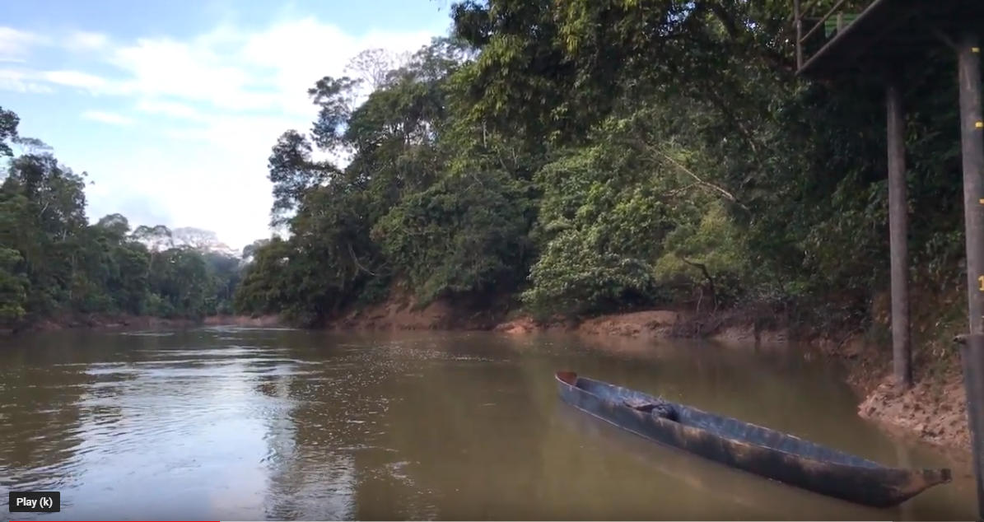
yaku urayta ‘downriver’
The flow of rivers is of fundamental importance for runa peoples’ spatial orientation. Go to the following link and listen to the ambient sounds of the rainforest. One bird, in particular, the waktaway, is heard calling. Watch, in particular, the flow of the water as it heads urayta ‘downriver’:
https://www.youtube.com/watch?v=SDTZMO3DivY

The causative suffix –chi
The opening dialogue featured a new suffix –chi, occurring in the verb wañuchina ‘to kill’, which is formed from wañuna ‘to die’. To kill, therefore, is literally translated as ‘to cause to die’. Any verb suffixed with causative –chi will take a direct object. This is a very productive suffix that will greatly increase your vocabulary.
Examples of –chi suffixed verbs show how this suffix affects a verb’s meaning :
rikuna ‘to see’
rikuchina ‘to show’
upina ‘to drink’
upichina ‘to give someone to drink’
wañuna ‘to die’
wañuchina ‘to kill’
puñuna ‘to sleep’
puñuchina ‘to put a baby or a child to bed’
purina ‘to walk’
purichina ‘to make someone walk, take someone around’
yachana ‘to know’
yachachina ‘to teach’
kuyuna ‘to move oneself’
kuyuchina ‘to make something move’
tukuna ‘to become’
tukuchina ‘to finish something’
nuspana ‘to dream’
nuspachina ‘to cause someone else to dream’
kushiyana ‘to become happy’
kushiyachina ‘to make someone become happy’
piñarina ‘to be angry’
piñachina ‘to anger someone’
llakina ‘to love’
llakichina ‘to make someone feel tender emotions, including love, sadness or empathy; also the name for a genre of songs meant to inspire such feelings’
llukshina ‘to leave or to emerge’
llukshichina ‘to cause to emerge, chase out (of an animal from a hole)’
hapina ‘ to catch, grab hold of of an objrct, animal, a person for romantic
relationship’
hapichina ‘ to cause something to be caught, especially of a fire being lit’

Written exercise 1
Draw a line to the best translation:

Ñambita rikuchin ‘He kills the agouti’.
Ñambita rikun ‘He’s caught fish’.
Chi sisata wañuchin ‘The baby sleeps’
Chi sisa wañun ‘I’ve made the baby sleep’
Sikuta tukuchin ‘She looks at the path’.
Siku tukun ‘I’ve lit the fire’.
Ñambimanda llukshin ‘He makes it come out of a hole’.
Uktumanda llukshichin ‘It emerges from the path’.
Wawata puñuchini ‘He/she/it kills the flower’.
Wawa puñun. ‘That flower dies’.
Ninata hapichini ‘She becomes an agouti’.
Yaku aychata hapin. ‘He shows the path.’

Open-ended questions with topicalizer –ga
We have learned about two types of questions, the polar, or yes/no question and the information question. We now consider a type of open-ended question with topicalizer -ga, which occurs in our dialogue. –Ga is a topicalizing suffix which can occur on any word to indicate focus. We will discuss its focusing function more in future lessons. A secondary use of its focusing function is to ask a ‘what about?’ question, which occurs in our opening dialogue. Speaker 2 asks speaker 1 in a very friendly and informal way about she is doing:
Speaker 2: Chagra-ma rini kumari ‘I’m going to the chagra, kumari’

Kan-ga? ‘And what about you?’

Open-ended questions are found throughout dialogues between people who wish to convey casual, friendly messages with each other. Their open-endedness gives speakers ample options to respond in ways that vary from straightforward to light-hearted and humorous.
Practice 5
Practice the open-ended question by having someone read each of the following statements and then ask you about what you are doing. You should then respond by either substituting the word in parentheses with an appropriate response, or by making up your own response.
Example
Ñuka chagra-ma rini. Kanga? (wasi) ‘I’m going to the chagra. What about you?’
Ñuka wasi-ma rini. ‘I’m going to the house’.
1.Ñuka aswa-ta upini. ‘I drink aswa’. (muyu ‘fruit’)
2. Ñuka uray-manda shamuni. ‘I come from downriver’ (hanak ‘upriver’)
3. Ñuka ushushi-ta charini. ‘have a daughter’. (churi ‘son’)
4. Ñuka wanganata kasani. ‘I hunt for forest pig’. (lagarto ‘lizard’)
5. Ñuka bagrita aysani. ‘I pull (i.e., ‘catch’ a catfish.’ (chulla shimi ‘literally: uneven mouth’, used for a type of fish with differently sized upper and lower lips’)
6. Ñuka mukahata awani. ‘I make a mukaha’. (ashanga ‘basket’)
7. Ñuka mikya-ta tupani ‘I meet up with my aunt’.(hachi ‘uncle’)
8. Ñuka apa yaya-yuk-mi ani. ‘I am a grandfather-possessor’ (apa mama ‘grandmother’)
9. Ñuka Tena-ma purini. ‘I travel to Tena’. (Puyo)
10. Ñuka llachapata taksani. ‘I wash clothes’ (plato ‘dishe(s)’ mayllana ‘to wash’ )
Culture focus: in the chagra
The agricultural field is more than a place to work. It is a site for people to take care of the land that will sustain them and to watch over what they’ve planted. Weeds are always competing for nutrients. Various rodents attempt to eat manioc even before it is harvested. Birds may even try to steal corn kernels off of their cobs. The chagra is also a place for couples to have private time, for children to be educated about subsistence activities, and for family members to strengthen their ties by working together.
Writing exercise
The sawli ‘machete’ is possibly one of the most valued tools for everyday activities. It is used for weeding gardens, for cutting various plants, trees, and food items, and countless other activities and tasks. The following pictures show a sequence of activities involving a sawli. Write a short narrative consisting of 3 or 4 sentences, about what you see happening. It might be helpful to know the following vocabulary words and phrases: wiru ‘sugar cane’, hapina ‘take hold of’; shayarina ‘to stand’; chyuw pitina ‘to cut completely off, to sever’.
--------------------------------------------------
sawli 1
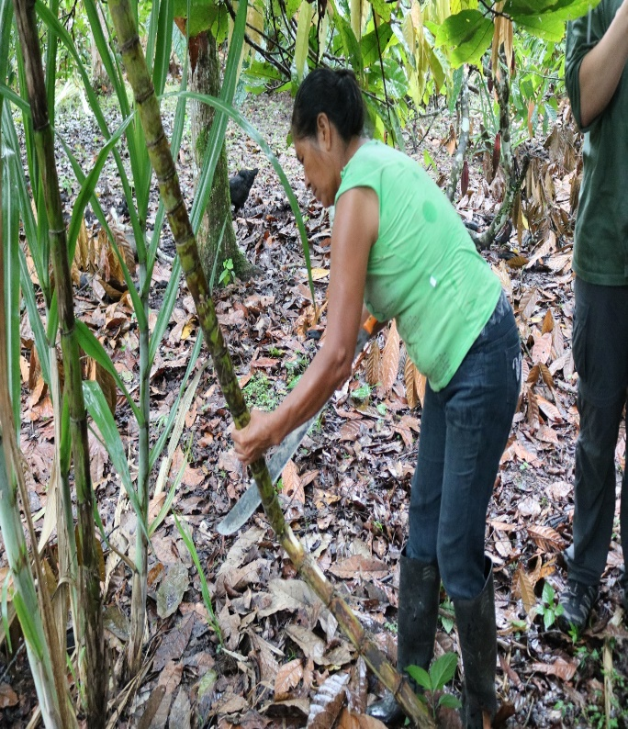--------------------------------------------------
sawli 2
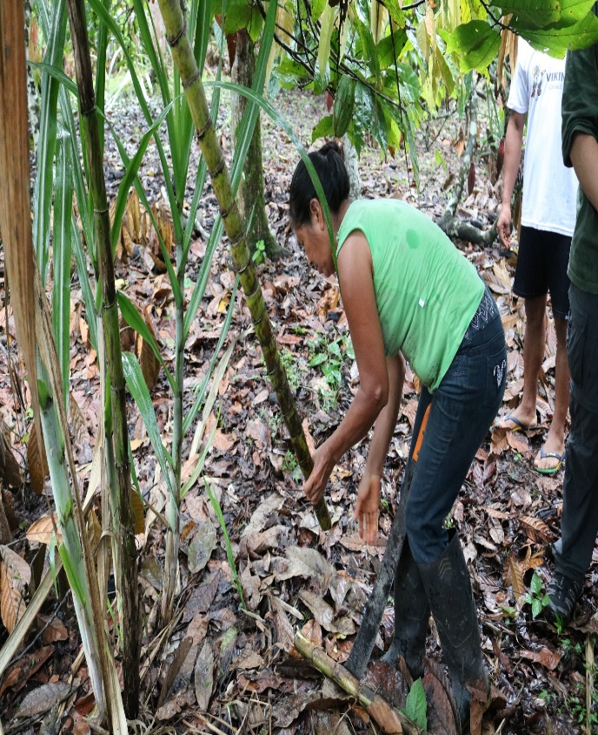--------------------------------------------------
sawli 3

