LESSON 6
Kanoaymi purinawn ‘It’s in a canoe that they travel’
Articulating the perspectives of self and other
We have discussed the use of the suffix –mi for responses to yes/no and information questions. This chapter introduces a related but distinctive function for –mi, as well as a new suffix –shi. While –mi and –chu form a pair of suffixes, -mi also ‘pairs off’ with another suffix –shi. Suffixes –mi and –shi are part of a subsystem of the grammar called ‘evidentiality’, which is found in languages throughout the world. In Quichua, evidential suffixes mark one’s knowledge source as stemming either from a speaker/articulator/utterer, or from the perspective of an ‘other’.
The speaking self -mi
Speakers of Quichua are careful to clarify the sources of their statements because there is a cultural preference for contextualizing statements within a particular perspective. This means that even the simplest statements are in need of some marker of perspective. Although speakers of English can simply say ‘John arrived from Montalvo’. A Quichua speaker would have to perspectivize such a statement as based on the speaker’s or someone else’s perspective:
Juan-mi Montalvo-manda paktamun.
‘(from my perspective) John (is the one who) has arrived from Montalvo.’
It is also important to remember that when using –mi or –shi in their evidential functions to mark perspective, any word within a sentence may have the –mi or –shi suffix attached, depending on where the main focus is supposed to fall. An alternative way of stating the sentence about Juan’s arrival would be the following:
Juan Montalvo-manda-mi paktamun.
‘(I assert from my perspective) that it is from Montalvo (and not from somewhere else), that John has arrived.’
When marking statements with speaker perspective –mi, there is often an implication of strong, possibly exaggerated certainty that may be enhanced with intonation and emphasis. This can result in a variety of speech act effects, such as accusing, blaming, and criticizing. Although such speech acts are not usually observed in the typically convivial atmosphere of everyday Quichua conversations, they occur quite commonly in narrative discourse. The following examples illustrate accusations from narrative conversations:
Kan-mi kurita shuwangi!
‘You have stolen the gold!’ i.e: I assert from my perspective that you are the one who has stolen the gold!

Kan-manda-mi kasna tukunchi.
‘Because of you we have become like this.’i.e.: I assert from my perspective that it is your fault that we are like this!
-mi + ana = mi-ana > mana
When a word suffixed with –mi occurs immediately before the verb ana, it ‘hops’
over to ana turning the verb into mana. As a result of this process, the vowel drops off of the –mi form. Despite the fact that this new-ish verb resembles the negative form mana, it has the opposite semantic sense. We may consider the form mana ‘asserted by speaker to be the case that . .’ as a kind of evidentially specified verb, which is opposed to evidentially-neutral ana which merely means ‘to be’.
Practice 1
Practice constructing evidential mana from a –mi +ana combination.
Example:
Paymi an Juan > Pay man Juan ‘He is Juan’
1.Ñukanchimi anchi Runa ‘We are Runa’

2.Kangunami angichi ayllupura ‘You-all are the same family’
3.Kanmi angi wakcha wawa ‘You are an orphan child’.
4.Ñukami ani sindzhi warmi ‘I am a strong woman’.
5.Paygunami anawn ali hapig runa. ‘They are good hunters.’
6. Ñukanchimi anchi Puka Yaku runa ‘We are Puka Yaku people.’
7. Kangunami angichi Canelos runa ‘You-all are Canelos people.’
8. Ñuka ayllumi an Cuhi ‘My family (name) is Cuhi.’
9. Kanmi angi sindzhi runa ‘You are a strong man.’
10. Paygunami anawn apayayukguna. ‘They have grandfathers (literally: They are grandfather possessors.)’
The voice of the ‘other’ -shi
Let us now consider the suffix –shi, which indicates that a statement is made from someone else’s perspective. The following example illustrates a simple statement about a person’s departure.
Faviola-shi rin.
‘Faviola (is the one who) has gone (according to someone)’.
In discourse contexts from everyday life, a speaker uttering such a –shi suffixed statement will often add qualifying remarks such as: ‘She told Uncle Venancio that she was going’ or, ‘Somebody said that somebody else saw her leave early this morning’, which would clarify where the claim originated. Despite the fact that a –shi suffixed statement indicates that someone else’s knowledge underlies the assertion, there is not necessarily any implication that the statement is unreliable.
If, however, a translational equivalent of this statement were attempted in English, it might be represented as any of the following variations:
Apparently it is Faviola who has left
It is alleged that Faviola is the one who has left
Faviola has, according to someone, left
All of these create implications of uncertainty for speakers of English, even though, as we just stated, they are not necessarily uncertain for Quichua speakers. The semantic ‘otherness’ encoded in –shi makes it an appropriate suffix for use in traditional narratives of all kinds. These narratives are meaningful for people and are not considered ‘not true’ because of being based on someone else’s perspective. The –shi suffix used in such narratives clarifies their basis on traditional knowledge or on ancesters’ experiences. Among speakers of the Upper Napo area, and in other dialects of Quichua as well, the phrase nishka nin, which literally translated means ‘it is said that it was said’ is often used instead of the suffix –shi.
The following example is typical of a PQ traditional narrative that employs -shi. It uses the phrase kalyari timpu ‘beginning times, as well as a special narrative past tense marker –shka:
Kalyari timpu shuk wakcha wawa-shi kawsa-shka sachay
‘In beginning times an orphan child (it is said) lived in the forest’.
In order to translate the perspective of the traditional, authoritative ‘other’ marked by –shi, the phrase ‘it is said’ is used.
-Shi may also be suffixed onto expressive adverbs, as happens in the following traditional narrative describing an encounter between a man and a forest spirit. The man is alerted to the presence of the forest spirit by the sound of the spirit’s ax hitting trees as it moves through the forest. This sound is described with repetitions of ton:
http://quechuarealwords.byu.edu/?ideophone=ton2
Ton ton ton ton ton-shi waktan.
‘It hit (the trees), (apparently going) ton ton ton ton ton.’
The framing of a story as based in traditional knowledge, however, does not cast doubt on its meaningfulness or truth. Moreover, -shi suffixed forms are often used to discuss happenings in the contemporary lived world. In the following example, a description of a fight is given with a –shi suffixed form because the speaker heard about the fights’ events from someone else:
Fernando-shi Sergiota makan.
‘Fernando (is the one who) has hit Sergio.’
Again, it must be emphasized that the use of –shi does not necessarily call into question a claim that it being made. Instead, it frames a claim as arising from an ‘other’. In upcoming chapters we will discuss instances of –shi suffixation creating possible implications that may lead to doubt or uncertainty. For now, however, it is best to think of –shi as simply a suffix used to indicate a perspective other than that of the speaker. As such, it is typically observed with sentences about someone or something, and is therefore most ‘at home’ with third person sentences involving a ‘he/she/it’, or a ‘they’..
Practice 2
Make up sentences using either the –mi or –shi evidential suffixes in the following pairs of words, and explain why you chose the suffix you did for a particular example.
Example
hapina (bagri) Payshi bagrita hapin. ‘He/she (apparently) has caught a catfish’
1.kachana ‘to send’ (shimi ‘word’)
2.awana ‘to make’ (ashanga ‘basket’)
3.mikuna ‘to eat’ (yaku aycha ‘fish’, literally: ‘water meat’)
4.upina ‘to drink’ (aswa ‘manioc beverage’)
5.wañuchina ‘to kill’ (pita lala ‘pit viper’)
6.yanuna ‘to cook’ (lomo ‘manioc’)
7.pitina ‘to cut’ (kaspi ‘stick’)
8.rikuna ‘to see’ (lagarto ‘lizard’)
9. rimana ‘to speak’ (runa shimi ‘Quichua’)
10. pichana ‘to sweep’ (wasi ‘house’)
Questions with -shi
The use of –shi to acknowledge the perspective of an other is extended, at times, to express feelings of puzzlement, wondering, or perplexity. When people wonder about matters that are beyond their grasp, they will sometimes ask a question with question words such as ima ‘what’, imawa ‘why’ or pi ‘who’ which are suffixed with –shi. Such questions, which are often unanswerable can be translated as ‘What/why on earth?’, ‘who in the world?’, ‘what the heck?’, etc When speakers use –shi to ask an unanswerable question, the –shi replaces the information question marker –ta which was introduced in Lesson 4:
Ima raygushi rin Masha Elario?
‘Why (on earth) has Brother-in-law Elario left?’
Imatashi kapari-n allku?
‘What (in the world) is the dog barking at?’
Pishi chasna wakan?
‘Who (on earth) is crying like that?’
Evidential –shi is used to express questions that are unanswerable, perhaps because unanswerable or unknown questions or musings have a quality of otherness, due to the fact that they are outside of the speaker’s capacity to know.
Written exercise 1
Translate the following –shi questions
1.Imatashi munan wawa?
________________________________
2.Ima raygushi mana shamundzhu masha Fausto?
______________________________________
3.Pishi paktamun?
______________________________________
4.Ima raygushi wakanawn wawawaguna?
______________________________________
5.Pishi bagrita hapin?
______________________________________
6.Pishi kurita shuwan?
______________________________________

Culture Focus: Forest resources: cacao
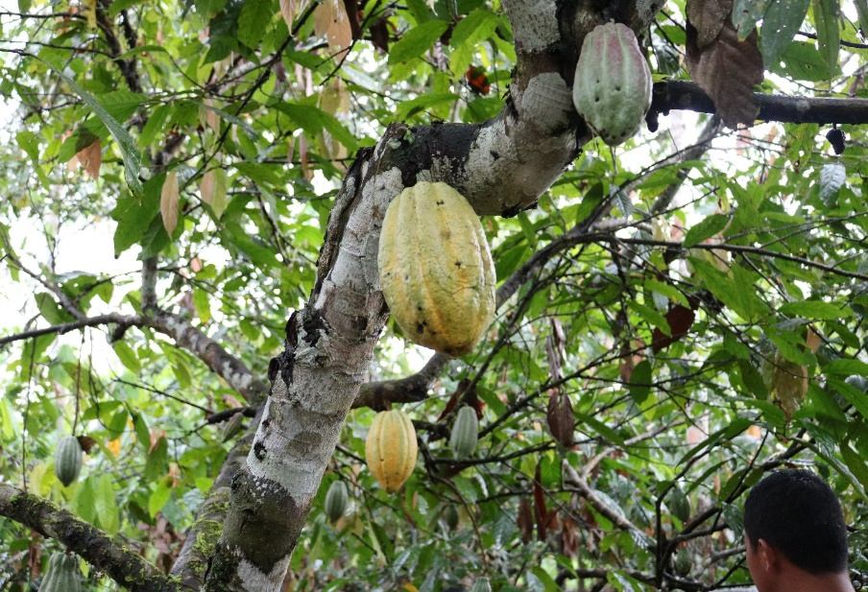
Theobroma cacao, Quichua cacao
Theobroma cacao, a member of the Steruliaceae family consists of many varieties of trees that yield a fruit which is highly valued and enjoyed. Runa harvest the large pods, whose shape resembles an acorn squash, break them open, and suck the sweet pulp from the bean pods. The bean pods themselves are a source of chocolate. Ecuadorian cacao beans are now exported around the world and used in high quality ‘boutique chocolate’ markets.
According to Runa, all trees have a spirit, but it is usually the most important or largest trees whose spirits become the subjects of mythic narratives. In the following exercise there is a fragment from a traditional narrative about a wild cacao tree, whose spirit becomes angry with a human man for presuming to harvest the wild cacao with out asking the spirit of the tree for permission first. The story was recorded by Tod Swanson and features Elodia Dawa recounting the story. You will listen to a portion of the story which features the words of the man’s wife who does not yet know that he has been killed and is wondering why he hasn’t returned home. She expresses her wondering by asking unanswerable questions with –shi. The fragment occurs at 1:58 and lasts until 2:11 at the following link:
https://www.youtube.com/watch?v=5SbQ4CKWyIE&feature=youtu.be
Please listen to this fragment which is partially transcribed below. Your assignment is to fill in the missing portions which features two unanswerable questions using –shi:
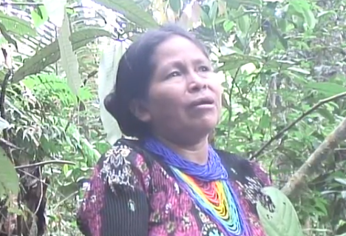
kambi ruya kwinto ‘cacao tree story’
Transcription exercise 1
Mana rikurishka, mana rikurishka, mana . . .
1._________________________________
‘He didn’t show up, and didn’t show up, (and so she said/thought) “Why on earth has he not come?”
Ña kasnay shamuna mara indi, ñaaa yaykushkay.
‘Now it was about the time when he was supposed to come, and the sun nowww it was entering (going down)’
Chi yaykukpi___________________________ nishka pay
‘As it entered, ”why on earth has he not come?” she said.’
Affinal ‘others’
In addition to one’s nuclear family, there are terms for the families a person is related to by marriage. Relatives related by marriage, called ‘affines’ by anthropologists, have distinctive terms and rules for address.
Awlla ‘all extended family of someone who marries into your family’
warmi ‘wife, also woman’
kari ‘man, husband’
kusa ‘husband’
masha ‘a man who marries into a family; primary sense: son-in-law; secondary sense: brother in law; tertiary sense: any man who has married into the one’s extended family.
kachun ‘a woman marrying into a family; usual meaning is sister-in-law’
warmi yaya ‘man’s father-in-law’
warmi mama ‘man’s mother-in-law’
warmi ñana ‘wife’s sister’
warmi turi ‘wife’s brother’
kari yaya ‘woman’s father-in-law’
kari mama ‘woman’s mother-in-law’
kari wawki ‘husband’s brothe’r
kari pani ‘husband’s sister’

Although terms like masha ‘brother-in-law’ and kachun ‘sister-in-law’ may seem neatly and unproblematically the same as the English language terms, they are not exactly the same. In English the terms ‘brother-in- law’ and ‘sister-in-law’ are reciprocal terms. In Runa Shimi they are not.
For example, in the context of her husband’s family a woman is called kachun. The term is respectful and endearing. In Napo it is usually appended to the woman’s first name.
Example:
NQ: Maria kachun shamun” ‘Daughter-in-law (sister-in-law) Maria has come’. PQ: Kachun Maria shamun. ‘Daughter or sister-in-law Maria has come.’
In the context of her husband’s family a kachun is of a different status than her husband’s sisters. Although in English she would call her husband’s sister “sister-in-law”, in Runa Shimi she would not call refer to them as kachun but rather as kari pani, or husband’s sister. Her husband’s brother is her kari wawki.
In the context of his wife’s family a man is called masha. It is usually appended to the man’s first name.
Example:
NQ: Pedro masha shamun
PQ: Masha Pedro shamun.
In the context of his wife’s family a masha is of a different status than his wife’s brothers. Although in English he would call his wife’s brothers ‘brother-in-law’, in Runa Shimi they are not his masha but rather his warmi turi. His wife’s sister is his warmi naña.
To summarize, then, in the context of one’s in-laws, a woman will be addressed as a kachun by her sister-in-law, or mother-in-law, but it is not appropriate for her to address her mother or sister-in-law as kachun. A man will be addressed as masha by his father-in-law or brother-in-law, but he should not address either of them with the term masha. The asymmetry of such terminological restrictions reveals the tension inherent in affinal relations, a tension found throughout the world’s cultures.
Practice 3
Tell a classmate the names and kinship relations of the most important members of your nuclear and extended family.
Example:
Ñukaga kusa-ta charinimi ‘I (do) have a husband’ or Nuka kusa-yukmi ani ‘I am a husband-possessor.
Ñuka kusa shuti Carlos-mi an ‘My husband’s name is Carlos’.
Another kind of ‘other’: fictive kinship
Quichua fictive kinship provides another set of relationships that allow people to extend their social network beyond nuclear family and affinal relations. Fictive kinship uses the Spanish compadrazgo system which allows adults to ‘co-parent’ a baptized child. For Runa, co-parenting may involve helping to provide necessities for a child that parents are unable to afford. However, the relationship is also important for the adults, as it allows them a new basis for interaction. When a child is ‘co-parented’ by another adult, that person is addressed by the child’s parents as compadre if male and comadre if female. The following terms are used for the relationship between the co-parent and the child:
marka yaya ‘godfather’
markamama ‘godmother’
marka ushushi ‘god daughter’
marka churi ‘god son’

