LESSON 9
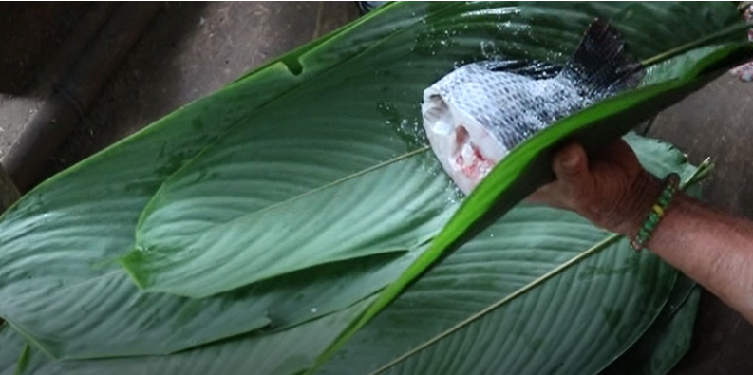
maytuna ‘to wrap in leaves and roast’
Suffixes of instrumentality, accompaniment and imperatives

The instrumental and comitative –wan
The instrumental –wan is suffixed to a noun, pronoun, verb, or adverb, to designate inclusion, accompaniment, or instrumentality. Below is an example of its instrumental use:
Example: Hachawan ruyata kuchuni. ‘I chop down the tree with an ax.’
In its comitative function, the –wan suffix encodes an idea of accompaniment rather than instrumentality.
Example: Faviolawan rini. ‘I go with Faviola.’
Practice 1
Practice making sentences with the instrumental –wan by suffixing it to the appropriate noun in each of the following sets of words. Vary your person/number usage and be sure to add the direct object marker –ta wherever necessary.
Example:
Kullki ‘money’/llachapa ‘clothing’/randina ‘to buy’
Kullkiwan llachapata randini ‘I buy clothing with money’

1. pacha ‘blanket’/kayutuy ‘in bed’/puñuna ‘to sleep’
2. kaspi ‘stick’/palo ‘snake’/waktana ‘hit’
3. waska ‘fiber rope’/ashanga ‘basket’/watana ‘to tie’
4. chaki ‘foot’/ñambiy ‘on the path’/purina ‘to walk’
5. sawli ‘machete’/panga ‘leaf’/pitina ‘to cut’
6. lomo ‘manioc’/aycha ‘meat’/karana ‘to give food’
7. pay ‘he/she/it’/shimi ‘word’/kachana ‘to send’
8. illapa ‘shotgun’/pawa ‘turkey’/wañuchina ‘to kill’
9. hacha ‘ax’/yuyu ‘heart of palm’/yuyuna ‘to harvest heart of palm’
10. yaku ‘water’/lomo ‘manioc’/mayllana ‘to wash’
11. manga allpa ‘pottery clay’/ mukaha ‘drinking bowl’/awana ‘to make’
12. garoti ‘rake’/muyu ‘fruit’/pallana ‘to harvest’
13. linterna ‘flashlight’/wawa ‘child’/maskana ‘to search’
14. kiru ‘tooth’/muyu ‘fruit’/kanina ‘to bite’
15. ashanga ‘basket’/yaku aycha ‘fish’/hapina ‘catch’
16. pillchi ‘hollow drinking gourd’/masha Leopoldo ‘brother-in-law Leopoldo’/upichina ‘to give to drink’
17. kanoa ‘canoe’/yakuy ‘in water’/purina ‘to travel’
18. panga ‘leaf’/aycha ‘meat/fish’/maytuna ‘to wrap with leaves and roast over a fire’

Culture Focus: Forest resources: cooking leaves
Stromanthe stromanthoides, Marantaceae Family, Quichua: llaki Panga
Throughout the western Amazon, llaki panga, which are also called maytuna panga, are the preferred leaves for steaming food. Fish, mushrooms, or other delicacies are folded into the leaf, tied off, and placed over a fire. Once steamed the bacteria are killed leaving the food ceiled in a sterile packet. Until opened the food remains protected from bacteria and so does not spoil quickly. Even steamed fish will keep for a few days in a maytu packet without refrigeration. Llaki panga leaves are also used to store and heat up leftovers. For this reason they are usually grown just outside the kitchen where they can be picked at a moment’s notice.
Although other species in the Marantaceae family can also be used to steam food, llaki panga are preferred because of the delicate aroma they impart. Thus they also function as a kind of seasoning.

The despitative –was
The inclusive/despitative –was is different in function from –wan. The main difference between –wan and –was is that when a speaker uses –wan its meaning is simply inclusive. The suffix –was also has inclusivity as part of its meaning. However, an additional dimension of its meaning is that it conveys a sense of unexpectedness as well.
For example, the sentence Paywas shamun could be translated with any of the following:
‘Even he/she has come’
‘Surprisingly, he/she also has come’
‘Despite what you may have thought would be the case, he/she has come’
Written exercise 1
Fill in the blanks below by suffixing the word indicated with the most appropriate suffix, using either –wan or was.
1.Payguna aychata, lomota, llachapata, pukunata-_________ shuwanawnmi.
2.Kan payta kungi! Nukata-______ kungi!
3.Chagramanda shamusha, ashanga-________ lomota apani.
4.Sawli-________ wañuchi motolota!
5.Manga allpa-____ awani ali mukahata.
6. Ñukanchi kushillu aycha, pawa, pawshi, sikwanga, charapa aychata-________ apamunchi.
The immediate imperative forms
Although Quichua speaking people are generally reluctant to forcefully manipulate and control the actions of others, there are occasions when this becomes necessary. If someone is behaving dangerously, or if immediate action is required, then speakers ignore politeness conventions and issue direct commands to each other. Rather than using the non-immediate imperative with its politifying suffix –pa, which was learned in Lesson 4, speakers will instead use a direct order. Such direct commands are appropriate for parents telling their children to do something right away (go and get my machete!), for anyone warning someone else about an immediate threat to their safety (watch out for that snake!), or for directing someone to do something requiring immediate action for their own benefit (come and eat!).
The immediate imperative is easily formed for verbs whose root vowels end in the i vowel, by taking the infinitive form of the verb and simply removing the infinitivizing –na suffix:
hapina ‘to take, grab, attach to oneself romantically’> hapi! ‘take’
upina ‘to drink’ > upi! ‘drink!’
sakirina ‘to stay, remain’ > sakiri ‘stay!’
pitina ‘to cut’ > piti ‘cut!’
If the verb root’s final vowel is a or u, then a y is added to that final vowel:
kallpana ‘to run’ > kallpay ‘run!’
shamuna ‘to come’> shamuy ‘come!’

Written exercise 2
Amasanga warmi ‘forest spirit woman’

The following recording is taken from a story about the power of a love charm to help a man who was not attractive to women. After using the love charm, however, the man is besieged by requests from women who suddenly want him. In the following brief excerpt, you will hear a voice quoting two women who use the immediate imperative to convince this man to take them. Their directives have been translated into English. Write the Quichua you hear the narrator say. (found at 2:37-2:42). https://www.youtube.com/watch?v=WsYD743QOw0&list=PLLRu2Lfj1ZibS3uTdbPNLEvA3qOPMdpmM&index=2
      - ‘Take me! (said one);
      - ‘Take me! (said another);
      - ‘I (am the one who) wants you’.

Written Exercise 3
Calpintero’s ‘woodpecker’s’ gift of fire
The next recording is taken from a Quichua story about a flood that destroyed the earth, possibly a version of the Biblical flood story. In this version, however, the ending of the story has been reworked to include an episode about the woodpecker’s gift of fire to humans. As the earth had been drenched with rain for so many days, fire was unavailable for cooking, and people were starving. In the following short excerpt, desperate people use the immediate imperative to ask the woodpecker to give them fire. Their request is ultimately granted and the woodpecker pecks at a tree until sparks of fire appear. Listen to the recording (at 2:48-2:55) https://www.youtube.com/watch?v=9WBoORq9SYc
Now translate the following into English:
1.Ninata kuway carpintero!
2.Ninata kuway!
3.Ñuka raykaywanmi wañuni! (nishashi nin: ‘saying, they say, he said)

Culture Focus: sociable visiting
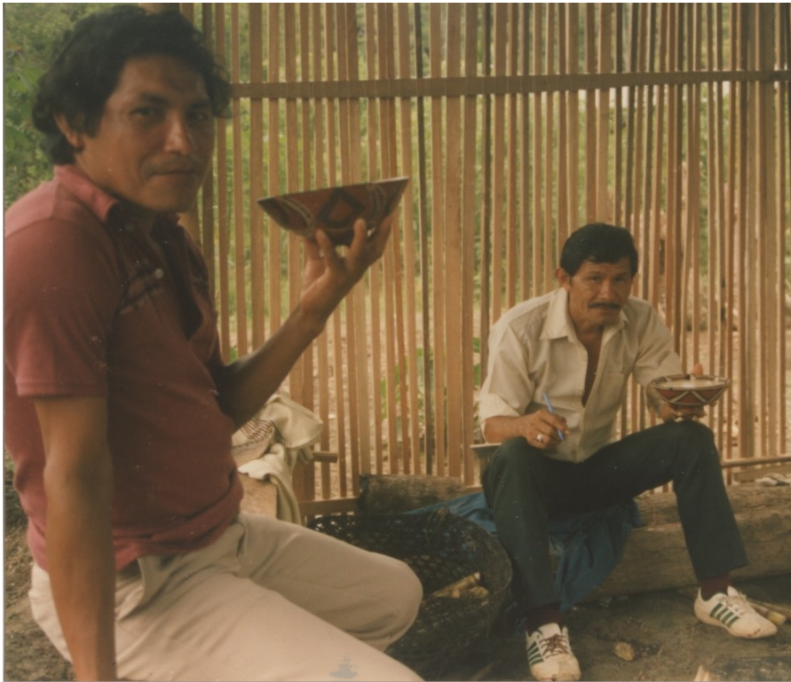
Two men visiting in Canelos, Ecuador. The host (left) shares aswa with his guest (right)
In everyday life, immediate imperatives are often used for hospitable invitations where someone is asked to do something that would facilitate their own comfort, such as sitting down, or eating and drinking what is offered. Sharing aswa is the ultimate sign of good hospitality. The following ideal dialogue is a model for visiting the home of someone else. Such visits make use of immediate imperatives that order someone to do something for their own comfort.

(V=visitor; H=host):
1.H:Don Pedro Buenos dias! ‘Good morning Don Pedro.’

2.H:Pasiyay ‘Come in.’ Literally: Pass time (with us)!

3.H:Tiyari. ‘Sit down.’

4.H:Aswata upi ‘Drink some aswa”’

5.H:Alillachu angi? ‘Are you well?’

6.V:Alimi ani ‘I am well’

7.H:Kamba warmiga? ‘And what about your wife?’

8.V:Paywas ali. ‘She is also well’

9.H:Kamba wawagunaga? ‘And what about your children?’

10.V:Tukwi alimi anchi. ‘We are all well.’

11.V:Kanga? ‘And what about you?’

12.H:Ñukas alimi ani. ‘I am also well.’

14.V:Wawagunandi? ‘And all of the children?’

15.H:Ari, tukwi alimi anchi. ‘Yes we are all well.’

The preceding dialogue contains several examples of ththe singular form of the immediate imperative. To make an immediate imperative form plural, simply add the second person plural form –ichi:
apamuna ‘to bring’ > apamu-ichi ‘(you-all) bring!’
randina “to buy” > rand-ichi ‘(you-all) buy!’
maskana “to search” > maskaychi ‘(you-all) look for!’

Practice 2
Practice the immediate imperative by transforming the list of verbs to follow, along with their possible direct objects, or adverbs, into immediate imperative statements.
Example:
tapuna ‘to ask’/ruku mama ‘grandmother’ > ruku mamata tapuy! ‘Ask grandmother (right now)!’
OR:
ruku mamata tapuichi! ‘You-all ask grandmother right now!’

tapuna ‘to ask’ ñawpana ‘to lead’ pitina ‘to cut’

pay kucha-ta waska
apa yaya kucha-ma maki riru
ñuka kumari hawa llakta-ma chaki riru
payba ushushi purun ñambi-ta pita lala uma
kumari supay ñambi-ta muyu

tigrana ‘to go back’ waktana ‘to hit’ karana ‘to give food’

ukta taylla ruya lomo
chagra-ma pita lala yaku aycha
llakta-ma lomocha aycha aycha
lunes-ta ruya kaspi papa
dzas palanda mallki kumal
ñuka wasi-ma taylla apangura lagarto aycha

watana ‘to tie’ upichina ‘give to drink’ yanuna ‘to cook’

kanoa aswa anzi dzas
kay sindzhi waska ayag aswa wayra shina
ismu ashanga mana alyi yaku payba lomota
ñuka maki trago kay palanda
ñuka chaki chunda aswa moreti muyu
atallaguna paparaw aswa yuyu

saltana ‘to leap’ kallpana ‘to run’ rikuchina ‘to show’

kucha yaku-y sacha ñambi-ma kanba ali mukaha
nina-y ñuka wasi-ma kanba ali tinaha
kayutu-y payba chagra-ma ismu hacha
pangaguna-y hista wasi-ma amarun

Negating the immediate imperative forms
The negative imperative is similar to the use of ‘don’t’ in English. It is formed with ama- and the negative suffix –chu. The negative imperative simply takes the imperative form of a verb and surrounds it. For example:
tiyari! ‘sit down’ (right now) > ama-tiyari-chu! ‘don’t sit down!’
tiyaringi! ‘sit down’ (at some point’ > ama-tiyaringi-chu! ‘don’t sit down!’
The negative imperative is typically constructed around a verb, but it may also include an adverb, a noun, or a noun phrase. For example:
Ama sapalla tarabaychu! ‘Don’t work alone!’
Ama paywan purichu! ‘Don’t travel (go around) with him/her!’
Practice 3
Now practice the negative imperative with the verbs and objects given in practice 2.
Example:
tapuna ‘to ask’/ruku mama ‘grandmother’ >
Ama ruku mamata tapuychu! ‘Don’t ask grandmother (right now)!’
OR:
Ama ruku mamata tapuichichu! ‘Don’t you-all ask grandmother (right now)!’
Kamachina ‘to advise’
Runa speakers tend to shy away from generalizations. There is a type of situation, however, where general statements are appropriate. This situation involves advising people, especially parents giving advice to children, about how to behave or not to behave. There are many ways of advising children by telling them not to do something specific, which we have just explained. However, another form of advice-giving involves generalizations that make use of the infinitive form of a verb. This kind of advice is often given in the form of a negative statement:
Amarunta mana mikuna ‘anacondas/boas are not for eating’
Aswa anzita mana upina ‘the dregs of aswa are not for drinking’
Turu llachapata mana churarina ‘muddy clothes are not for putting on’
Written exercise 2
Turn the following statements into advice-giving kamachina statements.
Example:
Ñuka sapalla kawsani ‘I live alone’ > Sapalla mana kawsana ‘(a person) is not to (i.e., should not) live alone’
1. Kay ismu wasiy puñunchi ‘We sleep in this rotted house’
___________________________________
2.Purun ñambita purini ‘I walk along weedy paths’
_______________________________________
3.Ayag aswata upichinchi ‘We give bitter aswa to drink’
_______________________________________
4.Ismu hachawan kuchunchi ‘We chop (trees) with a rotten ax’
________________________________________________
- Ashka karamelota chupanawn ‘They suck on (eat) lots of candy’
_____________________________________
- lluchu chakiwan sachay purini ‘With bare feet I walk in the forest’
_____________________________________
- Ñuka mushuk hachata shuwanawn ‘They have stolen my new ax’
______________________________________
- Payguna llullagunawan purinawn ‘They go around (hang out) with liars’
_____________________________
- Amarun aychata mikun ‘He/she eats anaconda meat’
_____________________________________
10.Kay ichushka wasiy puñushun ‘Let’s sleep in this abandoned house’
___________________________________

The first person plural imperative –shun
The first person plural imperative is similar to the ‘Let’s + a verb’ construction in English. It is formed with a verb root that is suffixed with –shun.
Example: hapina ‘to catch’ > hapishun ‘let’s catch’
Practice 5
Turn the following sets of words into 1st person plural imperative sentences using -shun. Your –shun verb may need a direct or instrumentally-suffixed noun.
Example: Ali muyu/upina > Ali muyuta upishun.
1. wira pawa/wañuchina
2. mushuk llachapa/churarina
3. aspirina/randina
4. wira wangana/maskana
5. Kwankiri yaku/hambina
6. llullu apangura/mikuna
7. chi iridza allku/karana
8. mushuk hacha/ruya/kuchuna
9. kullki/anzelo/randina
10. muru bagri/apanakuna
11. hawa llakta/purigrina
12. ashka aswa/upina
13. payba kullkiyuk turi/tapuna
14. ñañawa sawli/kuchuna
15. kay panga/yaku aycha/maytuna
16. hawa llakta shimi/rimana
17. maytuna panga/maskana
18. yana bagri/hapina
19. lomo kaspi/tarpuna
20. ashanga/lomo/aparina

