LESSON 15
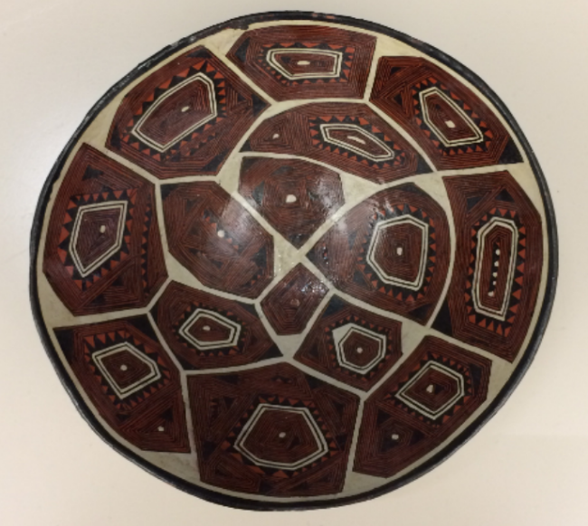
Interior view of mukaha, geometric pattern
The switch reference suffix -kpi
Instructional narrative: “How we work with clay”
1. Q: Ima shinata kawchungi manga allpata?
kawchuna “to roll or twist”
‘How do you roll clay?’
2. A: Manga allpataga apagirani, manga allpa pugruy, Puka Yakumanda hanagma.
pugru “well, hole, pit”
‘I went and got some clay in a clay pit, upriver from Puka Yaku.’
3. Chimi tiyag man manga allpa.
‘That’s where clay is.’
4. Chita apamusha, awa-kpi, tuvyara.
tuvyana “to explode”
-kpi: switch reference suffix which establishes that the agent of its verb is distinctive from that of a following verb
‘(After) bringing that and (trying) to create with that clay, it exploded.’
5. Kosakpimi tuvyara.
kosana “to roast, to fire”
‘(When) (I/someone) fired it, it exploded.’
6. Chimanda apacharanta lluchugirani.
apacharana: type of tree, the bark of which is used to fire clay
lluchuna “to peel”
‘Then I went and peeled some apacharana bark.’

7. Lluchugrisha, kutarani; kutasha, naranha pangay shushusha, chiwan karasha,
awarani mukhataga.
kutana “to grind”
shushuna “to filter, sieve”
karana “to feed, fortify”
‘(After) peeling it, I ground it up; (after) grinding it, I filtered it through orange leaves, and (after feeding the (clay) with that, I created a mukaha.’
8. Chiwanga, kosakpi, mana chari tuvangachu.
‘(When) I fire it with that (ground up bark), it will not, perhaps, explode.’
9. Kosakpi kutillata tuvyakpiga, kutillata karani manga allpata.
‘If, (when someone) fires (it), it again explodes, again I fortify the clay.’
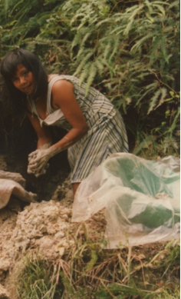
manga allpa pugru ‘a clay pit’

The switch reference suffix -kpi is best understood by contrast with the coreference suffix –sha because their meanings are opposite and they would never co-occur in the same verb. Just as coreference -sha establishes that two actions are performed by the same subject, -kpi establishes that the action of the -kpi verb and that of a following finite verb are performed by different subjects. A nice way of metaphorically conceiving of the function of -kpi is to imagine that it acts as a spotlight which highlights a different player in a dramatic performance. It is always suffixed behind the last vowel of a root:
llukshina “to emerge” > llukshi- + kpi “someone (other than the subject of the finite verb) emerges”
A verb root suffixed with -kpi is not marked for person, tense, or number. Speakers will sometimes use a subject, where ordinarily they wouldn’t, in order to be specific about who is doing what, but it’s not required by this kind of construction. Notice that lines 4,5,8, and 9 of the narrative all use switch reference suffixes, but none of the subjects of the switch reference verbs is specified. Context plays an important role in identifying subjects of switch reference verbs.
To understand the nature of the relationships between actions linked by a –kpi suffix, it is useful to think of them as either causally linked or temporally contiguous, as is also the case for the –sha suffixed verbs described in Lesson 14. Such linkages may be translated with a variety of different phrases, none of which occurs in Quichua, such as : if x happens, then y will happen; because x happened, y happened; when x happens or happened, y happens or happened. In some instances more than one of these interpretationss may be equally plausible.
If/then –kpi constructions
If the finite verb linked with a –kpi verb does not specify that an action is in the past, then the –kpi verb and the finite verb may be linked by an if/then relationship. An example of an if/then-like relationship between verbs linked by –kpi is found in example 9 of the instructional narrative:
Kosakpi kutillata tuvyakpiga, kutillata karani manga allpata.
‘(If, when) someone fires (it), it again explodes, (then) again I fortify the clay.’
Another example of such a linkage is found in the following:
Mana tamyakpi sachama purini.
‘(If, when, because) it doesn’t rain I walk to the forest.’
Temporal linkages formed by –kpi constructions
Another type of conceptual linkage between a –kpi suffixed verb and a main verb is temporal. This type of relationship is most evident when the finite verb is in the past tense. In such examples, the two actions may happen simultaneously with each other (when/while x happened, y happened), or one action may precede another (after x happened, y happened). In such cases, there is no necessary causal relationship between the two actions, but rather, a temporal or sequential relationship. Example 5 from the narrative illustrates the simultaneous relationship between two actions:
Kosakpimi tuvyara
“(When/while) (I/someone) fired it, it exploded.”
A similar kind of sequential relationship is found in example 4, where one action precedes another:
Chita apamusha, awakpi, tuvyara.
‘(After) bringing that and (trying) to create with that clay, it exploded.’
Practice 1
Practice switch reference constructions by making sentences with the following sets of words. Then provide a translation of the sentence you constructed.
Example:
(ñuka ñañawa wawa/ wañuna/ ñuka/ wakana) >
Ñuka ñañawa wawa wañukpimi, ñuka wakarani.
‘When/because my sister’s baby died, I cried.’
1. (wawaguna, killachina / ñuka, rina)
2. (kanguna, ashka pangaguna, pallana / mama, alita, kosana)
3. (Hachi Fernando, raykaywan wañuna / ñuka, pay, karana)
4. (mikya Lola shamuna / ñuka, aswa, pay, upichina)
5. (indi pundzha, ana / yaya, paktamuna)
6. (apa yaya, mushuk hacha, kuna / ñuka, wangana aycha, kasana)
7. (puma, ñuka, apanakuna / sindzhita, kallpana)
8. (ñukanchi, alita, allpa, allmana / paloguna, shamuna [neg])
9. (lomo, chayana / payguna, mikuna)
10. (sacha supay, wawa, hapina / kutillata rikurina [neg])
11. (supay, pay, nitina / pay, asinayana)
12. (payba mushuk hacha, shuwana / pay, muskuchina)
13. (runa, likcharina / supay, kallpana)
14. (runa, puñuna / supay, pay, rikuna)
15. (washamanda, ruya, takana / runa, pay, maskana)
Sequencing of –sha and –kpi
The designated name of -kpi as a ‘switch referenc’” suffix is an accurate indication of its function. Everytime you see or hear a -kpi, you should expect the very next verb to ‘switch’ to a different agent (or subject). In line 4, the -sha verb which precedes the -kpi verb can be understood to refer to the same agent or actor as the -kpi verb:
Chita apamusha awakpi, tuvyara.
‘(After) bringing that and trying to create (with it), it exploded.’
In this line, the first verb apamusha ‘bringing’ modifies its immediately following verb awakpi ‘someone creates’ However, since this second verb is suffixed with -kpi, the very next verb has to refer to a different agent or actor than that of the preceeding -kpi verb. And, in fact, it does, since the exploding clay is agentively distinctive from the narrator’s shaping of the clay described by awakpi.
Consider, next, line 9:
Kosakpi, kutillata tuvyakpiga, kutillata karani manga allpata.
‘If, when I fire it, it explodes again, again I fortify the clay.’
In this example, there are two switch reference verbs which occur right next to each other. The first verb kosakpi refers to the action of firing by the narrator. The next verb tuvyakpi refers to a different event, that of the exploding of the pottery. The fact that this verb too is suffixed with -kpi means that the very next verb has to refer to yet another distinctive agent, which it does. Remember that even though the agent of the final verb and of the first verb of the sentence are the same, the first verb has to be suffixed with -kpi to keep it distinguished from its immediately following verb. Syntax, then, is an important part of the proper usage and interpretation of –kpi and also –sha suffixes.
Written exercise 1
Practice using -kpi and -sha by completing the following sentences with the correct form of the verb in parentheses (You will either use -kpi, -sha, or a finite verb.)
Then provide a possible translation
Example:
________________ (tamyana ‘to rain’) payguna mana paktamunawrachu >
Tamyakpi payguna mana paktamunawrachu.
‘Because/since it rained/is raining, they didn’t arrive.’

1.________________ (shamuna) __________________ (tiyarina), payta upichirani aswawan.
_____________________________________________________________.
2. Pay tukwita __________________ (llatanana) payta __________________ (rikuna) supayga.
______________________________________________________________________.
3. Supay __________________ (uyarimuna), ñukanchi __________________ (mandzharina).
_____________________________________________________________________
4. Runagunaga mana _________________ -chu (samana) __________________ (sirina).
__________________________________________________________________
5. Pay ñukata __________________ (nitina) __________________ (asina).
________________________________________________________________.
6. Pay ton ton ton _________________ (takana) _________________ (purina) payta uyarani.
_________________________________________________________________.
7. Chunda __________________ (pukuna) payguna __________________ (pallana).
__________________________________________________________________.
8. Awkata __________________ (rikuna), ñukanchi __________________ (kallpana).
_____________________________________________________________________.
9.__________________ (tamyana) ñukaga __________________([neg]likcharina).
______________________________________________________________.
10.Kumari Faviola__________________ (hatarina), aswata __________________ (upina), chagrama __________________ (rina).
____________________________________________________________________.
11.Ñukata __________________ (upanayana), aswa __________________ (tiyana), payguna ñukata __________________ (upichina).
__________________________________________________________.
Practice 2
Construct switch reference sentences with the following sets of words.
Example:
(upinayana /upichina) > Kanta upinayakpiga, ñuka kanta upichini.
1. (puñunayana / rina)
2. (ñuka, llakina / payguna, aycha, karana)
3. (puma, sindzhita, kallpana / ñukanchi, sindzhita, apanakuna)
4. (pay, wawa, markana / kan, ashanga, aparina)
5. (wawaguna, killachina / pay, llukshina, wasi)
6. (indi pundzha, ana / chagra, ñukanchi, tarabana)
7. (palo, wasigama, llukuna / wawaguna, mandzhana)
8. (amarun, ñukanchi, rikuna / ñukanchi, kallpana)
9. (kari, shuk warmi, munana / warmi, llakirina)
10. (puma, urku, sikana / payguna, pay, [neg] rikuna)
11. (kan, ñuka, tapuna / kan, tukwi, rimana)
12. manga allpa, tuvyana / [neg] mukaha, awana)
Written exercise 2
Decide on a -kpi verb or a coreference -sha verb, or a tensed finite verb for each of the following sentences.
Shuk apa mama tiyawra. Chi apa mama ishkay churiyuk mara. Kay ishkay churiwan __________________ (kawsana) tiyawra. Chagrama __________________ (rina), lomota __________________ (tarpuna) palandatawas __________________ (tarpuna) kawsara. Payba churiguna aychata hapingaw __________________ (purina). __________________ (aswana) chapara apa mamaga.
Payguna aycha illak __________________ (paktamuna) apa mama __________________ (piñana) mana paygunata upichirachu.
Kayandi, aychata __________________ (hapina) pukunawan __________________ (markana), wasiy _________________ (paktamuna), apa mama ______________ (kushiyana) upichira paygunata.
Practice 3
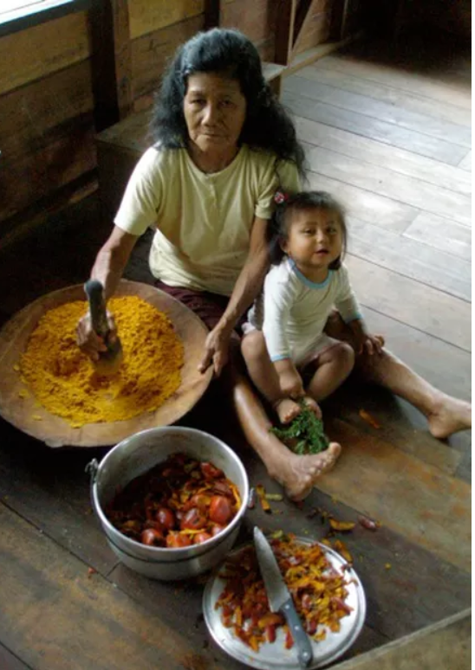
Make up 3 sentences that tell a short story about each of the following pictures. Make sure that at least one sentence uses a switch reference construction. A possible verb to use is given for each image
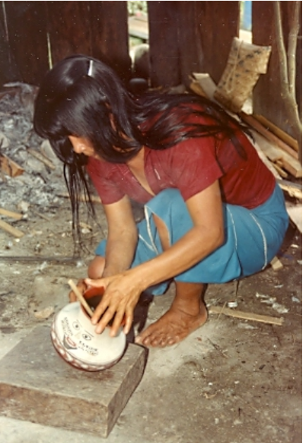
A awana ‘to make’ B chunda aswana ‘to make aswa with chunda’
1. 1.
2. 2.
3. 3.

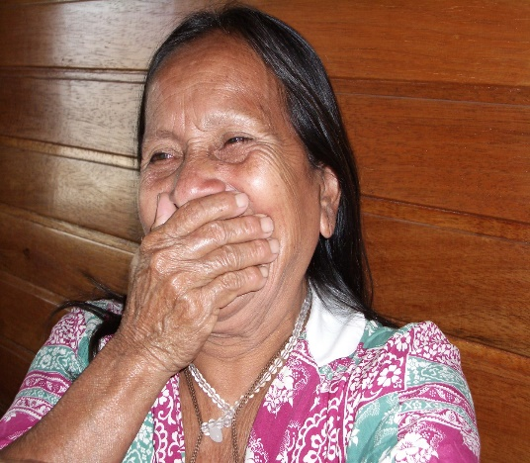
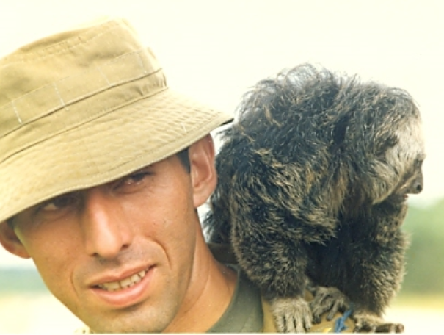
C asina ‘to laugh’ D chapana ‘to wait’
1. 1.
2. 2.
3. 3.

