LESSON 18
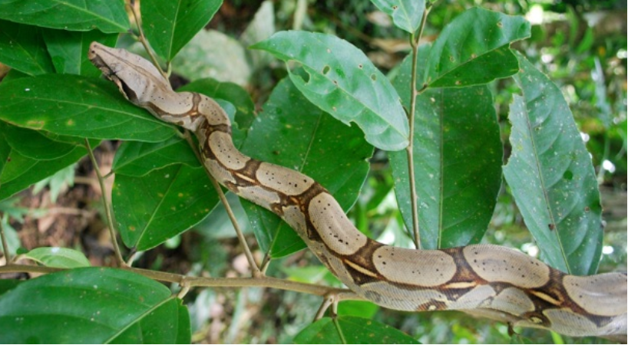
Sikwanga amarun ‘toucan boa’
Narrative: ‘Chased by a motolo’
1. Ñukanchi chagrangaw riranchi, ñuka, Tito, Kumpari Galves, Taruga kachigama.
taruga ‘deer’
kachi ‘salt’
‘We went to make a chagra, myself, Tito, and Compadre Galves, all the way to Deer Salt.’
2. Taruga kachiy paktaranchi chishita.
chishita (adv) ‘afternoon’
‘We arrived at Deer Salt in the afternoon.’
3. Kariguna ruyata kuchunawra hachawan; tsuping kuchunawra.
tsuping ideophone for a complete stripping or clearing away
‘The men chopped down trees with axes; tsuping (clearing everything) they chopped them.’
4. Ñuka yanapak arani ismu hachawan.
ismu (adj) ‘rotted’
‘I helped with my rotted ax.’
5. Chimanda kanoata rirani aswata llapingaw.
llapina ‘to squeeze, usually said of squeezing cooked, fermented aswa’ pulp in water.’
‘Then I went to the canoe to squeeze some aswa.’
6. Aswata llapiurani, paygunata upichingaw. Kungaylla paktamura Tito. Tsala nawiyuk ara.
tsala ‘white, pale, usually said of skin’
‘So I was squeezing aswa to give them to drink. Suddenly Tito arrived. His face was pale.’
7. ‘’Kumpari Galves kazi wañuy tukura!’ niwan.’
tukuna ‘to become’
kazi ‘almost’ (cf Sp casi)
‘’Compadre Galves almost ended up dead’ he tells me.’
8. ‘Imata pasara?’ nini
‘’What happened?’ I ask.’
9. Hatun motolo ruku payta kallpachira. Tarapoto ruyay tiyawn kunan. Ama rikugrichu!
motolo ‘type of pit viper’
kallpachina ‘to make run; to chase’
tarapoto ‘name of a tall palm tree’
‘A great big motolo chased him. He’s up in a tarapoto tree now. Don’t go and look!’

Nominalizing verbs with –y suffix
It is quite common for Quichua speakers to turn verbs into nouns by deleting the infinitive –na and adding a –y suffix, which is probably a metaphorical extension of the locative –y. The relationship between locative –y and nominalizing –y, is that a locational idea is implicit in the nominalized form. An analogy from English usage may be found in such expressions as ‘in the race’ for the verb ‘to race’. Location is a pervasive metaphor in English for a variety of ideas: ‘belief: ‘to believe in something’, activities: ‘to be in a war’ and states: ‘to be in a rage’. Quichua nominalized –y verbs have similarities with such constructions and are discussed in the following sections of this lesson.
The become construction: –y verb + tukuna
The verb tukuna ‘to become, turn into’, may be used with a –y suffixed verb root to indicate that a process is happening with little volitional control on the part of a person, or other, typically sentient being. For example wañuy tukuna may be used, and translated ‘to become dead, end up dead’, as it is in Line 7 of the opening narrative:
’Kumpari Galves kazi wañuy tukura ‘Compadre Galves almost ended up dead.’
Note that this nominalized form of tukuna is identical to the immediate imperative singular. Wañuy is considered a nominalized form because it can function as a noun-like word meaning ‘death.’ In combination with the verb tukuna, however, the nominalized verb may be conveniently thought of as having the same meaning as a past participle. The construction wañuy tukuna can be literally translated ‘to become dead, to end up in death, or more simply, to end up dead.’ This is a very productive construction that is capable of occurring with many different verbs.
Practice 1
Say the correct form of the verb in parentheses for each of the following sentences.
Example:
Ñukanchi _______________ tukuranchi ismushka aychamanda. (kwinana)
Ñukanchi kwinay tukuranchi ismushka aychamanda.

1.Ñukanchi _______________ tukuranchi Ulpiano wasiy (karana)
2.Payta _______________ tukura payba kachunmanda (upichina)
3.Tarabanamanda ______________ tukurangichichu? (pagana)
4.Bagrita ____________ tukura ñuka likay (hapichina)
5._________________ tukushun pumamanda o amarunmanda.(mikuna)
6. Ñukanchi mana _____________ tukuranchichu mingangaw (kayana)
7. Pumamanda ___________________ tukunawra sachay (apanakuna)
8.Motolomandaga _______________ tukura Kumpari Galvesta. (kallpachina)
9. Ñuka panita _____________ tukun karimanda. (ichuna)
10. Ñukata _____________ tukurani Anna Mariamanda.(llullana)
Culture Focus: a few varieties of lumu ‘manioc, yuca, cassava’
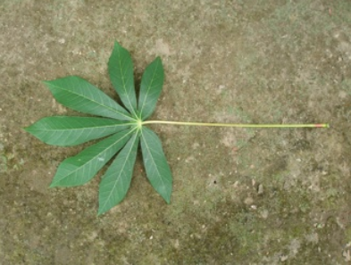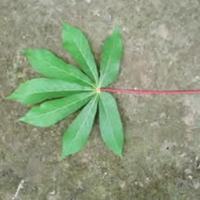
tsatsa lumu purutu lumu puka maki yurak tullu lumu
tsatsa manioc bean manioc red-hand-white-bone manioc
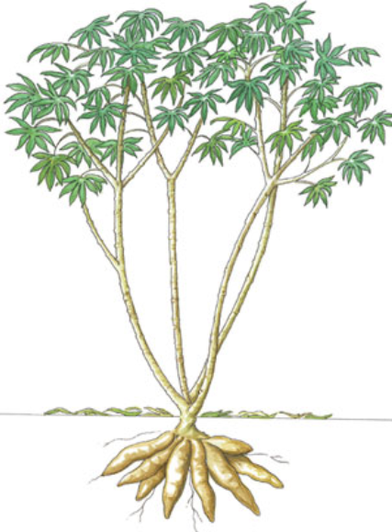
Manihot esculenta ‘manioc, yucca, cassava’
Manihot esculenta, the species name for what is commonly known in Quichua as lumu, or by non-Quichua speakers as manioc, yuca, or cassava, is a major source of carbohydrate energy for residents of Amazonian Ecudor. For Quichua speaking runa, it is a garden staple that is mostly used to make aswa, a lightly fermented drink which is a major source of carbohydrate energy, consumed by all. It is an intrinsic part of hospitality rituals as well as major celebrations. The preparation of aswa is done by women who boil the manioc tubers and then mash them together in a large wooden vat. The traditional method of making aswa also involves taking a small portion of the cooked, mashed manioc and letting it sit inside one’s mouth for a few minutes. This process of mastication introduces enzymes from saliva which catalyze fermentation.
Manioc gardens are significant spaces for working and socializing. Although many other crops are grown along with it, manioc is the most intensively cultivated. Women may spend hours every week weeding, cultivating, harvesting, and protecting their gardens from pests. They nurture their manioc tubers and may even think of them metaphorically as their children. Not surprisingly, the significance of gardens often involves beliefs about the sacredness of such spaces and the reverence that should be accorded to them. According to the following woman, one should announce oneself by lightly rapping on trees when entering one’s own chagra so that the spirits of the garden are alerted to your presence. Attempting to quietly enter someone else’s garden will result in illness, because the spirits of the garden will quickly detect your presence and realize that you are an intruder, and likely a thief as well, and, in a vampire-like way, they will suck your blood!
Translation challenge
Go to the following link which has been transcribed and partly translated, featuring a speaker’s description of proper etiquette when entering one’s agricultural field, as well as a warning about not entering other peoples’ agricultural fields. Listen to the first minute and twelve seconds, and try to translate the untranslated sentences below :
https://www.youtube.com/watch?v=hWub9fPll-4

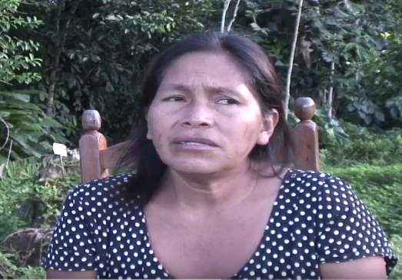
How to enter one’s chagra

1.Chitaga ñukanchita ñukanchi yayaga nig ara: “shukba chagrayga mana yaykuna chan.”
This is what our father used to say to us: “Into another person’s chagra, one is not to enter.”
2.“Amowa chagraybi ruyata kasna taw taw taw taw taw, taw taw taw taw taw waktasha yaykuna nig an.”
-------------------------------------------------------------------------------------------------------
3.“Dinuga shukba chagraybiga mashti amo kantasha, sakishka manga, nig ara.
Otherwise, into another person’s chagra, the owner, singing (magical songs) will leave it (the chagra)” he used to say.
4. Ñukanchi yawarta win upichun nisha!
“In order that they, wanting to, (the garden’s spirits) will drink all of our blood.”
5.Mana shukba chagrayga mana yaykuna nig ara.
-----------------------------------------------------------------------
6.“Kanguna yaykukpiga, kanguna yawarta upikpiga tsalaaa tukungichi” nig ara.
-------------------------------------------------------------------------------------------------
Chiga lomo mamaga win! amo, lomo amoga upi tukungichi yawarta nikga.
“And so the mother (spirit) of the manioc, all of it! You-all will end up (having all of) your blood drunk by the manioc’s owner spirit” he would say.
Mana yaykuna chan shukba chagraybiga.
----------------------------------------------------.
Amowa chagraybi, mashti, ruyay waktasha yaykuna an nisha nira.
------------------------------------------------------------------------------
“Yumingasha sakishkata dinuga”
Having left it, hexing it, and so
“Yumingasha sakishka dinuga”,
Having left it, hexing it, and so
Mashti yumingasha sakishka dinuga kangunataga mashti upi tukungichimi yawarta nig ara.
Um, “having left it, hexing it, and so, you-all, um, will end up with your blood drunk” he would say.
Chiwa raygu mana yaykuna chan shukba chagray nisha ñukanchita wawamandata
kunasha ñukanchita wibay tukug aranchi.
---------------------------------------------------------------------------------------------------
------------------------------------------------
Practice 2
Answer the following questions by making use of the words in parentheses.
Example:
Imata tukushun? (mikuna, puma) ‘What will become of us?’
Mikuy tukushun pumamanda. ‘We’ll end up being eaten by a jaguar.’
1. Imata tukunga? (kanina, palo)
2. Imata tukusha? (hapichina, amarun)
3. Imata tukungi? (mikuna, amarun)
4. Imata tukungauna? (llullana, kachun)
5. Imata tukushun? (ichuna, kari)
6. Imata tukungichi? (kallpachina, motolo)
7. Imata tukungichi? (kayana, kumpari Galves)

Completive –y verb + pasana constructions
In addition to the the compound construction just discussed, featuring a nominalized verb and an inflected form of tukuna, there is the possibility of using the verb pasana ‘to pass, finish’ with a nominalized verb to express completive meanings. We have discussed the use of –shka as a perfect aspect marker that is also used as a kind of genre marker for beginning times stories, and in expressions linked with surprise.
We now introduce a more ‘everyday’ construction for expressing completive meaning. This construction is formed by suffixing a verb root with –y, which is then used together with an inflected form of the verb pasana ‘to finish, pass. The resulting construction expresses the idea that something is completed and its completion is relevant to the time of speaking. This construction is therefore comparable to a present perfect construction in English:
Mikwi pasangichu? ‘Have you finished eating?’
Ña riy pasan ‘He/she/it has already gone.’
Armay pasanawn ‘They have finished bathing.’
Practice 3
Practice expressing the completive construction by responding to the following direct imperatives.
Example:
Mikwi! ‘eat!’
Ña mikwi pasanimi! ‘Well I’ve (already) eaten!’
1.Upichi!
2. Tarabay!
3. Chagrata allmaichi!
4.Ayllugunata upichi!
5.Kosasgunata alichi!
6.Maytuna pangata pallaichi!
7.Mukahata pintay!
8.Wasita pichay!
9.Aychata chakichi!
10.Kallari timputa kwintay!
Review question: -shka suffix
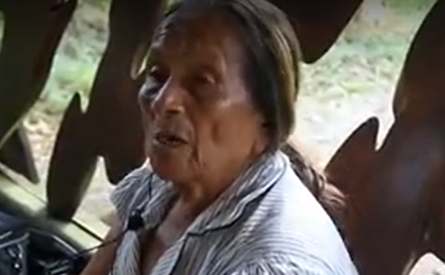
Ri pasashka! ‘She was gone!’
Go to the following link and listen to Video 1, featuring a speaker using the construction we have just practiced, using the verb rina ‘to go’, suffixed with –y, along with pasana. The speaker is describing a personal experience of expecting to find her mother by searching for her in her garden, and then realizing that she had already gone:
http://quechuarealwords.byu.edu/?ideophone=kushning
In this example, however, the speaker is using the –shka suffix, rather than an ordinary past tense suffix, saying ri pasashka rather than ri pasara. Can you explain why:?
Mama chagray paktaranchi. Rikukpi mama kiwata allmanga shamukga kushning! Ña ri pasashka mara mama!
‘We arrived at mom's chagra, and upon looking (realized) that, mom, having come to weed, (all that was left was a bit of) smoke (from her campfire)! She had already gone, mom had!’
Inceptive –y verb + kallarina constructions
The verb kallarina ‘to begin’ can be used in a type of compound verb phrase which is semantically similar to the English ‘begin to do something’ construction. Furthermore, it is formed according to the same principles as the verb + tukuna and verb + pasana constructions which have just been discussed. Consider the first example below:
Wawaga waka-y kallarira ‘The baby began to cry’
In this sentence, the nominalizing -i turns the verb root wakana into an infinitive-like form, translateable as ‘to cry.’
Practice 4
Practice this construction by transforming the following verbs into inceptive constructions, using the past tense for the main verb.
Example:
(ñuka, pay, apanakuna) >
Ñuka payta apanakuy kallarirani. ‘I began to follow him/her/it’
1. (pay, chagrana)
2. (pay, ñuka, chapana)
3. (ñukanchi, paba, wañuchina)
4. (turiguna, taruga, kallpachina)
5. (kanguna, ñuka, killachina)
6. (payguna, ruya, kuchuna)
7. (payguna, bayllana)
8.(yachak, takina)
9.(wawaguna, pugllana)
10.(ñukanchi,upichina)
Review Question: -shka suffix
Sindi kallarishka ‘(It) began to burn.’
Go to the following link and listen to Video 3, featuring a speaker using the construction we have just practiced, using the verb sindina ‘to burn’, suffixed with –y, along with kallarina. By way of background, the speaker is describing events from long ago, which he has heard about from others, when intertribal warfare was common. In this particular description, he explains how houses would begin to burn after being set on fire by aggressors. Can you explain why he says sindi kallarishka rather than sindi kallarira?
http://quechuarealwords.byu.edu/?ideophone=kushning
Chiga na wing wasi sindi kallrishka, hapirishka wasi kushning
‘And so then, the entire house began to burn, being caught (by fire) it smoked.’

General principles of sentence construction: subject deletion and transposition
Quichua belongs to a typological category of languages which arrange their meaningful elements in a subject/object/verb order. This means that a sentence which actually has a subject, direct object, and a verb will most likely feature these constituents in an SOV (subject, object, verb) pattern when a speaker is attempting to present information as unambiguously as possible. However, word order is subject to tremendous variation and there are several permutations of this general, ideal model. One important variable is the presence of a subject. As you have probably already noticed, subjects are frequently omitted.
Practice 5
Identify the subjects of the following sentences, and remove them, repeating whatever remains of the sentence.
Example:
Ñuka apa yaya kunan shamun. > Kunan shamun.
1. Ñukanchi ukta shamuranchi, paygunata yanapangaw.
2. Kan imata munangi?
3. Payguna yandata tsalisha tarabanawn.
4. Kan ama ñukata tapuwangichu!
5. Ñuka hachi Cervantes ñawpa ali kantak mara.
6. Payga ñañawanshi purik ara.
7. Kanguna tragota upi pasarangichichu?
8. Ñuka wawa yakuy pugllasha armak an.
9. Puka yakumanda warmiguna gustuta baylanawrami.
10. Shuwak runaga wasimanda kungaylla llukshira.
Subject transposition
When a speaker wants to emphasize the action or event described by a sentence, if a subject is in fact mentioned, then that subject may be moved into the sentence’s word-final position. Consider by way of illustration, the following sentence:
Pundzhanshi rikurinawra, estelleresga. ‘Brightly (they) appeared, those stars.’
The speaker of this sentence shifted the subject so that it was last, in order to emphasize the brightness of the stars. However, it is difficult to translate this into English, because we don’t usually construct sentences with adverbs in initial position. Practice 6
Move subjects to sentence final position to emphasize the action or event referred to in the sentence. First pronounce each sentence as it is and then recombine its elements. Example:
Estelleresga pundzhanshi rikurira. > Pundzhanshi rikurira, estelleresga.
1. Tangu pundzhan pundzhanshi rikurik man.
2. Talmu kuru lomo kaspiwan wikan wikanshi purik man.
3. Armadillu tazin wasinshi rikurin.
4. Amarunga yaku haway uman rikuriura.
5. Siluga kungaylla yananmi tutayara.
6. Siluga ruyanmi pundzhayara.
7. Ñukaga mana tukuta mikunichu.
8. Kikin lobo yakuy bagrita hapiura.
9. Bagriga yaku ukumanda dzas saltara.
10. Ñukaga lomo kaspita mana apamuranichu.
11. Ñuka ñañawa churi yapa shuwag man.
12. Payba llullu wawa mundo wakay siki man.
13. Payga ñawi lulunwan mana rikunata ushandzhu.

The subjunctive suffix –chun will be discussed in Lesson 20.

