LESSON 11
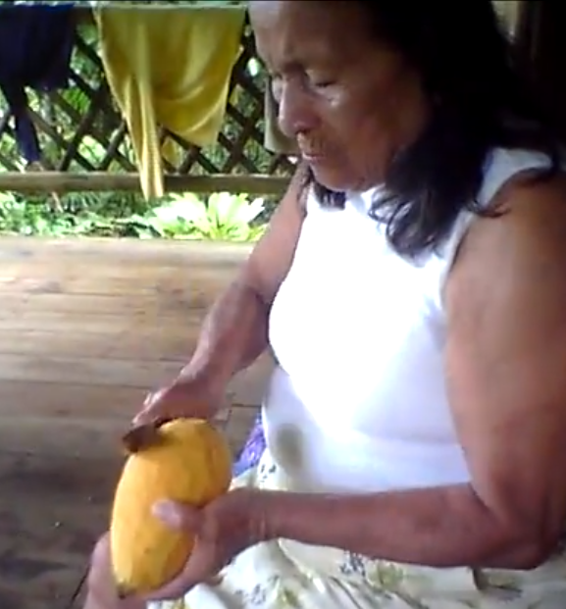
Piton muyu ‘the piton fruit’
The purposive –ngawa
Dialogue
1. Magdalena: Mayta riungi kumpari Davis? ‘Where are you going compadre Miguel?’
2. Miguel: Pitunta pallangaw riuni. Kanga?“I’m going to harvest pitun fruits. And
pitun ‘squash-like edible fruit’ what about you?’
-ngaw ‘in order to’
3. Magdalena: Chundata kuchungaw riuni. ‘I’m going to chop down a chunda tree.’
kuchuna ‘chop, cut down a tree’
4. Miguel: Kamba hacha mana valinchu. ‘Your ax is no good. Look it’s rotting. It’s
Rikuy ismuun. Shaka likiriun. splitting shaka (right in half).’
hacha ‘ax’
valina ‘to have value’
ismuna ‘to rot’
shaka ‘the lengthwise dimension of a split or tear’
likirina ‘to split, tear, lengthwise’
-u- durative suffix
5. Magdalena: Ciertomi ningi. Kamba ‘You’re right. Loan me your nice new ax.’
ali mushuk hachata mañachiway.
mañachina ‘to loan’
6. Miguel: Wasiy mawn. Apagri. ‘It’s in the house. Go and get it.’
-gri ‘translocative suffix meaning ‘to go and do something’
7. Magdalena: Dyuspagarachu kumpari. ‘Thank you compadre’
dyuspagarachu ‘thank you (literally: May God repay you)’
8. Miguel: Ari. Yuyuta kachawangi. ‘O.K. (And) send me some heart of palm.’
yuyu ‘heart of palm’
9. Magdalena: Ari. Chunda aswata upik ‘O.K. (And) come and drink some shamungi. chunda aswa.’
-k agentive suffix
Quichua speakers often make use of a type of verb construction which expresses a purpose-driven, not yet accomplished action or process. By means of the suffix –ngawa ‘in order to’, (sometimes shortened to –ngaw), which is added to a verb root, speakers are able to express the motivation for a main verb’s action. This is done for speakers of English with such sentences as the following: ‘I’m going (in order) to buy food’, or ‘He’s going (in order) to get some help’.
The main difference between such English language constructions and Quichua constructions is that in Quichua, the ‘in order to verb’often comes before the main verb rather than after it. A Quichua speaker would therefore most likely say: ‘(in order) to buy food I’m going’, or ‘(in order) to get some help he’s going’, rather than ‘I’m going (in order) to buy food’ or ‘He’s going (in order) to get some help’.
Although evidentials –mi and –shi, and also the interrogative -chu may be suffixed to –ngawa, it is considered a terminal suffix because it makes any further inflection or derivation of a verb root impossible. –Ngaw replaces the infinitive –na:
Randi-na ‘to buy’ > randi-ngaw ‘in order to buy’.
–Ngaw encodes a verb’s meaning with a potential mood, because it is only a possible action, event, or process that is being referred to:
Kuchu-na ‘to cut, chop a tree’ > kuchu-ngaw ‘in order to cut, chop a tree’
Because the action referred to by an –ngaw construction is not accomplished, it is considered to be encoded with a type of subjunctive mood.
Practice 1
Practice answering questions with purposive -ngaw forms. You may use any of the following expressions, all of which mean ‘why?’: imamandata?, ima rayguta?, or imawata?
Example
Imamandata tarabangi? ‘Why are you working? literally: what-from are you working?’
Ñuka yaya/yanapana
Ñuka yayata yanapangaw tarabani.
1.Imamandata aswangi?
Runa/upichina
ayllu/upichina
masha/upichina
baylakguna/machachina

2.Imamandata chunda ruyata kuchungi?
chunda muyu/tandarina
chunda aswa/aswana
chunda muyu/mikuna

3.Ima rayguta llaktama ringichi?
mikuna/ randina
ali llachapa/randina
mushuk hacha/randina
suni waska/randina
mushuk sawli/randina

4. Ima rayguta ñambita rinawn?
wangana/maskana
lomocha/hapina
ali upina muyu/pallana
runa/apanakuna

5. Imawata kuchata hambingi?
yana bagri/ hapina
challuwa/mikuna
chulla shimi/aysana
tanlla/hapina
chambirima/mikuna
kungukshi/aysana

6. Imawata wasima tigran?
wawa/rikuna
ashanga/maskana
aswa/upina
ñuka kari/upichina
ñuka warmi/rikuna
waska/maskana
lomo/yanuna

7. Ima rayguta ruyata kuchungichi?
muyu pallana
chagrana
yuyu, mikuna
muyu, upina
panga, pitina
chagra, chagrana

Practice 2
Construct mini-dialogues by answering the following questions in the affirmative. Then your instructor will ask you why you have something, and you will answer with a purposive construction.
Example:
Charingichu kayututa?
Nda. Kayututa charinimi
Imawata charingi kayututa?
alita puñungaw.
Choose your answers about why you are doing what you are doing, from among the following sets of words.
sindzhita, tarabana aswa, upichina
ruya, kuchuna alita, sirina
sachay, purina charapa aycha, mikuna
runa shimi, rimana lomo, tarpuna
chagrama rina alita kawsana
lomo, pitina aswa, aswana

1. Charingichu chagrata?
2. Charingichu charapata?
3. Charingichu shimita?
4. Charingichu chakita?
5. Charingichu mukahata?
6. Charingichu hachata?
7. Charingichu hamangata?
8. Charingichu wasita?
9. Charingichu makita?
10. Charingichu sawlita?
11. Charingichu ñambita?
12. Charingichu lomota?
The ideophone shaka
The ideophone shaka from the opening dialogue usually describes the lengthwise dimension of a split or tear. It may be used to describe the tearing of paper, fabric, or a long split in a piece of wood. Occasionally it may also be used to describe a linear marking on a surface that is made by painting or scoring that surface. Go to the following link:
http://quechuarealwords.byu.edu/?ideophone=shaka
Watch video 1 from a traditional story about two sisters who try to prevent two brothers from leaving them by running after them and grabbing their shirts, resulting in the tearing apart of their shirttails. These two sisters are the ones discussed in Lesson 8’s Culture Focus on wituk and manduru, pp. 119-120. The speaker uses shaka to describe the sisters’ tearing actions. Watch how the speaker’s gestures together with the ideophone shaka, depict this. Notice the use of the evidential –shi suffix, discussed in Lesson 6, which indicates that the story is a traditional one and not being told from the perspective of the speaker herself. The use of ‘apparently’ in the translation is one way of translating this sevidential. The –bas suffix, indicating inclusiveness, will be discussed in Lesson 19. The –shka suffix, which is perfective, will be explained in Lesson 16.
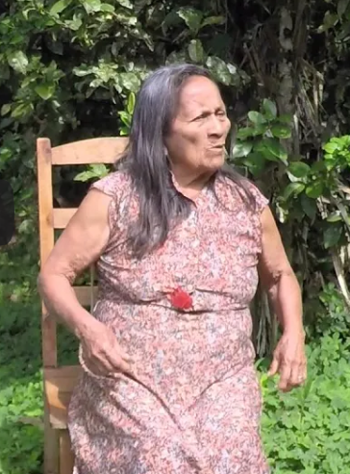
Shakaa shuk-bas shakaa-shi liki-shka-wna
‘(First) one tore shakaa and then another shakaa had also apparently torn.’

The durative suffix –u
The durative suffix –u is used to describe an action that is continuous with respect to some other event. A Quichua verb suffixed with –u is similar to the English progressive construction “I am ______-ing”. Durative –u occurs after the last vowel of the root and before the tense suffix. When the last vowel of the root is i, then durative –u creates an extra syllable in a verb’s form. For example:
rini ‘I go’ > riuni ‘I am going’
ringi ‘you go’ > riungi ‘you are going’
rin ‘he, she, it goes’ > riun ‘he, she, it is going’
ringichi ‘you-all go’ > riungichi ‘you-all are going’
rinawn ‘they go’ > riunguna ‘they are going’
When the last root vowel is a, then the vowel plus the –u are pronounced together as one diphthong which is represented as aw, and there is no extra syllable in the durative form. For example:
apani ‘I take’ > apawni ‘I am taking’
apangi ‘you take’ > apawngi ‘you are taking’
apan ‘he, she, it takes’ > apawn ‘he, she, it is taking’
apanchi ‘we take’ > apawnchi ‘we are taking’
apangichi ‘you-all take’ > apawngichi ‘you-all are taking’
apanawn ‘they take’ > apawnguna ‘they are taking’
When the last root vowel is also a u vowel, then the durative -u has the effect of lengthening that vowel. For example:
mikuni ‘I eat’ > mikuuni ‘I am eating’
mikungi ‘you eat’ > mikuungi ‘you are eating’
mikun ‘he, she, it eats’ > mikuun ‘he, she, it is eating’
mikunchi ‘they eat’ > mikuunchi ‘we are eating’
mikungichi ‘you-all eat’ > mikuungichi ‘you-all are eating’
mikunawn ‘they eat’ > mikuunguna ‘they are eating’

Practice 3
Answer the following questions, using a durative form for each verb.
Example:
Riungichu kumari? ‘Are you going comadre?’
Nda. Riunimi kumari. ‘Yes. I’m going comadre.’
1. wakawngichu?
2. tarabawngichu?
3. kasawngichu?
4. tiyawngichu?
5. apawngichu?
6. waytawngichu?
7. pitiungichu?
8. upiungichichu?
9. riungichichu?
10. tiyariungichichu?
11. llukshiungichichu
12. wasiungichichu?
13. mikuunchu?
14. wañuunchu?
15. tigramuunchu?
16. rikuunchu?
17. muskuunchu?
18. puñuunchu?
19. shamuunchu?
20. yanuunchu?
Finally, notice that -guna is usually substituted for the third person plural suffix –nawn when the finite verb is duratively marked. For example:
Payguna purinawn > payguna puriunguna
Practice 4
Practice making durative third person plural forms, using –guna with the verbs in each of the following sentences.
Example: Pay shamun > Payguna shamuunguna.
1. Wawa likcharin.
2. Hachi Venancio sachama purin.
3. Masha Ventura kuchamanda tigramun.
4. Pay ñukata riman.
5. Pani kayutuy sirin.
6. Apa yaya ñambita apanakun.
7. Ñukanchi kanoa yakuy shayarin.
8. Turi Cezar aychata munan.
9. Kan ñambita ñawpangi.
10. Kan kuchata puringi.
11. Pay pambay tiyarin.
12. Ñaña lomota yanun.
13. Kumpari Davis wanganata kasan.
14. Wawki wasimanda llukshin.
15. Pani pita lalata wañuchin.
Directionals –ma and –manda
In traditional grammar, the suffixes –ma and –manda could be called dative and ablative case marking suffixes, respectively. The dative –ma indicates action directed toward a specific goal, such as a place. The ablative –manda, by contrast indicates action away from a specific location, person, or a general place, such as a village. An example of their typical use reveals a fundamentally important orienting principle for peoples’ comings and goings. This orientation is provided by the flow of river systems which are described with –ma and –manda as either hanak-ma ‘toward upriver’ and hanak-manda ‘from upriver’ or uray-ma ‘toward downriver’ and uray-manda ‘from downriver’.
A major river for Pastaza Quichua speakers is the Bobonaza River which flows into the larger Pastaza, which in turn flows into the Marañon as well as the largest river of all, the Amazon. The major river for Napo speakers is the Napo River. PQ speakers’ memories almost always involve activities downriver, whether for trading, hunting, or for organized conflict. Our older consultants recall hearing stories from their grandparents about expeditions of canoes that had to travel all the way to the Marañon River for the purpose of mining for salt, which was useful and necessary, not only for cooking but for drying meat. These expeditions became a kind of imaginative backdrop for a genre of legendary stories about encounters with giant, people-eating hawks, chain-saw anacondas, and other larger than life monsters.

Practice 5
Practice using –manda with each of the following noun/verb combinations, being sure to vary your use of person and number. Use the durative –u whenever possible.
Example:
Wasi ‘house’ + apamuna ‘to take’
Wasimanda apamuunchi ‘We’re bringing (it) from the house.
1.chagra/paktamuna
2.kucha/hapina
3. ñambi/shamuna
4. sacha/llukshina
5.yaku/hapina
6.wasi/apana
7.chagra/pallana
8.kucha/aysana
9.uray/waytana
10.hanak/purina

Practice 6
Practice using –ma with each of the following noun/verb combinations, using durative –u wherever possible.
Example:
Wasi ‘house’ + apana ‘to take’
Wasima apawni ‘I’m taking (it) to the house.
1.kanoa/waytana
2.Quito/purina
3.sacha/rina
4.mama/kallpana
5.wasi/kallpana
6.chagra/rina
7.yaku/tuksina
8.allpa/kachana
9.yaya/purina
10.kaspi/waytana
Color words and their extensions: puka ‘red’
Sunglass frames described as puka
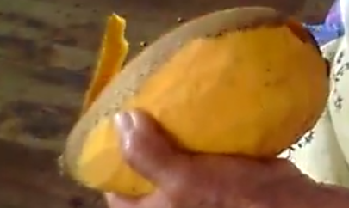
Piton fruit described as puka
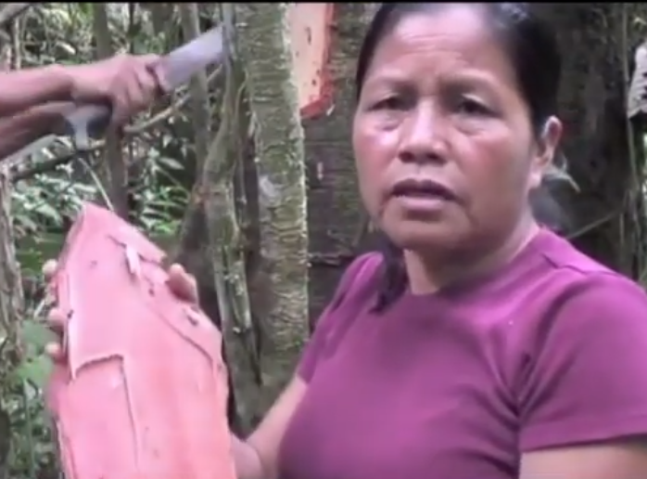
amarun kaspi interior bark described as puka

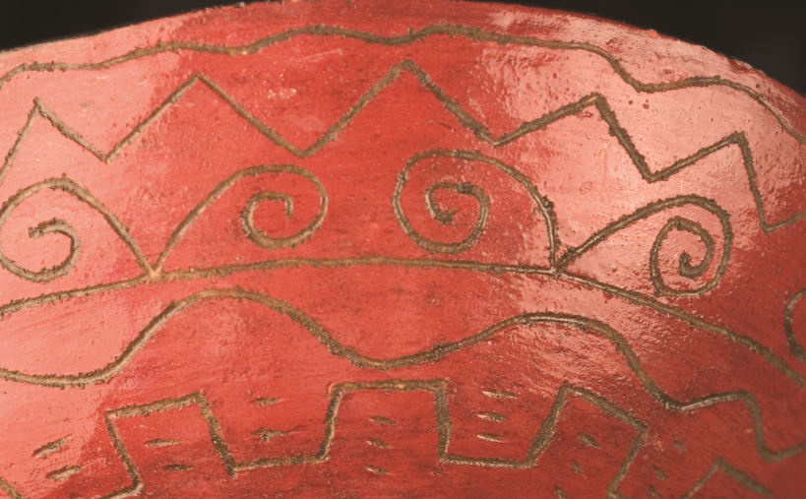
mukaha ‘clay drinking bowl’ exterior painted a puka color

Words for colors can be difficult to translate from language to language. The Quichua color term puka is an example of this difficulty. In addition to its use for a focal red color, it is used to describe the orange-like flesh of the pitun fruit mentioned in this chapter’s opening dialogue. Puka is also used to describe what in English would be labelled as ‘pink’ or ‘rose-colored’, as the underside of the bark of an amarun kaspi or ‘anaconda stick’ tree discussed in Lesson 7. Furthermore, puka is also said to characterize the color of a deer, of reddish brown earth, or of the painted surfaces of pottery used for drinking bowls.
Translation challenge exercise: the benefits of tree bark
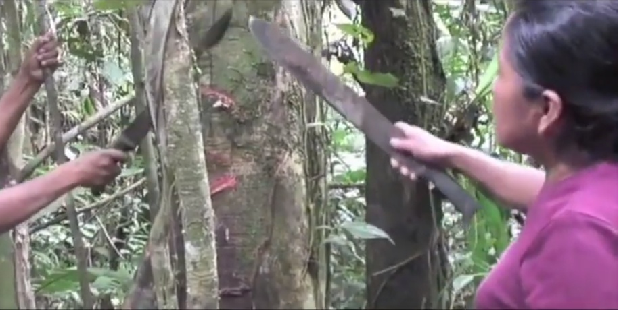
The benefits of tree bark

Go to the following link: https://www.youtube.com/watch?v=0BHdmoZZt6A
Listen to the transcribed excerpt, below, which occurs from 4 minutes until 4:33. The main speaker, from the Upper Napo dialect, is describing how to harvest bark from the amarun kaspi, or ‘anaconda stick tree’, for medicinal purposes. She refers to the color of the interior surface bark as puka ‘red’, and associates this color with a state of health, saying that if a person drinks broth from this processed bark, they will look healthy like the tree that it came from.
1.Kasna ra-sha apina pay-wa kara-ra llushtina.
2.Gustu, puka pay-kwinta, ambi pay-wa yaku-ra upi-sha, pay-kwinta puka tukuna.
3.Mana tsalaaa-lla, mana sambaya-shka, mana ima-s rikuri-nga.
4.Pay-kwinta ursa-yuk, pay-kwinta shina gustu vivu, kolor kolor warmi, kolor kolor kari, tuku-nga, kay kara upina ni-nun.
1.
2.
3.
4.

Audiovisuals of the ideophone shaka may be observed at http://quechuarealwords.byu.edu/?ideophone=shaka
Translate the –sha suffix as meaning something like the –ing suffix in English. See Lesson 14 for more detailed information.
This is a type of kamachina ‘advising’ construction covered in Lesson 9.
This is the Upper Napo variant of the direct object marker, discussed in Lesson 3.
This is the limitative suffix discussed in Lesson 10
This suffix indicates that an action has been accomplished and is discussed in Lesson 16.
This is a clipped form of the despitative –was, discussed in Lesson 9.
This is a form of the future tense, discussed in Lesson 17.
This suffix was discussed in Lesson 3
aya As there is no Quichua term for color in general, the Spanish term color ‘color’ is used here. You can translate this repeated occurrence as indicating ‘very colored’ or ‘colorful’.

