LESSON 3
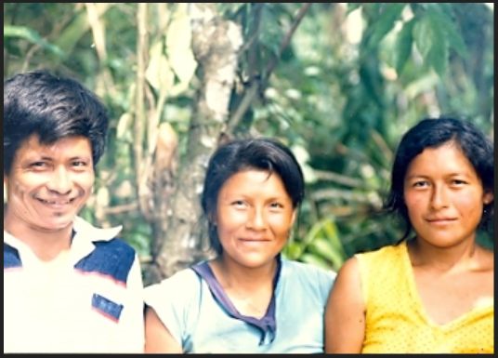
ayllu ‘family’

Talking about family
In conversation model 3 at the conclusion of lesson 1, there was a brief exchange between two people who had a type of relationship, the compadrazgo relation, which anthropologists refer to as ‘fictive kinship’:
Ringichu kumpari? ‘Are you going compadre?’
Ari. Rinimi kumari, kayagama ‘Yes, I’m going comadre; Until next time’
Fictive kinship, as the term implies, allows people to construct meaningful social relationships with others who are not part of their families. For Quichua people, social relationships are most meaningful when based on family ties. Words for friend such as amigo/amiga are borrowings from Spanish which are used, but not invested with as much significance as family relationships. In Quichua social interactions, it is most likely that a first question asked of someone will not be ‘what is your name?’, but rather ‘whose son/daughter are you’?
The extended family or ayllu is the most important unit of Quichua society. We know from earliest records, such as that of Juan de Betanzos, that the Inca empire, called Tawantinsuyu was organized around ayllus. Kinship terms were also used to express the relationship between the Inca and their deities. Inca Yupanque was the first to be given the title Indichuri, which can be translated as ‘the sun’s son’ or ‘son of the sun’.
Family and kinship terms for consanguineals (blood relations)
Although it is probably true for all human cultures, Quichua speakers place a strong emphasis on family relationships, and feel a very poignant sadness at the prospect of not having one’s family around them. Look at the following list of kin terms and then listen to the words of Senora Luisa Cadena at:
https://www.youtube.com/watch?v=l1ECt5i2U2c
Listen to the first 20 seconds. Senora Cadena tells about all of the family members who have passed from her life. She lists each kinship category that she does not have, and calls herself a wakcha ‘orphan’. She uses the impersonal verb illana ‘to lack’ (Lesson 7), which is suffixed with the attributive –k (Lesson 12). She also uses the despitative suffiix –was (Lesson 9), shortened to –s on each kinship term.
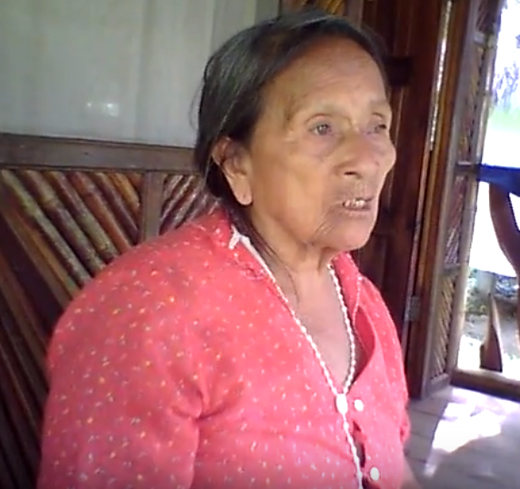
wakcha warmi ‘orphan woman’
Try to pick out as many kin terms mentioned by Senora Cadena, as you can from the following list:
ayllu ‘family (blood kinship)’
wakcha ‘orphan’
yaya ‘father’
mama ‘mother’
mikya ‘ aunt’, also used as a term of respectful address by a younger person to
an older, unrelated woman
hachi ‘uncle’
apa yaya (PQ) ‘grandfather’
apa mama (PQ) ‘grandmother’
ruku ‘old, big’
ruku yaya (NQ) ‘grandfather’
ruku mama (NQ) ‘grandmother’
musu (PQ) ‘adolescent male’
wambra (NQ) ‘adolescent male; (PQ) adolescent male or female, boyfriend or
girlfriend
churi ‘son, small boy’
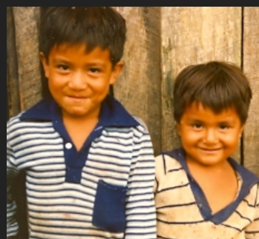
churiguna ‘little boys’

ushushi (ushi) ‘daughter, small girl’
turi ‘brother of a female’
wawki ‘brother of a male’
ñaña ‘sister of a female’
pani ‘sister of a male’
wawa ‘ baby, young child, toddler’
llulluku ‘newborn’
kari ‘male (adjective), husband (noun)’
kari wawa ‘boy baby, child’
warmi wawa ‘girl baby, child’
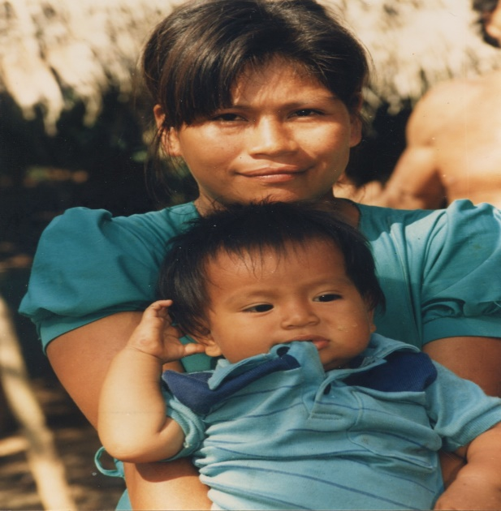
mama, churi ‘mother, son’
Asking questions about family with -yuk
Although questions to others about their families might be considered overly personal in some cultural contexts, the same is not true for Quichua speaking people who freely discuss their family matters, including illnesses, deaths, traumas, break-ups, and many other kinds of issues as well.
One of the most basic questions one can ask is a question that clarifies which family members a person actually has. The easiest way to do this is to ask a question using the possessor suffix –yuk along with the verb ana ‘to be’:
Mama-yuk-chu angi? Literally: ‘Are you a mother-possessor’?
Nda/Ari Mama-yuk-mi ani. Literally: ‘Yes. I’m a mother-possessor’
When a form of the verb ana is preceded by a word ending in –mi or –chu, however, there is a slight change in the resulting spoken form. In such an utterance, the suffixes –chu and –mi seem to ‘jump over’ to the verb, rather than staying on the original word they were attached to. Therefore, rather than pronouncing the response as follows:
Mama-yuk-chu angi?
The speaker will combine the -chu and whatever form of ana ‘to be’ follows, into one word: changi:
Mama-yuk-chu angi? > mamayuk changi?
It is as if the suffix –chu has hopped over to the next word. However, this ‘hopping over’ only happens when the next word is some form of the verb ana ‘to be. Another aspect of this process is that the vowel of the suffix –chu is deleted. This process happens no matter which form of the verb ana is used:
-chu +ani = chani -chu + anchi = chanchi
-chu + angi = changi -chu + angichi = changichi
-chu + an = chan -chu + anawn = chanwan; -chu +anun = chanun
The very same process takes place when a word ending in the –mi suffix is followed by a form of ana ‘to be’:
-mi + ani = mani -mi + anchi = manchi
-mi + angi = mangi -mi + angichi = mangichi
-mi + an = man -mi + anawn = manawn; -mi + anun = manun
Practice 1
Construct questions and answers about which ayllu members your conversationalists may have, using the preceding model.
Example:
Wawayuk changi ‘Do you have children?’
Nda, Wawayuk mani
      - Yaya
      - Apa yaya (PQ) ‘grandfather’
      - Ruku yaya (NQ) ‘grandfather’
      - turi ‘brother of female’
      - wawki ‘brother of a male’
      - pani ‘sister of a male’
      - ñaña ‘sister of a female’
      - mikya ‘aunt’
      - hachi ‘uncle’
      - ushushi ‘daughter’
      - churi ‘son’
      - warmi wawa ‘girl baby’
Telling about one’s family with charina ‘to have’ and direct object marker -ta
We now introduce a fundamentally important new grammatical relation, that of the direct object. The ideal direct object is something that is in some way, directly affected by the action of a subject, but the notion of being ‘affected by’ has to be interpreted rather broadly. In the following examples, the direct object is underlined:
I kicked the ball.
I drink aswa.
I saw my friend.
Although the ball is certainly affected by being kicked (it is moved from one place to another), it is arguable whether the aswa is affected by being drunk or whether a person is affected by being seen. Nevertheless, English speakers would consider these noun phrases to be direct objects, which must occur after a verb.
If you are still struggling to conceptualize direct objects, think of the most important part of a sentence that remains after a subject and verb are expressed. If that leftover part is not expressing locational ideas, it is more than likely a direct object.
Quichua direct objects generally occur before the verb. In PQ the direct object marker is the suffix –ta. This suffix typically occurs on nouns:
aswa-ta upini ‘I drink aswa’
lulun-ta mikuni ‘I eat eggs’
(Note that the t of –ta becomes a voiced d after a voiced sound and is pronounced lulunda)
Yaku aycha-ta hapini ‘I catch fish (literally: I catch water meat’)
The direct object marking system for Napo Quichua is a bit more complex because the direct object marker has, in addition to -ta and –da, another phonetic variant form. It is –ra after a vowel:
Aswa-ra upini ‘(I) drink aswa’
Lumu-ra mayllangi ‘(you) wash the manioc’
Wasira pichan ‘(he/she) sweeps the house.’
Besides the –yuk plus ana ‘to be’ construction, the verb charina ‘to have’ may also be used to ask about which family members a person may have. In this construction, the family member becomes a direct object and is suffixed with –ta or one of its variants:
Mama-ta charingichu? ‘Do you have a mother?’(PQ)
Mama-ra charingichu? ‘Do you have a mother?’ (NQ)
Practice 2
Construct questions using charina and a kinship term suffixed with a direct object marker..
Example
Apa yaya-ta charingichu? (PQ) ‘Do you have a grandfather?’
Apa yaya-ra charingichu? (NQ) ‘Do you have a grandfather?’

Nda. Apa yaya-ta charinimi. ‘Yes. I have a grandfather’.
Ari. Apa yaya-ra charinimi. ‘Yes. I have a grandfather’.

1.yaya
2.apa yaya
3.ruku yaya
4.turi
5.wawki
6.pani
7.ñaña
8.mikya
9.hachi
10.ushushi
11.churi
12.warmi wawa
Written exercise 1
Draw lines connecting the Quichua kinship term in the first column below to its English language equivalent in the second column.
1.Yaya ‘aunt’
2.Apa yaya ‘sister of female’
3.Ruku yaya ‘son’
4.turi ‘grandfather’(NQ)
5.wawki ‘father’
6.pani ’brother of male’
7.ñaña ‘daughter’
8.mikya sister of male’
9.hachi ‘grandfather’ (PQ)
10.ushushi ‘brother of female’
11.churi ‘girl baby’
12.warmi wawa ‘uncle’
Written exercise 2
Construct sentences about the most important kinship relations you have, using Quichua terms. You may use either the direct object + charina ‘to have’ construction, or the –yuk construction.
Example:
Ñuka yayata charini, wawata charini, turita charini . . .

Or:

Ñuka yayayuk mani, wawayuk mani, turiyuk mani . . .
Romantic love: llakichina
Although love for one’s family is very important, Runa also invest a great deal of energy in romantic love, which is seen as a kind of natural force that is in need of proper channeling and focusing through magical means. The closest term to English ‘love’ is llaki, although it has important differences in sense and connotation. For Runa, llaki involves notions of tenderness, affection, empathy, and can even involve sadness if one’s feelings are not reciprocated. If the object of one’s feelings of llaki are not reciprocated, then magical practices may be used
Love magic may involve the singing of songs, possibly along with the use of special substances from plants, animals, or insects. Peoples’ explanations for why a particular substance is chosen vary. For example, animals judged to be very successful at love include the freshwater dolphin, bugyu, said to travel in male/female pairs, and the toucan bird, sikwanga who, upon losing a partner, will seek another one that very day.
Listen and write exercise
Go to the following link and listen to Senora Elodia Dawa explain how attached to each other toucan birds are: http://quechuarealwords.byu.edu/?ideophone=win2
Although this short narrative has been translated into English, see if you can listen and find 10 Quichua words that you recognize and write them down. There are also a number of kinship terms from this lesson. New verbs from the video include: wañuchina ‘to kill’; kantana ‘to sing’; kayana ‘to call’; sakirina ‘to remain, stay’; shamuna ‘to come’
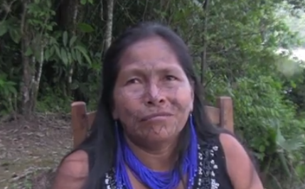
llakik sikwanga ‘loving toucan birds’
Try to write each word as you hear it, even if you don’t yet understand all of its suffixes:
---------------------
----------------------
----------------------
-----------------------
-----------------------
-----------------------

-----------------------

-----------------------

-----------------------

------------------------

