LESSON 2
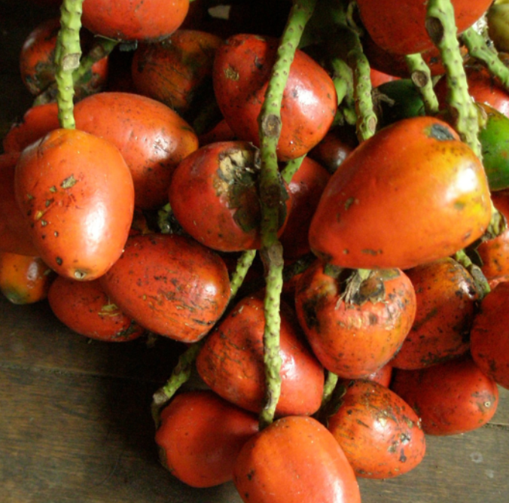
chunda muyu ‘peach palm fruit’

Expressing ideas of being: The verb ana ‘to be’
The Quichua verb is mostly regular. Verbs are conjugated by suffixing the person/tense morphemes to the root. The verb ana ‘to be’ is an important verb to know as its use is widespread for describing not only essential, permanent qualities that someone might want to claim, such as one’s name or kinship status (‘I am Rosa’ or ‘I am Fausto’s sister’), but also for describing ascribed or temporary behaviors as well as habitual qualities (‘He is an eater of meat’, or ‘She is a hard worker’).
The root of the infinitive ana is just one sound: a-, and the infinitive suffix is -na, which basically means ‘to _____ ’. The person/ tense suffixes then replace the infinitivizing suffix –na.
For the present tense, the suffixes are:
First person singular: -ni First person plural: -nchi
Second person singular: -ngi Second person plural: -ngichi
Third person singular: -n Third person plural: -nawn (PQ)
-nun (NQ)
Personal pronouns
Each present tense form of ana ‘to be’ occurs below with its pronoun.
Ñuka ani “I am” Ñukanchi anchi “we are”
Kan angi “you are” Kanguna angichi “You-all are”
Pay an “he, she, it is” Payguna anawn “They are”(PQ)
Payguna anun (NQ)
Note that stress is a bit irregular for the third person plural forms, shifting to the final syllable, which is boldfaced to indicate its stressed status, rather than the penultimate syllable.
Practice 1
Conjugate the following verbs out loud, using the correct pronouns for each verb:
tarabana ‘to work’
istudiana ‘to study’
mikuna ‘to eat’
tiyana ‘to dwell, hang out (of people) be located, be available (of objects, resources)’
muskuna ‘to dream’
kawsana ‘to live’
yanuna ‘to cook’
killkana ‘to write’
rimana ‘to speak’
waytana ‘to swim’
purina ‘to walk, treck, or travel’
puñuna ‘to sleep’
Tips for using pronouns and verbs
Although it is good practice to conjugate verb forms with their appropriate pronouns, it is important to remember that for Quichua, pronouns are not required when functioning as the subjects of sentences. Quichua is a Subject Object Verb language in principle, but subjects may be left out altogether, because contextual factors often give clues to the identity of the subject.
Another important consideration has to do with the way present tense is used. It is often used in a present perfect sense to indicate action that is complete as of the moment of speaking. For example, I may ask in English ‘Did you eat?’ A normal response would either be ‘Yes I ate (past tense)’ or ‘Yes, I’ve eaten’ (present perfect). In Quichua there is a present perfect construction which will be learned in a later chapter, but the present tense is often used to express this meaning as well:
Ñuka mikuni ‘I have eaten’ or simply:
Mikuni ‘I have eaten’
Practice 2
Use your new knowledge of verb conjugations in the following conversational model, where the first speaker asks a second speaker about a third person or persons, leaving out the pronoun.
example:
Mikunchu? ‘Has he/she eaten’?
Nda/Ari mikunmi ‘Yeah/yes. He/she has eaten’.
1.puñuna ‘to sleep’
2.waytana ‘to swim’
3. muskuna ‘to dream’
4. tarabana ‘to work’
5. rimana ‘to speak’
Practice 3
Now go back to the same list of verbs (puñuna, waytana, muskuna, tarabana, rimana), and practice the same question/answer sequence using either of the third person plural forms.
Example:
Pastaza Quichua:
Mikunawnchu? ‘Have they eaten?’ Nda. Mikunawnmi ‘Yeah, they’ve eaten.’
Upper Napo Quichua:
Mikununchu? ‘Have they eaten?’ Ari. Mikununmi. ‘Yes they’ve eaten’
Practice 4
Now go back to the same list of verbs (puñuna, waytana, muskuna, tarabana, rimana), and practice the same question/answer sequence using the second person and first person plural forms:
Mikungichichu? ‘Have you-all eaten?’
Nda/Ari Mikunchimi ‘Yes, we’ve eaten’
Written exercise 1
Complete the following sentences with the appropriate pronoun.

………………. ani
………………..mikun
………………..purinun
………………..llakinchi
………………..rimanchi
………………..killkangi
………………..angi
………………..rikunchi
………………..puñungichi
………………..waytangi
Practice 5
Construct questions with each of the following combinations of verbs and adverbs in any person/number that you have just learned, based on the situation described for each example. Attach the question suffix –chu to the adverb for each sentence.
Example:
Ukta ‘fast’/rina ‘to go’ (to a group of people):
Uktachu ringichichu? ‘Do you-all go fast?’
1.Alimanda ‘slowly’/ purina ‘to walk, trek, travel’ (to a person who has just had ankle surgery)
2.ukta ‘fast’/ yanuna ‘to cook’(about a group of women)
3.alilla ‘well’/ shamuna ‘to come’(to your neighbor)
4.wayra shina ‘very fast, lit ‘like the wind’ /kallpana ‘to run’ (about yourself)
5.sindzhita ‘strongly’/ awana ‘to make pottery’ (to a group of pottery-makers)
6.chunlla ‘quietly/ tiyarina ‘to sit’ (about a group of children)
7.waka waka ‘crying and crying’ puñuna ‘sleep’(about a baby)
8.alilla ‘well’/ rimana ‘to speak’ (to someone who has just told you something surprising)
9. sindzhita ‘strongly’ / kallpana ‘to run’(about a group of adolescents)
10. ukta ‘fast’ / waytana ‘to swim’ (to your sister)

Written exercise 2
Fill in the blanks for each of the following short sentences, using the correct present tense form of the verb in parentheses, which correctly translates the English into Quichua.
1. Payguna aychata (munana).’They want meat.’
2. Ñuka bagrita (hapina) ‘I catch a catfish’.
3. Kanguna lagartota (kasana). ‘You-all hunt a cayman’.

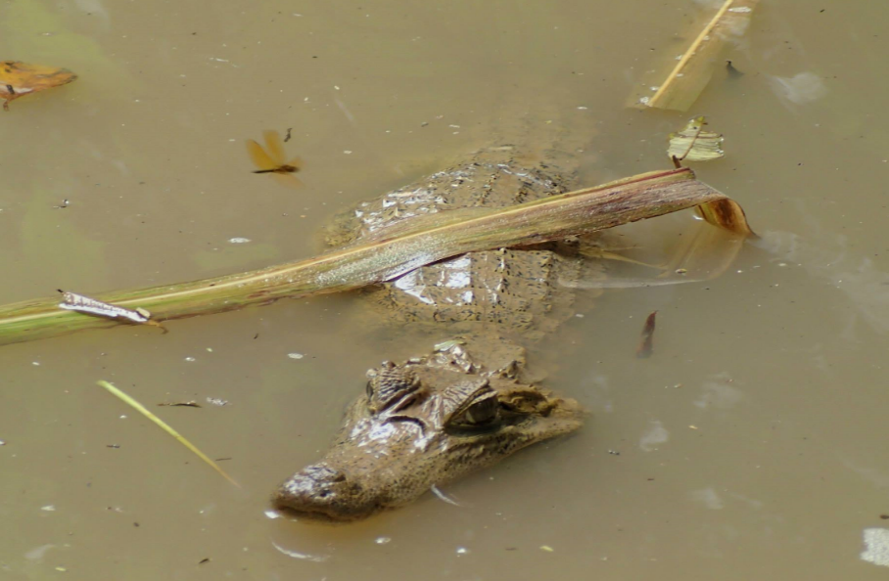
lagarto ‘cayman’

4. Pay charapata (rikuna). ‘He/she sees a turtle’.
charapa ‘turtle’
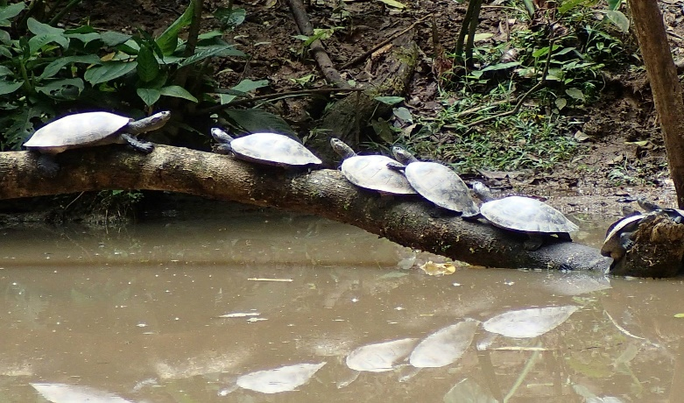
5. Kan alillami (kawsana). ‘You live well’.
6. Wawa chunlla (puñuna). ‘The baby sleeps quietly’.
7. Ukta (tarabana)! ‘You work quickly’.
8. Payguna wasiychu (awana)? ‘Do they make pottery in the house’?
9. Kanguna alillachu (muskuna)? ‘Do you-all dream well’?
10. Ñuka hachi kayutuy (puñuna). ‘My uncle sleeps in a bed’.
11. Ñukanchi lomochata (apamuna). ‘We bring a lomocha’. (large edible rodent)
12. Ñukanchi apayaya wasita (wasina). ‘Our grandfather makes a house.’
13. Ñukanchi (puñuna) wasi ukuy. ‘We sleep inside the house’.
14. Payguna hatun chagrata (chagrana). ‘They make a big chagra’.(agricultural field)
15. Ñukanchi (mingana) domingo pundzha. ‘We have a minga (work party) on Sunday day’.
16. Payguna wayra shinachu (istudyana).’Do they study fast (literally: like the wind)’?
17. Kanguna runa (ana).
18. Ñuka saksakta ______________ (mikuna) ‘I eat until completely full’
19. Sindzhitachu ______________ (purina) ‘Do you walk fast’?
20. Sacha wagratachu ____________ (kasana) ‘to hunt’ ‘Do you-all hunt tapirs’?
Culture Focus: Forest Resources: chunda muyu
bactris gasipae, Quichua: chunda
Bactris gasipae, sometimes referred to as the ‘peach palm’ fruit has historically been an important source of nutrition for indigenous Amazonians. It is boiled and eaten, or boiled and fermented into a mild beer. The wood from its tree is valued for its strength and has been used for weapons such as spears.
Transcption exercise 1: the historical present
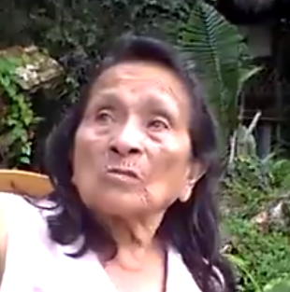
chunda uras ‘chunda season’
Go to the following link:
https://www.youtube.com/watch?v=X5Z97bfn6LM
Listen to Senora Luisa Cadena (27-33seconds) describe preparations for a traditional peach palm fruit festival that she heard reports about from her father. The following verbs are used: pallagrina ‘to go and harvest’; yanuna ‘to cut firewood’; warkuna ‘to hang’. Although the speaker is describing events from long ago, she uses present tense forms of verbs in an historical present sense. The nouns chunda ‘peach palm fruit’ and ashanga ‘basket are also used, as well as an evidential suffix –shi, to be discussed in Lesson 6, and a locative suffix –y, to be discussed in Lesson 12. Write as accurately as possible, the three sentences you hear her say:
-----------------------------------------------------------
-----------------------------------------------------------
-----------------------------------------------------------
Note whether any of them has an explicit subject pronoun.

