LESSON 12
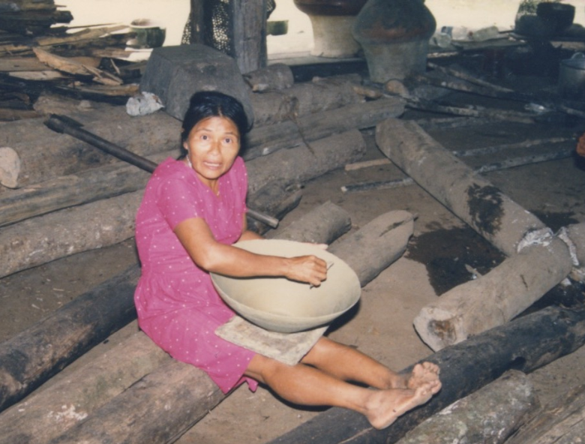
tinaha awag warmi

The attributive –k
This lesson introduces a very important suffix. It is a bit like the –er suffix in words like ‘do-er’, ‘go-getter’, etc. However it is used far more by Quichua speakers than the –er suffix is used in English. The attributive –k suffix attributes a certain role, ability, activity, or characteristic trait to the subject of its verb. What is attributed by the use of –k does not have to be an essential or defining quality. When the attributive –k is suffixed to verb roots it turns them into nouns which are capable of taking any suffix that a noun would take, such as pluralization. For example:
mandzhana ‘to fear’ > mandzhak ‘fear-er’> mandzhak-guna ‘the fear-ers’
purina ‘to walk, to travel, to trek’ > purik ‘walk-er, treker-er’> purikguna ‘the walkers’
The attributive –k may be present in one suffix already studied, the possessive –yuk suffix, which could be analyzed as yu-k. When it is followed by voiced sounds, the final –k is pronounced like a g. The following sentences illustrate some uses of this suffix.
Kawsa-k man ‘It’s alive!’ literally: ‘It’s a live-er (about a snake lying belly up)’
Macha-k man ‘He’s a drunk! (literally: ‘He’s a drink-er’)
Practice 1
Practice making attributive constructions using the following verb roots along with the verb mana ‘to be’ (-mi + ana):
Example:
ali/allmana > ali allmak man ‘He/she is a good weeder’
1. ali/yanapana
2. sindzhi/wakana
3. yapa/pugllana
4. ali/tarabana
5. gustu/asina
6. yapa/mandzhana
7. sapalla/purina
8. hawa llakta shina/rikurina
9. taruga shina/purina
10. ali/karana
11. yapa/mitsana
12. sindzhi/waktana
13. sapalla/kawsana
14. wayra shina/ismuna
15. kungaylla/shamuna
The attributive –k is also frequently used with imperative verbs. Consider the following construction:
Yanapak shamuy! ‘Come and help!” literally: “as-a-helper, come!’
Practice 2
Practice constructions that use one attributive and one immediate imperative verb, using the following sets. Vary between the singular and plural immediate forms and be sure to add any case suffixes necessary for words other than verbs.
Example:
kantana/shamuna > kantak shamuy! ‘As a singer, come!’
Or: kantak shamuychi! ‘As singers you-all come!’
1. wawa/rikuna/shamuna
2. tarabana/shamuna
3. wawa/chuchuna/shamuna
4. bagri/aysana/shamuna
5. hambi/tuksina/shamuna
6. walo/kayana/shamuna
7. mishki yaku/upichina/shamuna
8. wawa/chuchuchina/shamuna
9. usa/rikuna/shamuna
10. manga/shayachina/shamuna
11. nina/hapichina/shamuna
12. tarapoto ruya/kuchuna/shamuna
13. hacha/mañachina (+ -wa-)/shamuna
14. wawaguna/yuyana/shamuna
15. rimana (+ -wa-) shamuna
16. yanda/tsalina/shamuna
17. mukaha/awana/shamuna
Written Exercise 1
Construct ten sentences, all using the attributive construction, to describe yourself. The way you describe yourself doesn’t have to conform to your actual self or way of life. You can describe the kind of person you might be if, for example, you lived in a Quichua community. Try to make sentences that are more complicated than a basic attributive verb and main verb construction.
Example:
Ñuka aylluwan tarabak mani. ‘I am one who works with my family.’
1.
2.
3.
4.
5.
6.
7.
8.
9.
10.

Ideophonic adverbs and attributive -k
Many of the examples shared in this chapter’s discussion of attributive –k feature active verbs such as shamuna ‘to come’ and waktana ‘to hit.’ However, even verbs that describe relatively low animacy phenomena, such as design patterns or sounds may occur with attributive –k. Video 4 at the following link: http://quechuarealwords.byu.edu/?ideophone=lyuw
features a depiction of a painted design that is said to be a depiction of a river which moves in a curved pattern on the interior surface of a drinking bowl. In this depiction the speaker attaches the agentive –k to the verb muyuna ‘to curve around’, effectively saying, it’s a ‘curver’ along the pot’s surface:
Kasna muyug ara lluw ñambiga; chiwa rayguta kayga lluw muyuchiskawata riki!
As for the path, this is how it’s a curver, (going) lluw; look! That's why (the lines) have been made to curve lluw.’
Mukaha interior depicting curved movement of a river’s path
Locative suffixes
The locative morphemes –y/-bi, place an object, person, or some entity on, near, or in a specific location. Consider the following example:
Ñuka yayaguna, kallariga, Marañon-bi-shi kachita apag anawn.
‘My father and others, in the old days, would get salt (would be getters of salt) in Marañon (they say).
It functions similarly to the English preposition ‘in’, insofar as it is not only concerned with spatial location, but with blocks of time as well, as in the following example:
Kimsa killa-y-shi paktamug anawn.
‘In three months, they come back.’
Speakers may vary between –y and –bi, which are dialect variants. These two variants have come to be used in two different environments. Generally, -bi is used for monosyllabic words and for words ending in a consonant. –Y is used elsewhere. Occasionally, speakers will use both of them together by combining them into one suffix –ibi. Listen to the first 15 seconds of the following video clip. Listen in particular for the word sacha ‘forest’. Note how the speaker varies in his use of the locative suffix. Can you describe the two ways he uses the locative on this word by listening?:

https://www.youtube.com/watch?v=sIpkO3AGUmo
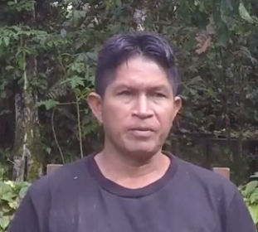
‘They lived in the forest’

Written Exercise 2
Practice your use of –y/-bi by adding the appropriate suffix to the word in parentheses in the following sentences. Then translate each sentence.
Example:
Ñuka kawsagmi ani ______________ (sacha) > Ñuka kawsag mani sachay.
Translation: ‘I live in the forest’.
- Ñuka puñugmi ani ______________ (kayutu).
- Ñuka hachi puñugmi awn ______________ (pamba)
- Lagarto mana tiyanchu __________________ (sacha)
- Lomo kaspita astanchi _______________ (kanoa)
- Ñukanchi rinchi ñuka mikyawa wasima; ____________(chay) upinchi aswata.
- Hachi Loberto yapashi yanga sirigmi an _________________(hamanga)
- Lomota yanunga rawni ______________ (hatun manga)
- Pumata rikurangichichu _______________ (sacha ñambi)?
- Yapami nanawan, ñuka _____________ (changa)
- Shuk ________________ (killa) shamunga rawn yayaga Marañonmanda.
- Ñuka aylluguna kawsanawn _________________ (Tena).
- (wasi) _________________ tiyanawn aylluguna.

Written Exercise 3
In the next exercise, use either –y/-bi, -ma, or –manda, depending on which makes best sense. Translate your answer.
- Wasi-___________ dzas llukshin, ukta wawata maskangaw.
- Ñukanchi wasi-_______ tiyawnchi.
- Chagra-____ rinawn lomo kaspita tarpungaw.
- Sacha ñambi tukurin. Chimanda llakta-___ paktanawn.
- Chay-_____ randigrichi mushuk llachapata!
- Imata charingi kamba ashanga-___?
- Chagra-____________ paktamunawn.
- Kanoa-___ apagrinchi kachita.
- Allkuguna tarapoto ruya-____ pumata kallpachinawn.
- Chunda muyuguna pukunawn. Chimanda urmanawn pamba-___.

Interpretive exercise
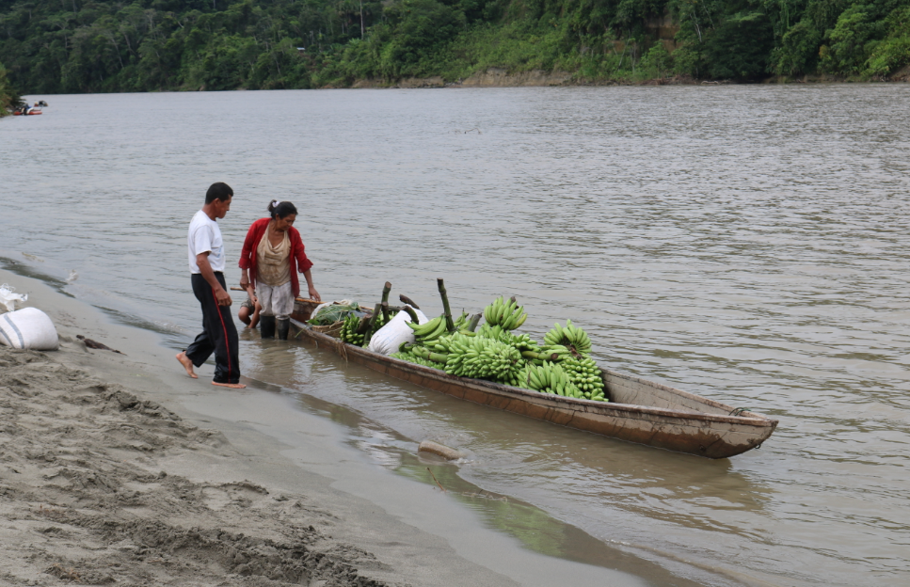
astana ‘to load’
Imagine a story that could explain what is happening in this picture, or, alternatively, along with a classmate, construct a dialogue that could take place between the people in the picture. You could use verbs such as astana ‘to load’, apana ‘to take’, shayarina ‘to stand’, randichina ‘to sell’, as well as any others that occur to you. Be sure to use the durative suffix –u with at least some of your verbs, as well as the locative marker, to indicate anything that is inside of anything else. You might also consider using the suffix –ndi from Lesson 10, as well as the purposive suffix –ngaw, Lesson 11.
The past tense
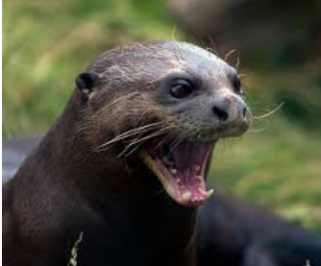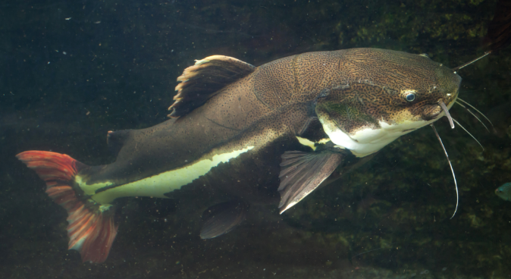
yaku lobo Amazonian river otter bagri ‘catfish’
The following is part of an interview between Luisa Cadena and Janis Nuckolls.
Luisa Cadena is describing an otter’s chasing of a catfish. PQ speakers refer to
otters as yaku lobo’s, or ‘water wolves’. Another term for them is pishña.

Narrative: The Otter and the Catfish
L:1. Lobo hapiura bagrita yakuy -- kikin lobo. ‘An otter was chasing a catfish in
-ra past tense morpheme the water—a real otter.’
lobo ‘lit.: ‘wolf’ ”, but here refers to
yaku lobo ‘water wolf’ which is an otter
kikin ‘real, true, authentic’
2. Hatun allku shina, ña lyuw wilymayuk man— ‘like a big dog, it’s shiny furred.’
ña ‘and, now’
lyuw ‘ideophone describing a shiny surface of any chromatic value’
3. Sida llachapa shina. Kan riksingichu ‘Like silk clothing. Are you
chi lobota? . familiar with that wolf?’
sida ‘silk’ (cf Sp. seda)
riksina ‘to know, be familiar with’
N: 4. Mana chita riksinichu. ‘No. I’m not familiar with that one.’
L: 5. Chasna rikurin. Chima ñuka rikurani ‘That’s how it looks. I saw it there, Tigri punguy. at the entrance to the Tigri (river).’
rikurina ‘to appear’
pungu ‘door, entrance of river’
6. Chitami “yaku allku” ninawn, runaguna. ‘That’s what(some) people call a ‘water dog’.’
nina ‘to call, name, refer to’
7. ‘Rikuychi! Shamuychi! Lobomi hapiun ‘‘Look! Come! An otter is catching
bagrita’ ninawn.’ Ñuka kallparani, rikungaw. a catfish!’ they say. I ran to look.’
kallpana ‘to run’
8. Loboga apanakumuura muru bagrita. ‘The otter was following a speckled muru ‘speckled, splotched’ catfish.’
9. Chi bagri yaku ukumanda dzas tsup^{h}uumi ‘That catfish leaped dzas from
saltara.’ under the water (and fell back in)
tsup^{h}uu.’
. Chimanda lobo polang rikura bagrita. ‘Then the otter (emerged) polang and looked at the catfish.’
dzas ideophone for any quickly
accomplished action’
saltana ‘to leap’
tsupu ‘ideophone for sound of the
moment of falling into water’
polang ‘ideophone for the moment of emerging from underwater’
For a revealing look at how ideophones are used, including several which occur in this narrative, visit the following links:
For lyuw:
http://quechuarealwords.byu.edu/?ideophone=lyuw-2
For dzas:
http://quechuarealwords.byu.edu/?ideophone=dzas
For tsupo:
http://quechuarealwords.byu.edu/?ideophone=tsupo
For polang:
http://quechuarealwords.byu.edu/?ideophone=polang
For chyuw (Lesson 4):
http://quechuarealwords.byu.edu/?ideophone=chyuw
For tak (Lesson 7):
http://quechuarealwords.byu.edu/?ideophone=tak

The past tense paradigm
The past tense morpheme –ra- usually occurs before the person/number suffixes. The following paradigm represents its conjugations for PQ:
Ñuka ri-ra-ni ‘I went’ Ñukanchi ri-ra-nchi ‘We went’
Kan ri-ra-ngi ‘You went’ Kanguna ri-ra-ngichi ‘You-all went’
Pay ri-ra ‘He, she, it went’ Payguna ri-naw-ra ‘They went’
This paradigm illustrates the mostly regular past tense formation. The exceptional forms are the third person singular and plural. The expected third person singular form would be *riran. But the correct form is rira, because the third person singular –n is dropped. In the third person plural, the expected form would be *riranawn. However, there is an inversion in the order of tense and person/number markers, so the actual form is rinawra.
The past tense conjugations for Tena Quichua work in the same way as for PQ. The past tense suffix is –ka, however:
Ñuka ri-ka-ni Ñukanchi ri-ka-nchi

Kan ri-ka-ngi Kanguna ri-ka-ngichi

Pay ri-ka Payguna ri-nu-ka

Practice 3
Conjugate each of the following verbs into their past tense forms, along with their accompanying pronouns:
shamuna tupana waktana chagrana tandarina
puñuna mikuna watana ñawpana randigrina
rimana rikuna mañana tarabana pallana
nina tarpuna mañachina pitina llukshina
urmana llullana mikuna yanuna tigramuna
shayarina karana purina yuyuna ismana
tiyarina maytuna hapina tapuna likirina

Practice 4
Practice the following substitutions using the words from the list in place of the underlined word.
Example:
Kaynaga, mayta rirangi? Llakta-ma rirani.
sacha
kucha
Sachama rirani
Kuchama rirani
1. Kaynaga, imata rarangi? Mukahata awarani.
ashanga/awana
chagray/tarabana
llachapa/randina
upina muyu/maskana
payba ayllu/riksina
2. Kaynaga, pita rikurangichi? Kanta rikuranchi.
payba ushushi
kanba churi
mikya Lolawa kari wawa
kikin ali runa
3. Imata ninawra? ‘Shamuychi! Mikuychi!’ ninawra.
aguha/randigrina
wawaguna/yuyana
ali aycha/apamupana
charapa lulun/kachana + -wa-
wasi/sakirina, aychata rikungaw
4. Ima pundzhata hawa llaktama rirangichi?
martes
viernes
sabado
lunes
miercoles
jueves
domingo
5. Imata rikurira? Payba uma rikurira, yaku ukumanda.
muru bagri
yana bagri
payba singa
payba chupa
payba willma
payba ñawi
payba ñawi lulun
Written Exercise 4
Fill in the following blanks with the correct past tense form of the verb in parentheses.
1. Ñukanchi apa yaya kayna (wañuna).
2. Ishkay sacha allku yakuy (urmana).
3. Kanguna, alillachu (paktamuna)?
4. Ñuka mana -chu lomo kaspita (apamuna).
5. Payguna pawata kasangaw, sachay (purina).
6. Ñuka hachiguna sindzhi runa (mana).
7. Kan -chu wanganata (hapina)?
8. Ima rayguta pay allkuta (watana)?
9. Ñukanchi palota, payta wañuchingaw (waktana).
10. Kayna tuta ñuka pachawan (puñuna).
11. Kanguna mangata -chu (randina)?
12. Kunan pundzha ñukanchi chagray ; (tarabana) chimanda
(samana).
Written exercise 5
The following short section of a narrative is adapted from a traditional horror story called the huri huri story. The huri huri is a forest spirit which has the capacity to destroy humans. Translate the following introductory segment.
Huri Huri
Runaguna puringaw rinawra. Aychata hapingaw rinawra, win kariguna. Shuk warmishi sakirira wasiy. Aswata aswara. Karigunata chapawra. Chimanda ishkay virdi kamisayukshi paktamunawra. ‘Imamandata kasna sapalla tiyawngi?’ ninawrashi. Ñukanchiga histama shamunata munaranchi. ‘Ña aychata hapingaw rinawra, winguna’, nirashi warmiga. Chasna nira warmiga. Chimanda aswata upichira. Mana munanawrachu. Ñawi kumulla manawra. Ñawita mana rikuchinawrachu, ishkandiguna. Chimanda payguna rikuuraguna aswa maytuta. Aswa maituga tak montonarishka mawra. Chi ishkay virdi kamisayukguna lansayuk manawra. Chi lansawan shuk maytuta tsak, shuk maytuta tsak, shuk maytuta tsak tuksinawra. Chasna tuksinawrashi. Chimanda ninawra ‘ama upichingichu kay aswa maytuta’! Ama upichingichu!’ Hatun uktuta maskay! Hatun kumishinta maskay! ‘Chawpi tuta huri huri huri uyaringa’ nirashi: huri huri huri huri huri huri huri huri huri huri huri huri huri huri. Kamba yayata, kamba turita, kamba kusata hapi! Paygunata uktu ukuy ling ling ling satingi. Kumishinwan tak tapangi, ninawrashi

