LESSON 20
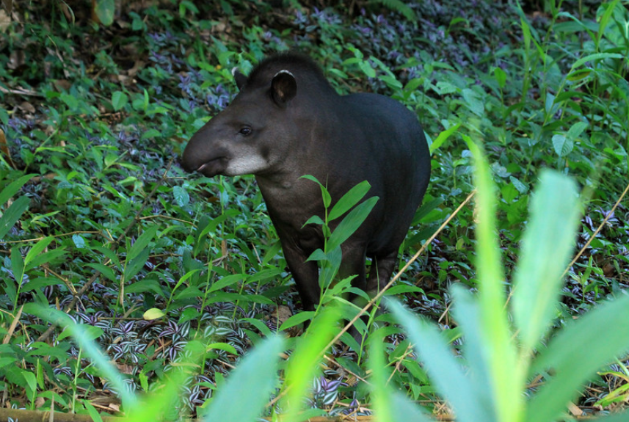
Sacha wagra ‘tapir, literally: ‘forest cow’

Evidential –cha, chari
We turn now to a third member of the evidential set of suffixes that Quichua speakers may employ when they want to specify an unknown perspective. This third evidential marker does imply a lack of certainty, and may, therefore be considered conjectural. When a speaker states something that is not grounded either in that speaker’s or anyone else’s perspective, the evidential –cha is used. It is possibly a shortened form of the adverb chari ‘maybe, perhaps’. –Cha is used more by Upper Napo speakers, while the adverb chari is most often used by Pastaza Quichua speakers.
To understand the importance of –cha and chari, it is important to emphasize the desirability of open-endedness in peoples’ assertion making habits. Speakers are careful to clarify the sources of their statements, not because they wish to be empirically accountable to objective facts that are verified by means of evidence. Rather, they exercise such care because there is a cultural preference for contextualizing statements within a perspective. Although being empirically objective and carefully framing a statement’s perspective may at times seem to converge with the same end result, namely, a statement that is careful about making any claims at all, the underlying motivations are different.
Speakers wishing to be careful about making only empirically based claims would have to be concerned with an abstract, de-contextualized notion of truth. In Amazonian Quichua culture, by contrast, there is a moral and aesthetic preference for articulating the perspective from which a statement is made. This perspectivism is not only part of human communication. It is part of Quichua peoples’ animistic cosmology, which allows for the possibility that all life is capable of articulating a perspective.
However, there doesn’t seem to be much interest on the part of Quichua speakers in articulating a synthesis of multiple perspectives to arrive at a final, coherent picture. Instead, people are anxious to avoid a kind of moral presumptuousness, which is how speaking about others’ actions and words, without properly contextualized knowledge, is interpreted. Perspectivism for Quichua speakers, then, seems motivated, in part, by a kind of negative politeness, in that speakers do not wish to impose on others by presuming to speak for them.
The concept of negative politeness does not fully explain things, however, since it is based in an individualized notion of selfhood. The Quichua self is more of a relational self than an individualistic one. A relational self is one that is situated in one’s family group or ayllu. There is a professed ideal for speaking well ali rimana, which involves speaking relationally, and which, for Quichua speakers, means speaking perspectivally. Someone who does not speak from an acknowledged perspective is a killa, ‘useless’, a lulla ‘liar’, or a lala ‘exaggerator’. Because strength is relational and relational speech is perspectival, speaking perspectivally is a key quality of being a sindzhi runa ‘strong man’ or sindzhi warmi ‘strong woman’. Speaking relationally is considered empowering because it forges bonds of interconnectedness with others.
Being uncertain and being careful about not saying more than one is sure about are far more desirable, than speaking with certainty about something. When –cha is used, it behaves like the evidential enclitics –mi and –shi, attaching to any class of word after other suffixes have been added. However, it is the least used enclitic, and may be falling into disuse. Speakers are more likely to use the conjectural adverbial chari to express uncertainty than they are –cha. It is not clear whether –cha is simply a shortened form of the adverb chari, or was once a more actively used enclitic suffix that is on its way to becoming obsolete. Their semantics are fairly interchangeable in Pastaza Quichua:
Payba mikya Lolacha shamura
Or:
Payba mikya Lola chari shamura
‘His/her Aunt Lola perhaps came.’
Napo Quichua speakers will often use -cha instead of -chu when asking a yes/no question. This is an alternative way of asking a question without being so direct. For example: Kariyukcha an? Is she married (i.e., Is she perhaps a husband-possessor)?
This might be a sensitive topic and so could be translated as ‘Is she maybe/perhaps married?’
In Napo, questions with -cha are often used to elicit a confirmative response from interlocutors which sometimes simply serves, like the English ‘uh-huh’, to keep the conversation going. The question is confirmed by answering with -da/ra as follows:
Paywa pani shamuncha? ‘So his sister (perhaps) came?’
Shamundá. ‘Uh-huh. She came’.
Tamiancha? ‘What, is it (perhaps) raining?’
Tamiandá ‘Uh-huh. It’s raining.’
Or with the future:
Paywa pani cirtu shamungachá? ‘Is his sister really, perhaps coming?’
Shamungará ‘Uh-huh. She is coming all right.’

In Napo, speakers may also use chuy ‘really, for real?’ to imply that someone is skeptical of something.
For example:
Pay kariyujchuy? Is she really married?
Pay shamuunchuy? Is he really coming?
Written Exercise 1
Translate the following English sentences into Quichua:
Example:
Does she really have a child?
Pay wawayukchuy?
1.Does he really have a wife?

2. Did you-all perhaps drink aswa?

3.Have you perhaps come to help (literally: as-a-helper perhaps, have you come)?

4.When you arrived, were they perhaps home?

5.Might we perhaps go to the forest today?

6.Will he perhaps go to the forest in order to hunt for meat?

7.Did they perhaps see a pita lala?

8.Did the aswa perhaps run out? (tukurina)

9.Has Uncle Fausto perhaps come?

10.Your child has perhaps lied.

11.We perhaps are going to go to sleep.

Speech Reports
Having shown how the grammar of Quichua encodes perspective, which is
highly valued over decontextualized certainty, we turn now to a discussion of discourse practices which also encourage speakers to attend to perspective by representing what others say. An important difference between Quichua and a standard average European language like English is that Quichua has very few illocutionary verbs. Verbs such as ‘to warn’, ‘to announce’, ‘to proclaim’, ‘to threaten’, ‘to reassure’, ‘to insist’, and ‘to explain’ are just a sample of the many illocutionary speech act verbs that populate everyday English language discourse. All of them have in common their encoding of an act of speaking that is accomplished in a certain manner or mood, or for a certain purpose.
By contrast, Quichua verbs that encode speaking constitute an extremely small group. They include: nina ‘to say’, which is often used to frame quoted speech; rimana ‘to speak, tell’, which simply states that speaking took place, but not necessarily anything about the content of what was spoken; kaparina ‘to shout’, kamina ‘to insult’, and llullana ‘to lie’. Another difference is that Quichua speakers do not typically comment on what people say without reporting the words they spoke. To illustrate this point, consider the following sentence, which would be typical for a speaker of English:
‘The Peruvians explained how to grab (it).’
A Quichua speaker, instead, would report the words that explained, rather than stating that explaining took place:
‘Kasna rasha hapingi’ ninawnshi peruanoguna
‘’This is how, doing, you grab (it)’ say the Peruvians.’
Another important difference between represented discourse in Quichua and in English is that Quichua speakers do not make a distinction between direct and indirect speech. Unlike languages such as English, there is no way to give an indirect report, such as the following:
‘He said he would go.’
In Quichua, by contrast, the words that served as the announcement for the person’s departure would be represented in a speech report as follows:
Riunimi nishashi nira pay.
‘’I’m going’, saying (according to someone), he said’.
Although it sounds redundant, the formula nisha nira ‘saying he/she said’ is commonly employed. It is used to frame discourse as a speech report by representing actual words that someone would or did say.
Written exercise 2
Translate the following Quichua sentences into English.
Example:
‘Bagrita mikushun’ nishami ninawra payguna
‘Let’s eat catfish’, saying (I-as- speaker assert), they said.
1. ‘Tiyarik shamuy aswata upingaw’’ nishmi nin pay.

2. ‘Ñukaga mana warmiyuk chani’ nishashi nin.

3. ‘Ñukanchiga pugllanakunawranchi’ nishashi ninawra.

4. ‘Ñukanchi rinchima’ nishashi ninawra.

5.‘Runagunata upichingaw aswasha’ nishami nin payga.

6.‘Ringami rawni sachama’ nishashi nin Hachi Albertoga.

7. ‘Wañuchi tukungami rawnchi pumamanda’ nishami niranchi.

8. ‘Kanchu rikuk arangi indillamata’ tapusha niwan pay.

9.‘Ña mikwi pasanchimi’ nishashi niwanawn.

10.‘Ama sapalla sakiringichi ichushka wasipi!’ nishami nin.

Culture Focus: Forest Resources: tapirs and the foods they eat
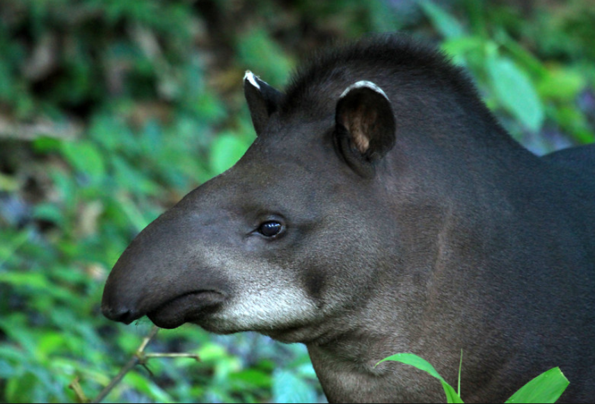
Tapirus terrestris, Quichua: sacha wagra ‘tapir, literally: ‘forest cow’
The Amazonian tapir is a large mammal that eats many kinds of plants, including fruits from palm trees, which it helps to propagate through the cycle of eating and defecating the fruits’ seeds as it travels through the forest. People often attempt to hunt tapirs by anticipating where they will most likely feed, based on knowledge of fruits’ seasonal maturation and decay. Two palm tree fruits enjoyed by people, the chunda, discussed in Lesson 2, and the morete, dicussed in Lesson 13, are also enjoyed by tapirs. The following traditional story reflects tapirs’ enjoyment of morete insofar as it features a mythic tapir man who initiates a relationship with a human woman by giving her gifts of large baskets full of morete fruits.
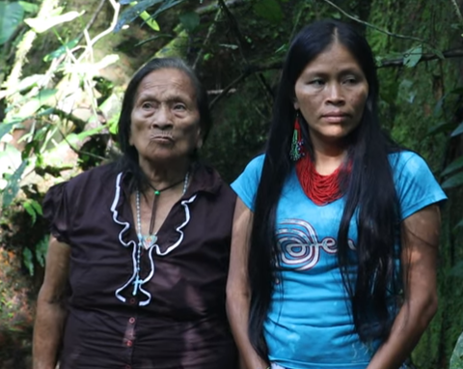
Sacha wagra warmi ‘the tapir woman’
Translation Challenge
Listen to the the first 2 minutes and twelve seconds of the following narrative at:
https://www.youtube.com/watch?v=wN1NNJgJUXA&feature=youtu.be​
about a woman who marries a tapir and eventually becomes one herself. Notice how many examples of speech reports there are. See if you can transcribe and translate the speech reports that are missing below:
Translation Challenge 1
1.Shuk warmishi sapalla tiyag ara ushushillawan
‘A woman (they say) lived alone with just her daughter’
2.Y tiyashkayshi “____________________________” nishashi ashangata aparisha rin!
‘And being there (they say)________________________ saying (they say) taking the basket, she (the daughter) goes.’
3.Chiga churuwawaguna, imawawagunatashi, lluchunawawagunatashi apisha apamusha karag ashka.
‘And so little snails, whatever little things (they say), little crayfish (they say), taking, bringing back, she would give (her mother) to eat.’
4.Chasna rawsha shi shamura pay.
‘Doing like that, (they say) she came.’
5.Ashangay hundakta moretetashi aparimura.
‘She brought morete in a basket completely filled.’
6.Shuk pundzhatas chingarira.
‘On another day also she disappeared.’
7.Ali mama maskawwwrashi.
‘Her mother was looking all over for her.’
8.Chiga tak aparisha shamusha “_____________________________” nishkashi “sachay”
‘And then carrying a completely filled (basket), coming, (the daughter) (apparently) said
“________________________________________”.
9.“Chimi kasna moreteta pallasha kuwan nukata!
_______________________________!” nishkashi.
“That’s who, harvesting, gave this many morete to me.
_______________________________________” they say she said.
10.“_______________________!” nishka mama.
“____________________________” said the mother.
11.Chiga warmiga “___________!” nisha kayashka, chi kallari urasga runa shara kay wagra.
And so then the woman, saying “_____________!” called him. In beginning times, this tapir was a person.’
12.Chiga shamushka, Ima rigra rukuyuk shashka!
‘And so that one came, and what a huge (set of) arms he possessed!’
13.Mama ali rikusha “________” nishkashi “_________________________
____________________” nirashi mama.
‘The mother, looking carefully, _____________ she apparently said “_____________________________” apparently said the mother.
14.“Hm hm. Shinawangachu?” nishkashi. Pay waktakpi nukawasmi randi apasha garotiwan!
“Hm hm. Is that what will happen to me?” she apparently said. “If he hits (me), I will be the one, instead, to take (and beat him) with a club.”
15. “________” nishkashi “_____________________” nishka.“ Ñukaga—“
“__________” shamushka kari shamusha tiyawshka.
“___________” she apparently said “____________________” she said. “As for me—“
“___________” (her) husband who had come, coming (to the mother and daughter) he was there.’
16.“________________________.
____________________________” nishka.
“_____________________________.
_____________________________.” He said.
17.“Shinasha ña pay munashkama.
Piru rikusha puriwangichi” nishkashi mamaga.
‘”Like that being, then it’s what she might want, but come and visit me”,
apparently said the mother.’
18.“Ari” nishka. Nisha apasha rishka.
“OK” he said. ‘Saying, and taking (her) he went.’
19.Apasha rik, rishka warmiga ña, apasha rik,
ña rik, semanay shamushka.
‘Taking (her) and going, the woman she went, then, as he was taking (her) and going,
So then going, in another week, she came.’
20..Kuti moreteta apamushka. “_________________”
‘Again she brought morete.’ “__________________”
21.”_______________________?”
__________________________?
22.Ima aychaschu illan?” nirashi.
“Is there no meat whatsover for you?” she apparently said.’
23.“Shinashaga kutiga aychatami apanga rawni” nishkashi.
“________________________________________ “she apparently said.”
23.Chiga turigunaga tandarishkawna. “_______________________________,
___________________! Maybishi sirtu atun wasi kawsan?”
‘So then the brothers gathered together (and said) ________________________
_________________! Where on earth is this actual house where he lives?’
24.Apanakusha rishkawna.
‘Following along they went.’
25.Rishkay rikukpiga, kasna shashka atun angu!
‘Having gone, and looking around, there was this big buttress root!’
26.Chitashi payba wasi ashka.
‘That, apparently, is where his house is.’
27.Mayta angu shashka, chi shashka payba wasi.
‘Wherever there’s a buttress root, that, apparently is his house.’
Culture Focus: Forest Resources: Buttress Roots as Homes
Angu ‘buttress root’
The term ‘angu’ has a number of meanings, including vine, vein, and buttress root. Buttress roots are large structures that grow around trees as supports, typically, for trees with shallow root systems. In Amazonian Ecuador, buttress roots are considered to be the dwelling places for animals of all kinds.

The inchoative suffix -ya
The inchoative suffix -ya describes a change of state. It can be translated by the English “to become X.” In the overwhelming majority of cases, the change of state described by -ya- is a perceptible change. This is a very productive suffix. It often transforms a noun, adjective, or adverb into a verb. For example, one derived -ya- verb which should already be familiar to you is pundzhayana ‘to become day.’ A few of the more commonly derived -ya- verbs follow:
tuta ‘night’ tutayana ‘to become night’
puka ‘red’ pukayana ‘to become red’
wira ‘fat’ wirayana ‘to become fat’
kuska ‘straight’ kuskayana ‘to become straight”
chuya ‘clear’ chuyayana ‘to become clear’
wiksa ‘stomach’ wiksayana ‘to become pregnant’
wawa ‘baby’ wawayana ‘to give birth’
allu ‘mold’ alluyana ‘to become moldy’
kaspi ‘stick’ kaspiyana ‘to become rigid’
kuru ‘short’ kuruyana ‘to become short’
witu ‘weed’ wituyana ‘to become weedy’
chulla ‘uneven’ chullayana ‘to become uneven’
wistu ‘crooked’ wistuyana ‘become crooked’
ichilla ‘little’ ichillayana ‘to become little’
kushi ‘happy’ kushiyana ‘to become happy’

Written exercise 3
Construct 10 sentences using any of the inchoative verbs from the above list.
Example: kushiyana ‘to become happy’
Payba wawa mikushka washa, kushiyawn.
‘His/her baby after having eaten, is becoming happy.’
1.
2.
3.
4.
5.
6.
7.
8.
9.
10.

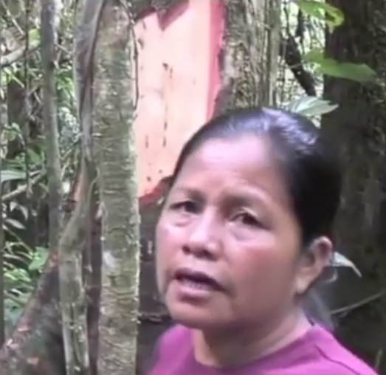
‘It becomes meat. Again it grows back.’
Challenge transcription and translation
Listen to the following exchange where women assert that a tree will not die after its bark is harvested, at the following link:
https://www.youtube.com/watch?v=0BHdmoZZt6A
Listen from 5:10 to 5:18, transcribe, and translate what she says. Note her use of the inchoative suffix –ya.
_______________________________________________________________________
The subjunctive suffix -chun
The subjunctive suffix –chun is similar to the purposive subjunctive learned in Lesson 11. The main difference is that –chun is used in an ‘in order to’ sense that encodes a different agent or entity than that of the main verb. The example below illustrates the appropriateness of the purposive –ngaw subjunctive used to describe an action performed by the same agent as that of the main verb:
Ñuka riunimi wasima, aswata upingaw.
‘I (assert that I) am going home in order to drink aswa.’
When a purposive clause expresses the idea that a different agent will accomplish an action or process, then –chun is used instead, as in the following example:
Ñuka riunimi wasima pay aswata upichun nisha.
‘I (assert that I) am going home in order that (i.e., wanting that) he/she drink aswa.’
The second example sentence would be appropriate if it was necessary for the person heading home to be there in order for someone else to drink aswa. This might be the case if, for example, there was no aswa at home, and the person heading there was bringing it.
As is true for the example above, the verb nisha ‘wanting’, which modifies the main verb, often follows the subjunctivized verb form as a way of indicating that the subjunctive action or process is subordinated to the will, desire, or intention of the main verb’s agent. Unlike many main clauses in Quichua, which have an optional subject or subject pronoun, the clause which contains the subjunctivized verb often has an explicit subject, whether a definite individual or a pronoun.
Subjunctivized clauses are always about a third person. If the third person is plural, then the verb takes its regular third person plural ending with –chun added last:
Ñuka riunimi wasima, payguna aswata upinawchun nisha.
‘I (assert that I) am going home in order that (i.e., wanting that) they drink aswa.’
An additional property of subjunctivized clauses is that they can be and often are negated. Someone can do something in order for something else not to happen. In such instances, the negation form ama occurs before the subjunctivized verb:
pay wanuchun nisha ‘wanting that it die’ >
ama pay wanuchun nisha ‘wanting that it not die’
Practice 1
Practice turning subjunctive clauses into negated subjunctive clauses.
Example:
Pay riksichun nisha ‘wanting that he/she become acquainted>
Ama pay riksichun nisha ‘not wanting that he/she become acquainted’
1.Payguna mikunawchun nisha

2.Pay upichun nisha

3.Payguna pandanawchun nisha

4.Pay wañurichun nisha

6.pay sambayachun nisha

7.Payguna makanakuchun nisha

8. pay raykaywan wañuchun nisha

9.pay sambayachun nisha

10.payguna hapi tukunawchun nisha
Practice 2
Practice your command of the subjunctive –chun by constructing sentences with the following sets of words.
Example:
Ñuka /pallana/palanda; wawaguna/mikuna
Ñuka palandata pallanga rawni, wawaguna mikunawchun nisha.
‘I’m going to harvest plaintains in order that the children eat.’
1.Kan/ukta/purina; (negate)payguna/chapana
2.kan/sindzhita/allmana; (negate)kiwa wiñana
3.(imperative) kanguna/sindzhita/kawina; (negate) amarun ñukanchi/hapina
4. ñuka lomo kaspi/tarpuna; lomo/ wiñana
5. ñuka/pay/kantana; pay/ ñuka/llakina

Culture Focus: Forest Resources for beautification
Quichua peoples’ ideas of beauty are closely linked with nature. When people attempt to express beauty, it often involves responding to what is appealing, vital, and salient in nonhuman species by attempting to imitate those qualities, thereby becoming more like them. For example, when a Quichua woman was asked by Tod Swanson for a special word to describe a particular shade of purple in the berries of an anthurium, she responded not by describing the berry’s color, but by expressing her feelings about its beauty, saying, in effect “How I would like to look like that fruit!” Looking like the land does not mean simply imitating its designs however. It means adapting the body to the land through habitual patterns of aesthetic response, like dancing adapts bodily movements to a partner. Thus a person comes to look like the land much like a husband or wife comes to resemble their partner, sharing mannerisms and so on, after decades of living together.
Exemples of how people bring about this process of resembling nature, are the many ritual songs through which women take on the attractive qualities of sweet-smelling or sweet-tasting plants. However, everyday practices of beautification also reveal attempts to emulate nature. In Lesson 16, the value of applying the piton tree’s pounded leaves to one’s hair to ensure against excessive shedding was discussed. We now mention two other plants said to be beneficial for hair.
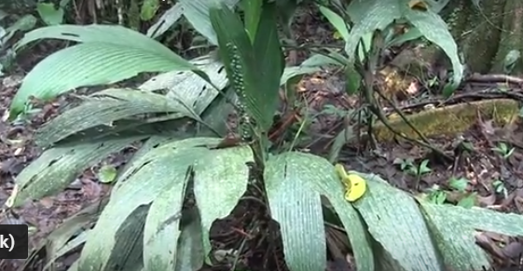
Omok plant for thicker hair
Transcribe and translate the brief decription, at the following link, of what people from a village called Sara yaku are said to do to make their hair grow better and thicker. The speaker uses a subjunctive form of the verb wiñana ‘to grow’:
https://www.youtube.com/watch?v=q3UsLVsohTs

Transcription:

Translation:

An example of a plant said to be beneficial for making hair shiny is found in video 2 at the following link, where the speaker uses the ideophone lyuw to describe the shininess that will result from bathing one’s hair with this plant’s leaves:
http://quechuarealwords.byu.edu/?ideophone=lyuw-2
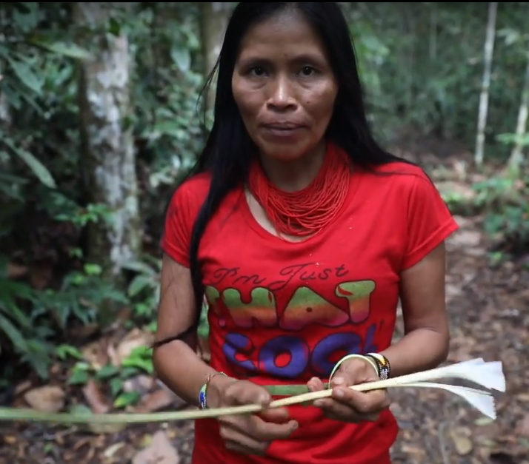
A plant that makes hair shiny

Photo by Greg Mauldin
Photo by Greg Mauldin
The Quichua words were “Ñuka imasnara chi muyu kwinta rikuirij ashai!” (Swanson and Reddecop 2017)

