LESSON 17
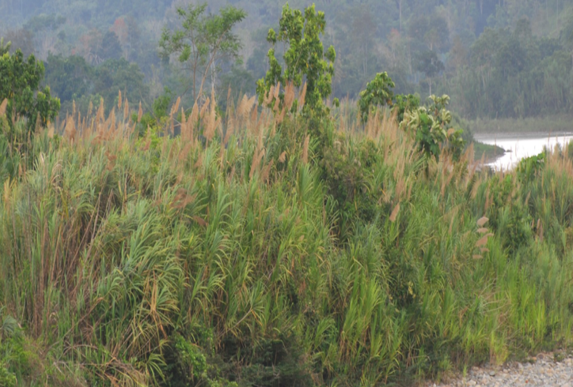
Ñukanchi runaga? Mana raykay wañushunchu sachay
‘As for us runa? We will not die of hunger in the forest!’

Talking about the Future
‘Uncertainties’
1. Sylvia: Mama! Raykaywan wañuuni!
raykay ‘hunger’
‘Mother! I’m dying of hunger!’
2. Theresa: Imata rashun? Aycha illanmi. Lomo illanmi. Palandawas illanmi. Imata mikushun?
-shun; 1st person pl future
‘What will we do? There is no meat. There is no manioc. And there are no plaintains either. What will we eat?’
3. Theresa: Kaya chari mana tamyangachu. Kaya risha chagrama.
-sha; 1st person sg future
‘Tomorrow perhaps, it won’t rain. Tomorrow I’ll go to the chagra.’
4. Sylvia: Ima urasta tigramunga yayaga?
uras ‘general time frame, hour’
-nga; third person sg future
‘When will father come back?’
5. Theresa: Indi pundzha shamungami. Kaya chari paktamunga.
indi ‘sun’
‘He’ll come on a sunny day. Tomorrow perhaps he’ll arrive.’
6. Sylvia: Ñañagunagaya? Ima urasta shamungawna?
-ngawna; 3rd person pl future
‘And what about my sisters? When will they come?’
7. Theresa: Kan yapa killachiwawngi, kasna tapusha. Ima urasta shamungawna, payguna? Ima shinata yachasha, ñuka, ña?
killachina “to bother, disturb”
‘You are bothering me a lot, asking like that. When will they come? How will I know now?’
8. Sylvia: Ringami rawni, paygunata maskangaw!
-nga + rana compound future construction
‘I’m going to go and look for them.’
9. Theresa: Ama richu! Sakiri! Hapi tukungami rawngi supaymanda!
‘Don’t go! Stay here! You’re going to be caught by a supay!’

This chapter introduces the future tense. It is used, as in English, to refer to actions which are projected to take place after the time at which the speech event takes place. However, an important cultural observation is that Runa are very cautious about stating predictions concerning action that is a year or more in the future because the future is considered so uncertain.
Making predictions about actions in the distant future, like ‘counting chickens before they hatch’, is considered arrogant and precipitous. It tempts fate and is therefore considered bad luck. Although the grammar allows one to express future action, it is generally used to express immediately pending action. For example someone might use the future to say ‘I am going to the river to bathe so if it rains bring the clothes in.’
By contrast it is rare to hear a person say something like, ‘three years from now my daughter will graduate from high school.’ Generally statements of the long range future are avoided altogether. If statements of long range planning are made by traditional Runa, they are prefaced by something like this: ‘Only God knows if we live or die, perhaps if we live...... (X will happen, or I will do Y). A short hand for expressing this sentiment is the verb kawsasha which means ‘being alive, (I, you, he, she, it, we, or they) will . . .’ The word kawsasha is generally placed at the beginning of any sentence expressing action a year or more in the future:
Kawsasha shamuk wata shamusha. ‘Being alive, (or: if I live) I will come next year (literally: the year that comes).’
The actual future tense paradigms follow. The differences between the two dialects are only obvious in the third person plural.
1) Future construction in Upper Napo Quichua:
ñuka shamu-sha ñukanchi shamu-shun
kan shamu-ngui kanguna shamu-ngichi
pay shamu-nga payguna shamu –nga
2. Future construction in Pastaza Quichua
ñuka shamu-sha ñukanchi shamu-shun
kan shamu-ngi kanguna shamu-ngichi
pay shamu-nga payguna shamu-ngawna/nguna
One complication regarding the future tense in PQ, is that its third person plural form changes when the vowel immediately preceding the -ngawna is –aw, as happens, for example, when the durative aspect is used. In such an environment, the future suffix is the same as the plural marker –guna that is used for nouns. For example:
Payguna rawngawna > payguna rawnguna
Written exercise 1
Fill in the following blanks by choosing either a past or future form of the verb in parentheses. For some sentences, both may be possible.
1. Kaya ñuka mukahata __________________ (awana).
2. Ima urasta __________________ (apamuna) payguna, kanoata?
3. Pay __________________ (chapana) chari, payba ayllugunata.
4. __________________ -chu (rina) kanwas, sachata puringaw?
5. Ñukanchi wagrata rikusha __________________ (wañuchina)!
6. Kanguna supayta uyasha, chunlya __________________ (shayarina).
7. Wawaguna pambay __________________ (llukana), purina urasgama.
8. Pay mana kutillata __________________ (paktamuna); rira hawa llaktama.
9. Kayna yapa ñukata __________________ (killachina) kasna tapusha.
10. Kayna tuta, piguna __________________ (shamuna)?
Culture Focus: Forest Resources: cane
Gynerium sagittatum, Quichua pindu
Gynerium sagittatum, called pindu or pindo is the distinctive cane that grows along river banks. In some regions pindo so dominates the vegetation of islands and riverbanks that at least two rivers in the Ecuadorian Amazon are named after it. One of them is a tributary of the Puyo which in turn flows into the Pastaza. Pindo cane can grow four meters high. It is the most preferred material for the long poles used to maneuver canoes in whitewater areas where paddles are less useful. Pindo is also used for chicken coops, for framing temporary shelters when camping on islands, or for making garabatus, which are hooks on the ends of long pindo poles for harvesting fruits growing high in the trees. Before the 1960s when agrarian reform and the establishment of schools imposed a more settled life, many Quichua and Shuar families migrated seasonally to “purina chagras” or hunting camps located several days or even weeks journey up or down the rivers. To avoid enemies, families generally camped on the pindo-dominated islands sleeping in temporary shelters constructed out of this plant. While the men journeyed inland to hunt during the day, the children, particularly the girls, hunted for bird eggs in the vegetation of the islands. Thus the sight of pindo often evokes memories of this riverine life.
Practice exercise 1
pukushka piton ‘ripe piton’

Listen to the video at the following link: https://www.youtube.com/watch?v=XaDuzJKcTOc
from 30 seconds, until 2:14, beginning with the question pukushka chan? (i.e., pukushkachu an? ‘Is it ripe?’). Using a large knife, the speaker is meticulously peeling a large edible ‘fruit’, which is actually more comparable to what English speakers would categorize as a vegetable, such as a butternut squash, as it has a very firm flesh. Watch how she skillfully peels the piton fruit with no cutting board, using only her hands. At about 2 minutes, she proudly proclaims that being a Runa person for her means that she has expert knowledge of the forest and its resources. Listen carefully as she uses a future tense verb to say that she will not die in the forest. She states this because of her detailed knowledge of the forest’s resources. The other speaker, Nuckolls, is asking informal questions. Some of the dialogue is transcribed below. Listen and fill in the blanks with what has not been transcribed. With your instructor’s help, translate what the narrator says:
N: Pukushka chan?
C: Pukushka! Mana pukushkaga, ________________!
N: Kay sani shina –
C: Kay puka, puka pukushka! Ayyy! ______________________________.
N: Imata?
C: Kay pitonda Kaaasna ___________________tiyan.
N: Chuba piton shuk sami?
C: Shuk sami! Muyu wawa kaylla muyu!__________! Chita risha chibi tiyak, Awka chari anawn, Chiribogay_____________. Kanoay pachaga! Imata shina ________________ astarinawn! Astarishaga tinahay, ismu tinahay ____________. Y payguna undachisha___________, ña chayakpi, chayan _____________chayan chili muyu shina!
Chili muyuta _____________?
N: Riksinimi.
C: Eso! Chi shina ___________.
N: Ima ali aswa?
C: Ima ali aswa!
N: Ña hurti chan?
C: Ndaya ima munayta ranawn! ___________________!
Ñukanchi runaga?
N: Chi?
Mana raykay wañushunchu sachay!

The compound future construction
The compound future construction which was used in Line 8 of the dialogue, can best be translated by the English ‘I’m going to do X,’ where X stands for some verb. The verb expressing the main idea of the action that will take place is suffixed with the third person singular –nga. This construction describes an action which will happen in the fairly near future, and in fact, may already be starting to happen. It is used far more often than the future tense studied in Part 1. It is always used with a durative form of the verb rana ‘to do, make.’ Furthermore, speakers usually add the evidential suffix –mi to the –nga verb. The following examples illustrate the compound future and ordinary future constructions:
tiyarina > tiyarisha ‘I’ll sit down’
tiyarina > tiyaringami rawni ‘I’m going to sit down.’
Practice 1
Practice the compound future by constructing sentences that use the following sets of words.
Example:
(hawa llaktay/kawsana) > Kawsangami rawni hawa llaktay.
1. (pay/yanapana)
2. (upina/aswa)
3. (puñuna/kay wasiy)
4. (kasana/sachay)
5. (hatun lagarto/wañuchina/kunan pundzha)
6. (mushuk hacha/maskana)
7. (maskana/ali tuku)
8. (turu llachapa/taksana)
9. (apa yayagunata/chapana)
10. (hatun ruya/kuchuna)

Practice 2
Revisit the examples of Practice 1 and transform each of the preceding sentences by combining a compound future form of rina ‘to go’ with the main verb in an ‘in order to’ adverbial form.
Example:
Kawsangami rawni hawa llaktay > Ringami rawni hawa llaktay kawsangaw
1.
2.
3.
4.
5.
6.
7.
8.
9.
10.
Questioning with the compound future
The verb that is the most important semantically, of the compound future construction is the verb suffixed with –nga. Evidence for its importance is found in the construction of yes/no qustions Speakers frequently ask yes/no questions about a compound verb’s action by suffixing –chu onto the –ngaw verb rather than onto the finite verb:
Ringachu rawngi kachun? ‘Are you going to go, sister-in-law?’
Ari! Ringami rawni.
Practice 2
Practice asking yes/no questions about compound future actions by transforming the following.
Example:
Ringami rawni Quitoma ‘I’m going to go to Quito’>
Ringachu rawngi Quitoma? ‘Are you going to go to Quito?’
1. Paktamungami rawni kaya.
2. Aparingami rawni papachinata.
3. Tarpungami rawni lomota.
4. Pallangami rawn pangata.
5. Kasangami rawnguna aychata.
6. Kuchungami rawni ruyata.
7. Llukshingami rawn ruyamanda.
8. Likcharingami rawn kunan.
Exhortative future constructions ‘should I?’ ‘should we?’ And ‘let’s’
The questions expressed in English such as ‘should I?’ “should we?” And ‘let’s’ are constructed in Quichua as follows:
Baylashachu? ‘Should I dance?’ = bayla- + -sha (first person singular future marker)+ -chu (yes/no question marker).
Aswata upishunchu? ‘Should we drink aswa?’ = upi- + -shun (first person plural future marker) + -chu
Baylashun! ‘Let’s dance’ = bayla + -shun (first person plural future marker)
Practice 3
In the list of examples below first cover the English column and translate the Quichua examples into English. Then cover the Quichua column and translate the English sentences into Quichua.

The ‘should I’ construction:
Luzda sindishachu? Should I turn on the light?
Luzda wañchishachu? Should I turn out the light?
Pungura paskashachu? Should I open the door?
Pungura tapashachu? Should I close the door?
Kaybi tiyarishachu? Should I sit here?

The ‘should we’ construction:
Luzda sindishunchu? Should we turn on the light?
Luzda wañuchishunchu? Should we turn out the light?
Pungura paskashunchu? Should we open the door?
Pungura tapashunchu? Should we close the door?
Kaybi tiarishunchu? Should we sit here?

The ‘Let’s’ construction:
Luzda sindishun. Let’s turn on the light.
Luzda wañuchishun. Let’s turn out the light.
Pungura paskashun. Let’s open the door.
Pungura tapashun. Let’s close the door.
Kaybi tiyarishun. Let’s sit here.

Written exercise 2
Runa shimima pasachi ‘Translate to Runa shimi.’
I will go. ______________________
You will cook. ______________________
They will drink. ______________________
S/he will come to eat. ______________________
He (she, it) will come tomorrow. ______________________________
We will eat in the house. ______________________________
Next week we will go to Quito. _______________________
In one year I will return. _______________________

Useful expressions for talking about temporality
There are a number of temporal expressions that function as adverbs which establish a temporal frame for the accomplishment of an action, event, or process. One interesting difference between the way Quichua speakers and English speakers talk about the past is in how it is metaphorically conceptualized. We talk about the past as being metaphorically ‘behind’ us as we move ‘forward’ in time. For Quichua speakers, by contrast, the future is metaphorically ‘behind’ because what is in the future is unseen. This is evident in the expression kaya washa ‘the day after tomorrow’, which literally translated is ‘the day behind tomorrow’. Some of the most widely used temporal expressions are listed below:
ñalla ‘soon, almost’
kaya ‘tomorrow’
pasak ‘last, previous’
shamuk ‘coming, next’
shamuk semana ‘next week’
shamuk killa ‘next month’
shamuk wata ‘next year’
washa shamuk watauna ‘distant future’
minzha ‘day after tomorrow’ (T)
kaya washa ‘day after tomorrow’ (PQ)

Written exercise 3
Check the following sentences to see if the temporal expressions match the tense used for the sentence. If the sentence doesn’t work, correct it with an acceptable sentence.
Example:
Kayna waytanga rawni ‘Yesterday I am going to swim.’ (not acceptable)
Acceptable sentences;
Kayna waytarani ‘Yesterday I swam.’
K aya waytanga rawni ‘Tomorrow I am going to swim.’

1.Kaya ñuka kamba wasima shamusha.
2.Kaya pundzha llaktama rikani.
3. Kayna palandara mikukani.
4. Minzha Ecuadorma shamushami.
5. Shamuk wata ashkara pasiyanga rawni.
6. Shamuk killa ñuka llaktay tiasha.
7. Shamuk semanauna Veneciara tiyanga rawni.
8. Kaya sachama rikani.
9. Kayna sachamanda paktamukani.
10. Kaya Napo yakuy waytanga rawnchi.
11. Kunan llachapara taksanga rawni.
12. Kaya wawaunawan pukllanga rawnchi.
13. Ñalla Tenama ringa rawnchi.
14. Ñalla sachamanda shamukani.
15. Kaya chagray tarabakani.
16. Shamuk killa ñuka llaktama ringa rawni.
17. Kaya Tenama risha.
18. Shamuk wata Sudamericama puringaw risha.

Culture focus: Forest resources as Aesthetic expression
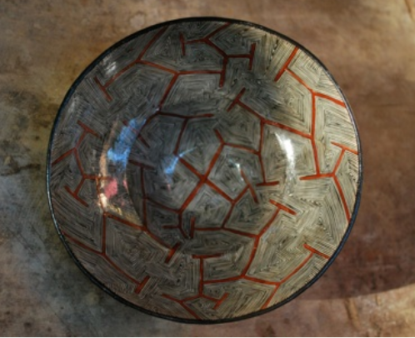
Mukaha design imitates distinctive branching pattern of the ayawaska vine
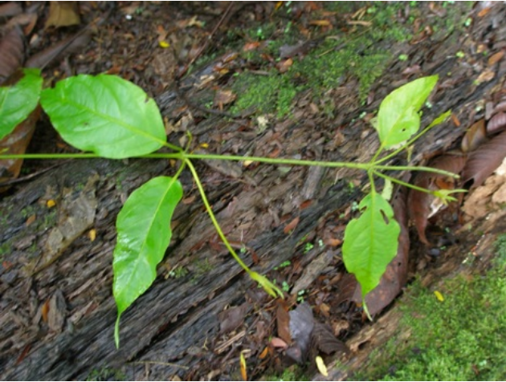
Banisteriopsis caapi, Quichua: ayawaska ‘spirit vine’, from aya ‘spirit and waska ‘vine’

The importance of Banisteriopsis caapi for the western Amazon cannot be overestimated. Along with yuca, it is among the most important plants that is associated with Amazonian cultural identity. It gives a distinctive shape to visual art, music, and medicine. Most importantly, perhaps, it shapes relationships between communities as well as between humans and other species.
According to Runa thinking drinking ayawaska allows people to communicate with plants, animals, and also to understand aspects of human interrelations that may be masked by the daily rituals of life. People say that certain kinds of social problems, especially disruptions in social relationships can be better understood while under the influence of ayawaska.
According to chemists ayawaska is essentially a vehicle for delivering dimethyltryptamine, or DMT in a form that can be more easily remembered and reflected upon. There are two forms of DMT. One form is produced by the pituitary gland during deep rapid eye movement sleep, as well as at the transitional moment of death. This form of DMT produces the ordinary dreams that all people have at night as well as the visions associated with near death experiences. The problem is that very little can be retrieved from these processes because most dreams are almost immediately forgotten or are remembered in a very vague or hazy form.
The ayawaska drink, however, allows the inducement of visions to take place unhindered, and over a period of time because the DMT, along with other chemicals in this plant produce a sort of ‘waking dream’ that can be reflected upon and remembered.
Significantly Runa do not use fortune tellers. When a yachak i.e., a ‘knower’, or any ordinary person drinks ayawaska, he or she discerns what has happened in the past or what is happening in the present, but drinkers generally refrains from making predictions.
Practice 4
For each of the following sentences, transform it from a past to a future tense sentence.
Example:
Kayna puncha Napo yakuy waytakanchi. ‘Yesterday we swam in the Napo River.’
Kaya pundzha Napo yakuy waytanga rawnchi. ‘Tomorrow we’re going to swim in the Napo River.’
Or:
Kaya pundzha Napo yakuy waytashun. ‘Tomorrow we will swim in the Napo River.’
1.Kayna tuta lumura yanukani.

2.Kayna puncha wawaunawa ñambiy puklyakangichu?

3.Kayna pundzha sachama rikani.

4.Unay Quitoy sakirikanguichi.

5.Pasak killa chagray tarabakani.

6.Pasak wata ñuka llaktama paktamukani.

7.Mario kayna punzha Tenama rika.

8.Kayna wawaunawa pasianga rikanchi.

9.Pasak wata ashka yachakunara riksikanchi.
The attributive future
The future tense can be used in compound constructions, such as the attributive suffix -k construction, discussed in Lesson 13. Consider the following example:
Yanapak shamusha, literally: ‘as a helper, I’ll come.’ Or ‘I’ll come and help’.
Practice 5
Practice the attributive future construction by responding to each of the following sentences with a future tensed attributive sentence. Vary your use of person and number.
Example:
Kamba hachi yandata munan. (apana/rina)’Your uncle wants some wood.’
Ñuka apak risha. ‘I’ll go and take some (Literally: ‘As a taker I will go.’)
Or:
Kan apak ringi. ‘As a taker you will go’
etc.
1. Payba pani raykaywan wañuun. (aycha/karana/purigrina)
2. Ñukanchi ñaña kayutuy sirin. (hambina/rina)
3. Ñukanchi hacha shaka likirira. (ali hacha/mañana/tapugrina)
4. Kanguna yapa mandzharirangichi supayta. (sachay/kasana/[neg] rina)
5. Ñuka churita upinayan. (aswa/llapina/upichina)
6. Ñuka yaya yapa nanaywan purin. (pay/pukuna/shamuna)
7. Mana ima mikunatawas charinchichu. (maskana/rina)
8. Lomo illakpi, pay mana ima aswatawas charinchu. (lomo/apana/shamuna)

Practice 6
Review the difference between -kpi and -sha, by using one or the other in the following sets of words. If the word sets call for the switch reference -kpi, make the following clause in the future (either the simple or compound).
1. (manga allpa, tuvyana / nuka, karana)
2. (tamya, kallarina / payguna, [neg] chagra, rina)
3. (wawaguna, yapa, wakana / kallpana, wasi)
4. (ñuka, mushuk llachapa, randina / ñuka, dzas, churarina)
5. (maki riru, ñuka, nanana / ñuka, doktor, rina)
6. (chi señora, illapata, randichina / ñuka, paba, kasana)
7. (ñuka, lomo kaspi, tarpuna / lomocha, chagra, shamuna)
8. (pay, ñuka, tapuna / ñuka, pay, kuna)
9. (payguna, yapa, ñuka, upichina / ñuka, saksakta, tukuna)
10. (yayaguna, unayana, sacha / ñukanchi [mana] dzas tigrana)

Practice 7
The man pictured below has already been given many bowls of aswa to drink, and is about to receive another one. Imagine a possible story that would describe what might happen soon, according to your imagination. Describe, using future tense statements what will happen next. Be sure to use a variety of future expressions learned in this lesson, including simple future, compound future, and attributive future constructions.
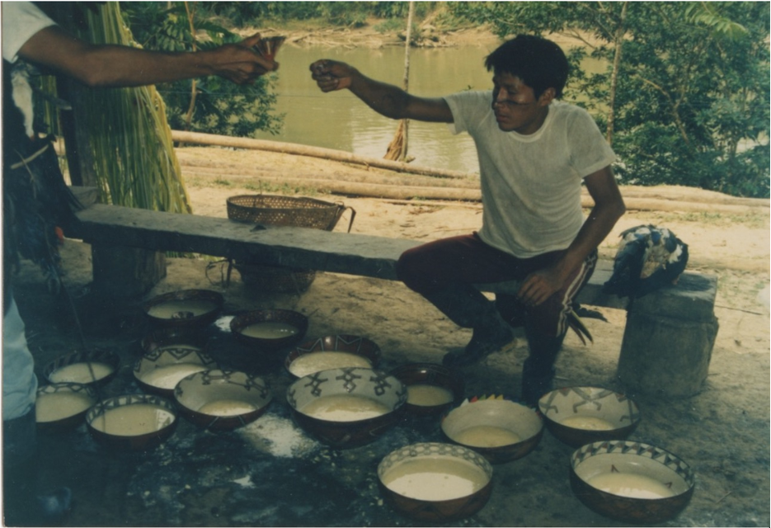
Ashka aswa ‘a lot of aswa’
1.
2.
3.
4.
5.
6.
7.

