LESSON 19
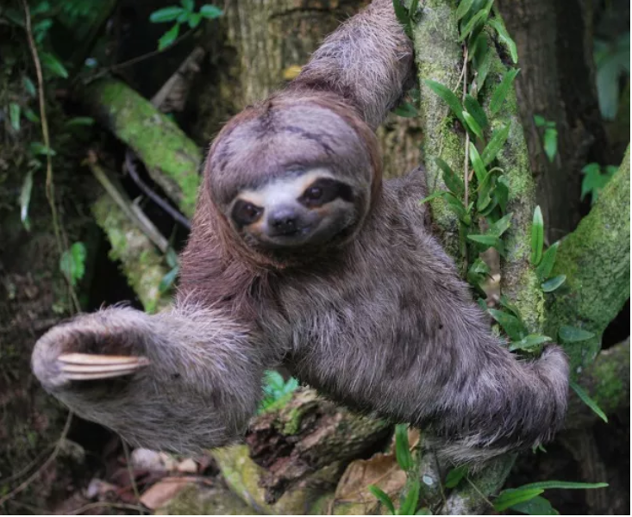
indillama ‘sloth’
The present conditional –ma
The present conditional is a mood that expresses possibility. However, Quichua speakers do not have separate words for auxiliary verbs such as ‘would’, ‘might’, ‘should’, and ‘could.’ One suffix –ma may be used for any of these meanings. For simplicity, we will refer to all of the semantic moods of this suffix as ‘conditional’. The conditional is formed by adding the -ma suffix to a verb after the present tense suffixes have been added. This is a fairly regular process. Only the first person conditional is irregular. It is formed by the same process as that used for immediate imperatives:
Shamuy-ma (instead of *shamuni-ma) ‘I would/might/should/could come’
The remaining paradigm is regular:
shamungima ‘You would/might/should/could come’
shamunma ‘S/he would/might/should/could come’
shamunchima ‘We would/might/should/could come’
shamungichima ‘You (pl) would/might/should/could come’
shamununma (NQ) ‘They would/might/should/could come’
shamunawnma (PQ) ‘They would/might/should/could come’
The –ma conditional suffix is identical to the –dative –ma suffix which expresses the idea of motion toward a goal. The main difference is in their distribution. The dative –ma is suffixed to nouns, while conditional –ma occurs on verbs. It is possible that conditionality evolved out of dative –ma’s meaning.
The conditional –ma may itself be further affixed with evidentials –mi, -shi, and the negation/question suffix –chu. The following examples illustrate such constructions:
Sachay purimami ‘I (assert) that I might walk in the forest.’
Tukuta mikungimachu ‘Might you eat grubs?’
Payguna mana paktamunawnmachu ‘They might not arrive.’
Written exercise 1
Translate the following conditional statements.
1.Rupay akpi, yakuymi armanchima.
___________________________________
2.Palandara tarpungimachu?
__________________________________
3.Ushasha rimanma.
__________________________________
4.Baylak shamunawnma.
___________________________________
5.Pita lalata wañuchinima.
_______________________________________
6.Mana riksishka sachaymi pandanawnma.
_____________________________________
7.Mana piñasha ñukata kipirinma.
__________________________________________
8.Yuyangi! Kamba makita rikuchikpi pay kaninma!
__________________________________________
9.Kan sambayasha sakiringima kaybi.
__________________________________________
10.Kamba llachapa turuyakpi taksangima.
________________________________________
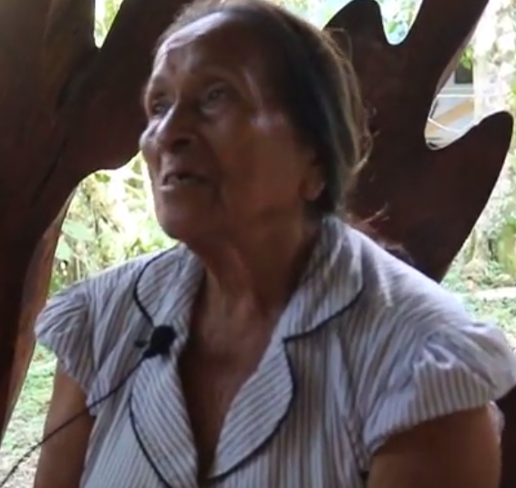
What might happen to us

Practice 1 : Fill in the Blanks and translate
Go to the following link and listen from 37 until 57 seconds, to part of a personal experience narrative told from a woman’s childhood memory, involving a trek through the forest with her father. In the final sentences you will hear the conditional –ma to describe what her father said might happen if she doesn’t follow his advice. Fill in the words that are missing below and then translate the sentences.
https://www.youtube.com/watch?v=wOzfcM3ahTQ
1.Chi pay __________ ___________ __________ Runas illashka sachay! Nukata 2.___________ yaya: kushillu ismata, wira ismata _____________ purik man pumaga! 3.Rikusha ______________! ___________ _______________! niwara nuka yaya.
Translation:
___________________________________________________________________
___________________________________________________________________
___________________________________________________________________
The relative order of meaningful elements
In Unit 18, we began to learn about the syntax of Quichua utterances. The principles of subject-object-verb word order and subject deletion and transposition were explained. Besides the frequent deletions and transpositions undergone by grammatical subjects, there are several other principles to keep in mind. Although it is usually true that direct objects precede their verbs, they may also occur immediately after their verbs. What is most important is that a direct object is closer to its verb than instrumental -wan or locative -y forms. For example, consider the following the two sentences. The first is completely acceptable because the direct object is closer to the verb than the phrase sachay ‘in the forest’:
Sachay pawata wañuchira. ‘In the forest the turkey he killed.’
The second, however, would not be likely heard:
*Pawata illapawan wañuchira. ‘The turkey with a rifle he killed.’
The preceding sentence is unlikely to be heard because it places the instrumental argument illapawan ‘with a rifle’ closer to the verb than its direct object. The reason that direct objects occur in close proximity to their verbs has to do with the fact that they are typically most affected by the verb’s action. There is a greater semantic relatedness between a verb and its object, and this is reflected by its placement close to the verb, whether immediately before it, or immediately following it.
The relative order of these forms may be diagrammed as followed:
1 2 3
locative -y direct object verb
instrumental -wan
dative –ma
ablative –manda
distance/temporal suffix –gama
adverbs (non-ideophonic)

What is important to emphasize, again, is that direct object forms most commonly precede verbs, but may also occur after their verbs. Recall the following example, from line 1 of lesson 9, where the direct object is placed right after the verb, and is followed by a locative form:
Lobo hapiura bagrita yakuy. ‘A wolf was catching a catfish in the water.’
3 2 1
Whatever their position, direct objects will almost always be in closer proximity to their verbs, than a locative, instrumental, or dative form. This means that either of the following two sequences may occur: 123 or: 321. The following two examples illustrate both of these possibilities:
1 2 3: Hachawan pita lalata pitira. ‘With an ax, he cut the pita lala.’
3 2 1: Pitira pita lalata hachawan. ‘He cut the pita lala with an ax.’
Although both of these examples are possible, the overwhelming majority of sentences will use the 123 principle of word order.
Practice 2
Practice forming constructions with the following sets of words, using instrumental, locative, or direct object markers. Assume that subjects have been deleted. First go through each example, inflecting its verb for present tense, and use the 123 priciple of syntax. Then turn that sentence into a present conditional form, using the 123 word order.
Example:
masha Alberto/upichina/aswa > Aswawan masha Albertota upichin. (123)
> Aswawan masha Albertota upichinma (123 present conditional)

1. ñambi/linterna/purina
2. mushuk llachapa/randina/kullki
3. rina/hawa llakta/kanoa
4. yanuna/manga/lomo
5. tsalina/hacha/yanda
6. shayachina/nina/manga
7. puñuna/pacha/kama
8. sawli/waktana/palo
9. allpa/mukaha/awana
10. wawa/wasi/apagrina

Practice 3
Now construct sentences, again following the 123 or 321 order, using the following word sets, and also, including -gama or -manda suffixes wherever possible. Assume that subects have been deleted, and use the ‘going-to-do’ compound future construction in any person/number.
Example:
chaki/chagra/rina > Chakiwan chagrama ringa rawnguna. ‘They are going to go to the chagra on foot.’
1.trago/upina/tukurina
2.llakta/saplla/purina
3.tukurina/aswa/upichina
4.Kwankiri yaku/sindzhita/waytana
5.payba tambu/wayra shina/rina
6.mikyawa wasi/kusa/katina
7.wiki llukshina/nuka/asina
8.chayana/lomo/yanuna
9.maki/waska/watana
10.shimi/bagri/hapina
11.linterna/maskana/wawa
12.wasi/ñambi/apanakuna
13.llakta/purina/alimanda
When order is not strictly regulated
When a sentence consists of two or more forms belonging to one slot, their relative order is not as strictly prescribed. Speakers often take two constituents belonging to the same slot and place one in front of the verb and the other after the verb. This helps to distribute the sentence’s semantic weight a little more evenly. For example, either of the following two sentences could occur, because both of the case marked constituents have slot 1 suffixes:
Hanagma rira kanoawan. ‘Upriver went (he/she) by canoe.’
Or:
Kanoawan rira hanagma. ‘By canoe went (he/she) upriver.’
The semantic differences between these equally possible sentences will largely be a result of the speaker’s intentions for meaning. Generally, the constituent mentioned first has a certain priority for the sentence’s overall meaning. However, intonation can be at least as important for communicating semantic significance (more on this subject later.)
If ever in doubt about where to place the elements of a sentence, a good rule of thumb is to place any words or phrases referring to animate objects, agents, etc., in closer proximity to the verb, than words referring to inanimate objects, entities, etc.
One final point needs to be made. The rule stating that words suffixed with slot 2 forms must occur before the verb can be circumvented by placing one word before the verb and another after the verb. For example:
Alita karanawra wawata. ‘Nicely fed (they) the child.’
1 3 2
Or:
Wawata karanawra alita. ‘The child (they) fed nicely.’
2 3 1
Both of these sentences are technically consistent with the rules previously outlined because they place the direct object wawata ‘the child’ immediately adjacent to the verb. The 123/321 rule is most important when both constituents are placed on the same side of the verb.
Practice 4
Construct sentences with the following word sets, using suffixes from slots 1 and 2. Arrange your constituents in any order, as long as you place the direct object close to its verb.
Example:
ruya/mana valik hacha/kuchuna
Ruyata kuchurani mana valik hachawan. ‘I chopped the tree with a no good (literally: a not valued ax) ax.’
1. hawa llakta/kanoa/tigrana
2. mandzhana/yaku/yaykuna (neg)
3. llakta/saplla/purina
4. kungaylla/chupa/rikuchina
5. wawaguna/yapa/unayana
6. kari/alita/kawsana
7. turu/allpa/urmana
8. kungaylla/maki/rikuchina
9. payba warmi/yanga/llullana
10. Irmilinda/chari/rina
11. ashanga/charapa lulun/maskana
12. shaka/sapi/likirina
13. kaya/hanag/rina
14. lomo kaspi/chagra/apagrina
15. yaku hawa/uman/rkurina
21. uma/hapina/akcha

Culture Focus: Forest Resources: sloths and bromeliads
Bradypus variegatus Quichua: indillama ‘brown-throated three-toed sloth’

The three toed sloth is commonly encountered in the Ecuadorian Amazon. Known for its extremely slow movements and its habit of sleeping most of the day, it is often made fun of or pitied. Ideas vary on whether its meat is appropriate for humans to eat. Some runa profess to never eat sloth meat because of this animal’s extremely vulnerable and pathetic nature. Others will, nevertheless, kill sloths for meat.
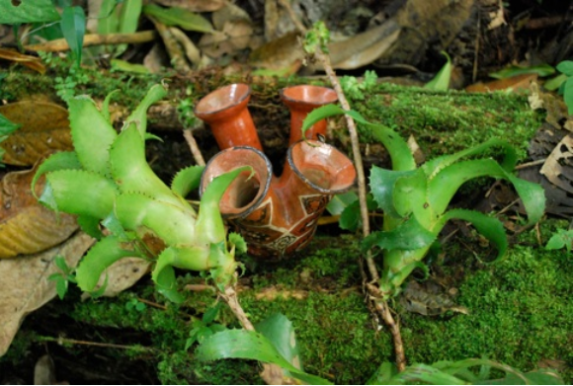
Bromeliads next to ceramic reproductions of their structures
There are thousands of species of bromeliads, many of which are found in the Ecuadorian Amazon. Many have a structure tht allows them to hold rainwater, which is drunk by hundreds of species of organisms. Besides their ability to hold rainwater, their leaves are also food for sloths. In the following video, women find bromeliad leaves that have been partially eaten by sloths. This finding inspires one woman to think about sloths and some of their endearing behavior. She then explains how pathetic they are and asserts that she would never eat them, despite knowing some people who do.
While explaining her empathy for the sloth, the narrator also relates how the sloth is like a person who has a chagra. Just as people live from certain plants grown in their gardens, the sloth is also said to have its own garden high in the canopies of trees where bromeliads are found. When it has eaten all of the bromeliads in a particular place, it is said to climb down from its perch very slowly, over the course of an entire day.
Written exercise 2
Watch the following short video, first in English, then in Quichua.
https://www.youtube.com/watch?v=JLO2tie3SJw&feature=youtu.be
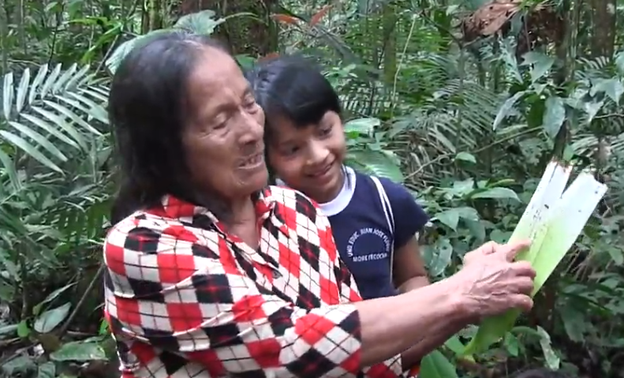
Pobre indillama! ‘poor sloth!’
Next, try to imagine yourself as a poor sloth in search of food high in the canopy. Write 5 sentences below that would capture a sloth’s perspective as it climbs slowly. Use varied sentence structures, including coreference verbs modifying main verbs, switch reference verbs, future tense verbs, habitual constructions, and conditional verbs. Each sentence should have at least 5 words.
1.____________________________________________________
2.____________________________________________________
3.____________________________________________________
4.____________________________________________________
5._____________________________________________________

Tools for connecting ideas
Quichua does not have conjunctions to connect clauses. English words such as ‘but’, ‘and’, ‘or’, and ‘if’ have no translational equivalents for Quichua speakers. Much of what creates cohesion between different clauses depends on intonation which, together with function words and comparative terms may help create links between sets of ideas. Two such terms that are often used together are imayna, a contracted form of ima shina ‘how like’ and chasnalla ‘just like that’ To illustrate this, consider the following example from a traditional story about a man who was repulsive to all women until a forest spirit helped him become irresistibly attractive to all women.
In the following example, the forest spirit addresses the man and tells him what is about to happen, using a set of comparative terms to introduce two different thoughts:
Imaynata kan nukata maskawrangi? Chasnallatami warmiguna kanda munasha maskanga rawnguna!
‘In the way that you were looking for me? In just that way, women (who are) wanting you, are going to search for you.’
The first sentence is articulated with a rising question intonation which is followed by a second sentence that falls assertively with its intonation.
Practice 5
Construct two sentences that establish a comparison, using imayna and chasnalla, with appropriate intonation. Also, be certain to use a future tense, a compound future construction, or a conditional verb in the chasnalla sentence.
Example:
Kan, sindzhita, tarabana/pay, sindzhita, tarabana
Imaynata kan sindzhita tarabarangi? Chasnallata paymi tarabanga rawn!
(You know how) you worked so hard? In just that way, she is going to work!
1.Kan, aswa, upichina/ ñuka aswa, upichina
2.Payguna, wawa, maskana/ ñukanchi, wawa, maskana
3.Kanguna, aycha, hapina/ ñuka, aycha, hapina
4. wawaguna, sambayasha puñuna / apa mamaguna, sambayasha puñuna
5. ichilla wawa, wakay kallarina / indillama, wakay kallarina
6. Kan, ichuy tukurina / ñuka ñaña, ichuy tukuna
7. kanguna, mikuy pasana / ñukanchi, mikuy pasana
8. payguna, motolo, tupana / kan, motolo, tupana
9.kan, tiyarik shamuna / ñuka tiyarik shamuna
10.payguna, raykaywan, kawsana / ñukanchi, raykaywan, kawsana

