LESSON 13
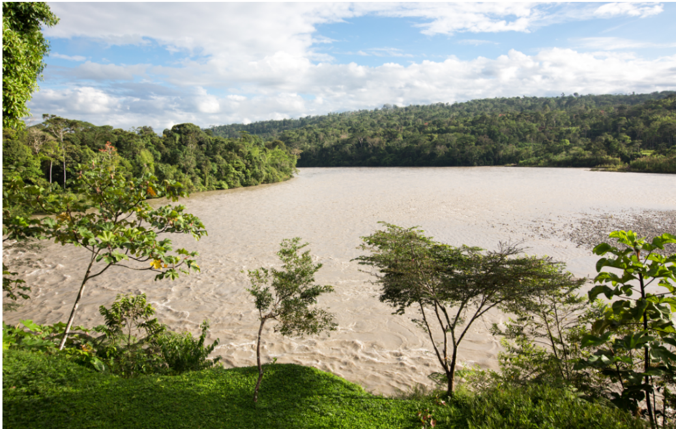
Napo yaku ‘Napo River’
Habitual aspect with attributive –k
Conversational narrative between Luisa and Jacinta, about grandparents’ experiences navigating the Bobonaza, Pastaza, Marañon, and Wallaga River systems to mine for salt.
1.L: Ñuka yayaguna kallariga Marañonbishi kachita apag anawra.
‘My father and others, in the old days used to get salt in Marañon.
kallari ‘beginning, beginning times, mythic times’
kallarina ‘to begin’
Marañon ‘large river in NW Peru flowing into Amazon River.’
2.J: Ah ow! Wallagay, kikin Wallagay nig anawra.
‘Yup! In Wallaga, it was actually in Wallaga, they used to tell us.’
kikin ‘actual, real, authentic’
3.L: Kimsa killayshi paktamug anawra, chi Wallaga pungumanda, kay runaguna,
tawna-lla-wan.
‘It would take 3 months for these people to arrive back (here) from the source of the Wallaga River, with only a steering pole!’
killa ‘moon, month’
tawna ‘long steering pole used to navigate a dugout canoe’.
-lla emphatic suffix meaning ‘only, just’
pungu ‘door, opening, entrance, source’
3.L: Kaybi kachiga mana tiyag ara; Peruanomandalla kachiwan mikug manawra; chuya shina, kamba kamisa shina ruyag kachi.
‘Here, there didn’t use to be any salt. It was only with salt from Peru that they used to eat. It was clear-like, and it was salt that was white like your shirt.’
chuya ‘clear, empty’
ruyag ‘white’
5.E: Ñuka yayaga nig ara mamata: ‘Kunanga haku, kachita apagrishun!’ ‘Wallaga punguy paktakpi, kayta, kayta, kayta, pugrumi anawn’ nig ara mamaga.
‘(When it was time for a trip), my father used to say to my mother ‘Let’s go now. Let’s go and get some salt’’ Upon arriving at the entrance to the Wallaga, the pools of salt were here and here and here and here’ my mother used to say.’
haku ‘let’s go’
pugru ‘pool, well’
In Lesson 11 we introduced the attributive suffix –k, stating that it is used a lot more often by Quichua speakers than the somewhat equivalent –er suffix is used in English. This lesson introduces another compound verb construction that features attributive –k. In Lesson 11 we introduced mikuk shamuy! ‘As an eater come!’, which combines two verb roots into one verb phrase. There are a mber of other types of compound verb phrases used by Quichua speakers that any fluent speaker needs to be able to use.
The new type of compound verb construction introduced here is the habitual construction, which occurs in past and present tenses. Habitual constructions express a type of aspect distinction. To understand what aspect is, consider how it is independent from tense in the following examples featuring the progressive aspect in English:
Past tense/progressive aspect: I was going
Present tense/progressive aspect: I am going
Future tense/progressive aspect: I will be going
Aspect is a grammatical distinction found in all languages. It encodes the temporal unfolding of actions, events, and processes with respect to their ongoingness or completeiveness. Aspect has already been encountered in Quichua in the form of the durative –u suffix. The difference between aspect and tense is that tense relates an action, event, or process to the time of speaking, while aspect is about the ongoingness or completiveness of that action, event, or process Aspect, tense, (and mood as well), are complexly intermingled in languages and may at times converge within a single suffix. Do not be too concerned about trying to untangle them, therefore.
To illustrate the difference between aspect and tense in Quichua, consider the following examples. In example 1 below, the drinking of the aswa took place and, with respect to the time of speaking, is over. In example 2, the drinking of aswa is expressed as an habitual, ongoing activity that took place in the past.
1.Aswata upirani. ‘I drank aswa.’

2.Aswa upik arani. ‘I was an aswa drinker/I used to be an aswa drinker/I would drink aswa.’
In Quichua, a verb suffixed with attributive -k , when combined with the past tense, expresses a meaning that is comparable to the ‘used to’ or ‘would do’ construction in English.
Practice 1
Construct sentences with each of the following sets of words, using the past habitual construction.
Example:
dzas/shamuna (instantly, quickly/to come)
Payguna dzas shamuk anawra
1.sindzhi/wakana (strongly/to cry)
2.yapa/pugllana (a lot/to play)
3.ali/tarabana (well/to work)
4.gustu/asina (well, pleasantly/to laugh)
5.yapa/manzhana (a lot/to fear)
6.sapalla/purina (alone,/to walk)
7.hawa llakta shina/rikurina (like a highlander/ to appear)
8.alita/karana (well/to give food)
9.yapa/mitsana (a lot/to be stingy)
10.sindzhi/waktana (strongly/to hit)
11.sapalla/kawsana (alone/to live)
12.wayra shina/ismuna (like the wind (quickly)/to rot)
Challenge Transcription and translation exercises:
The habitual past construction

1.Listen to the first fifteen seconds, from 22 through 37 seconds of a personal experience narrative at the following link:
https://www.youtube.com/watch?v=wOzfcM3ahTQ
There are 3 habitual past constructions occurring within this section of the narrative. Try to find the sentences in which they occur and then transcribe them. Don’t worry if you can’t translate the entire sentence. Simply focus on translating the habitual constructions.
Answers:
1.

2.

3.

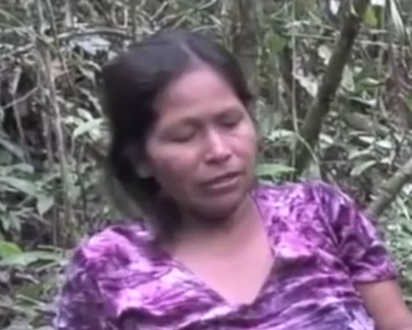
Tree bark as a stimulant

2. Listen from 4:52 until 5:08 at the following link:
https://www.youtube.com/watch?v=0BHdmoZZt6A
to the words spoken by a woman who is explaining how roasted tree bark scrapings helped her children to be alert and get good grades in school. Try to transcribe and translate her sentences.
[Answers:
Chasna nuka wawaguna chi kay karalla, nuka hawallakta rimidiyu sami mana upichik chani. Kay siempre runa kay sami usak ani nukaga, wawagunata upichingawa tukwi, imay, chiga na payna ali notata charik anawn kay samiwan]

The cislocative suffix -mu
The verbal suffix -mu indicates that an action is returning to its point of origin. A possible, but not necessary implication of this meaning is that it include the idea of motion or action toward a speaker. As a specification of verbal motion, it may be thought of as a kind of spatially completed cycle for actions. Just as there is a temporal marking for what has been completed in the past, present, and future, there is also a cyclical retuning to a spatial starting point.
Consider the following sentences from a narrative of personal experience. The speaker relates a frightening incident during a short trip she and others had taken, involving an encounter that her husband had with a deadly snake:
Taruga kachi-gama paktaranchi chishita.
-gama suffix meaning ‘as far as’
‘We arrived as far as Deer Salt in the afternoon.’
A bit later in the narrative, the speaker relates how her husband had, once they arrived, gone looking for something to eat, only to return to his original starting point, having encountered the deadly snake:
Kungaylla paktamura Tito. Tsala ñawiyuk ara.
kungaylla ‘suddenly’
tsala ‘pale’
‘Suddenly Tito came back. His face was pale.’
The suffixation of –mu on paktana ‘to arrive, complete’ encodes the idea of coming back to an original starting point. In this instance, the man Tito arrived back at the place where his wife and others waited for him
Other examples of how verbs meanings change as a result of the suffixation of -mu:
shitana ‘to throw’
shitamuna ‘to throw back to a point of origin.’

apana ‘to take’
apamuna ‘to bring’

hatarina ‘to get up’
hatarimuna ‘to get back up again (i.e., to lie or fall down and then get back up
again).’

kungarina ‘to forget’
kungarimuna ‘to forget to bring something back home, e.g., to take something away
with you and forget it there’

paktana ‘to arrive at a destination’
paktamuna ‘to come home; to arrive back at the starting point’

pushana ‘to take a person or group of people to some destination’
pushamuna ‘to bring a person or group of people back home or back to a starting point’

yaykuna ‘to enter’
yaykumuna ‘to come back in after going out’

katina ‘to follow’
katimuna ‘to follow a person back to their home or starting place’

rikuna ‘to look’
rikumuna ‘to turn and look back’

rikurina ‘to appear’
rikurimuna ‘to reappear, as the sun at sunrise’

tigrana ‘to return’
tigramuna ‘to return here to a starting place’

uyana to hear, listen, understand, obey. Sn: cazuna.
uyarina ‘to be heard, to sound’
uyarimuna ‘to sound in the direction of a listener, or speaker; said of the sound of
airplanes or motorized canoes approaching’

The suffix -mu may also be used with verbs that express the cyclical movement of natural phenomena returning to a starting point:
tamya urma-mu-n ‘rain falls’
indi llukshi-mu-n ‘the sun comes up’
Verbs suffixed with –mu may be further suffixed with durative –u as long as the action is not accomplished quickly or instantaneously. The durative –u would occur right after the –mu suffix, as it does below, where an ongoing, rather than an accomplished arrival is encoded by the second example:
1.Canelosmanda paktamun ‘He/she has arrived from Canelos’.
2.Canelosmanda paktamu-u-n ‘He/she is (in the process of) arriving from Canelos’.
The translocative suffix –gri
The suffix –gri is used to refer to an action that is performed by transferring oneself to another location. It can be roughly understood as a ‘to-go-and-do-something’ suffix. Although –mu and –gri are not perfect semantic opposites, they can be contrasted in two ways. –Gri is usually used for actions that move away from a speaker, while –mu suffixed verbs often involve movement toward a speaker. They also contrast with respect to their grammatical aspect.Verbs suffixed with –gri typically refer to punctual, instantaneous actions and can therefore be modified by the ideophonic adverb dzas, as well as other adverbs that mean ‘quickly’ such as ukta and wayra shina.
For the same reason that –gri-suffixed verbs may be modified by dzas, ukta, or wayra shina, they may not be suffixed with the durative aspect marker –u-, which would contradict the immediate meaning of adverbs having to do with sudden actions. Verbs suffixed with –mu, however, may be further suffixed with durative –u.
Practice 2
Make up sentences for each of the following verbs, adding the –gri suffix. Each of your sentences should make use of an appropriate adverb such as dzas, wayra shina, or ukta. Your sentences may make use of any type of verb that you have so far learned. A particularly appropriate verb for such a sentence would be an imperative, as in the following example:
Example:
maskana ‘to search for’
Maytuna pangata ukta maskagrichi ! ‘(You-all) go quickly and search for roasting leaves’.
1.apana ‘to take
2.tiyarina ‘to sit down’
3.pushana ‘to fetch’
4.rikuna ‘to see’
5. puñuna ‘to sleep’
6. anchuchina ‘to remove, take off”
7. llapina ‘to squeeze aswa pulp’
8.kuchuna ‘to chop a tree down’
9. allmana ‘to weed’
10. taksana ‘to wash clothes’
Practice exercise 3
Complete the following sentences by inflecting the verb for any person/number markers, and, considering the verb’s meaning, add a durative –u if appropriate.
Example:
Ama motolo rukuta __________________ (wanuchigrina)
An appropriate way to inflect this verb would be as follows, with no durative –u, since the verb is suffixed with –gri:
Ama motolo rukuta wanuchigrichu! ‘Don’t (you) go and kill that big pit viper!’
Once you have determined, based on the verb’s meaning and context,
whether it is appropriate or not to add durative –u, then, if the sentence does not already have an adverb, add any adverb that would be an appropriate modifer for each verb.
Example:
Ama motolo rukuta wanuchigrichu! > Ama ukta wanuchigrichu motolo rukuta
‘Don’t go and kill the big pit viper’! > ‘Don’t quickly go and kill the big pit viper’!
1. Urkuta _________________ (sikagrina)
2. Urkumanda __________________ (raykumuna)
3. Urkumanda __________________ (raykumuna)
4. Motolo kiruta __________________ (apamuna)
5. Purun ñambibi wawata __________________ (ñawpagrina)
6. Sachay __________________ (purigrina)
7. Alimanda __________________ (llukamuna)
8. Dzas __________________ (kallpagrina)
9. Tarugata __________________ (kallpachigrina)
10. Ama __________________ -chu (urmagrina)
11. Ama tutay __________________ (paktamuna)
12. Kunan __________________ (tarabana)
13. Kunan __________________ (tarabagrina) sachama.
14. __________________ (randigrina) kachita.
15. Uktumanda __________________ (yaykumuna)
16. Ama ñuka mashata __________________ (rimana)
17. Aswata __________________ (llapigrina) ayllugunata upichingaw.
18. Hatun chagrata __________________ (kuchugrina)

The –gama, -kta, and –ta adverbial suffixes
The –gama and -kta suffixes both encode an idea of ‘until’. The suffix –gama is the most unrestricted, as it may attach to any word class to indicate the idea that a spatial or temporal limit has been reached. In the first example below, a spatial limit is demarcated with –gama as the speaker relates how her father used to travel as far as the Marañon River in Peru.
-gama for a spatial limit:
1.Ñuka yaya yapa purik–mi ara Marañon-gama.
‘My father used to travel as far as the Marañon River.
In the next example, -gama specifies a temporal limit.
-gama for a temporal limit:
Ñukanchi sakirinchi kayagama.
‘We stay until tomorrow.’
The suffix –kta differs mainly from –gama insofar as it attaches to verbs for the purpose of turning them into adverbs. A verb suffixed with –kta has a completive sense insofar as the verb’s action is now understood as having happened to the complete extent possible. –Gama, by contrast is affixable to nouns, and is more often used when a spatial limit has been reached. Consider how adding –kta to verb roots changes the meanings below:
illana ‘to be lacking’ > illakta ‘until gone’
ismuna ‘to rot’ > ismukta ‘until rotted’

sambayana ‘to become tired’ > sambayakta ‘until tired out’
saksana ‘to be full of food’ > saksakta ‘in a state of having eaten as much as one can’
Culture focus: Forest Resources: Lapalm fruit
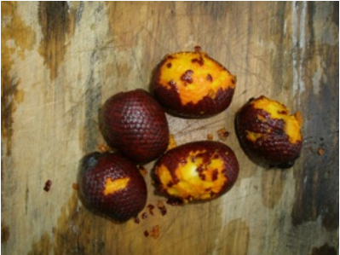
morete muyu ‘morete fruit
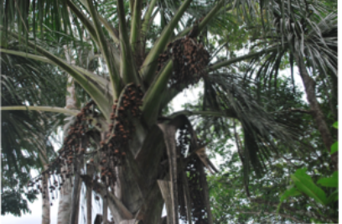
morete ruya ‘morete tree’
Morete palm trees grow clusters of maroon colored fruits that have been compared to hand grenades in terms of their shape. Between the large seed and hard scaley skin is an orange meat with a squashlike consistency and a pungent sweet taste. Moretes are prized as a fruit by humans, birds, and animals. When they are ripe the fruits drop to the ground. After being washed and softened in hot water the outer skin is peeled off and the meat consumed. Moretes bear fruit in December and January. In the wild, moretes flourish in swampy areas where they become groves called a moretal or a morete cocha. (lit: morete lake’). Morete trees are capable of actually growing in water for large parts of the year. Because the swamp limits access by hunters and the abundant fruit provides a wealth of food, moretales often becomes havens for mammals and birds such as macaws and other parrots. Moretales have an uncanny quality for many Amazonian people because they are identified as the home of anacondas with all their ambivalent religious significance.
Practice exercise 4
Listen and transcribe a brief section, from 18 until 22 seconds, which features a –kta suffixed verb, from a traditional story about a human woman who becomes the wife of a tapir. In this segment, the speaker mentions how full a basket of morete fruit was:
https://www.youtube.com/watch?v=wN1NNJgJUXA&feature=youtu.be
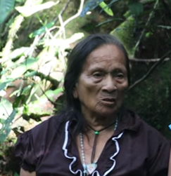
A full basket of morete fruit
Transcription:
__________________________________________________________
Written exercise 1
Complete each of the following sentences with the best -kta adverb, choosing from saksakta, sambayakta, ismukta, and illakta:
1.__________________ tarabarani.
2. __________________ mikurani
3. Kiwa ______________ allmawranchi.
4.Chi amarun ____________ wañura.
The final suffix to be discussed, the adverbial –ta, addresses yet another function for this suffix, which we have already met, in the form of the PQ direct object marker -ta, as well as the PQ interrogative -ta for information questions. The adverbial –ta is one suffix that may be used to turn adjectives into adverbs:
ali ‘good’ > alita ‘well’
sindzhi ‘strong’ > sindzhita ‘strongly’
ñañu ‘narrow’ > ñañuta ‘narrowly’
chulla ‘uneven’ > chullata ‘unevenly’
chuya ‘clear, empty, clean’ > chuyata ‘clearly, cleanly’
ichilla ‘little’ > ichillata ‘slightly, incompletely’
iridza ‘ugly > iridzta ‘uglily, scarily, badly’
Written exercise 2
Construct sentences using the following –ta-suffixed adverbs together with the verbs in parentheses.
1.iridzata (muskuna ‘to dream’)
2.alita (allmana ‘to weed’)
3.ichillata (kwintana ‘to speak’)
4.chuyata (sakirina ‘to remain)
5.sindzhita (tarabana ‘to work’)

