LESSON 14
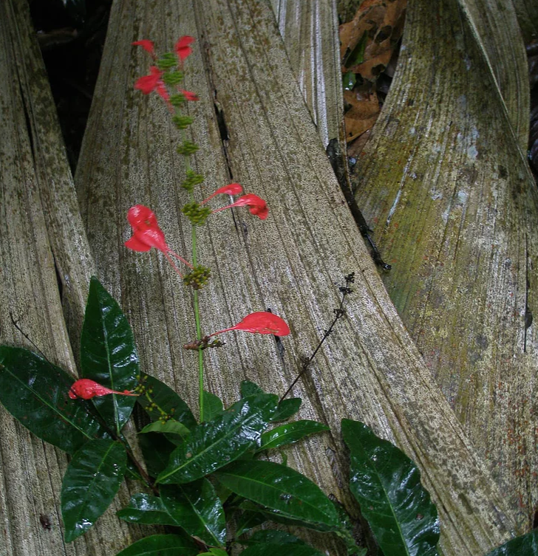
Rayu sisa ‘lightening flower’ Family: Rubiaceae Warscewiczia coccinea

The coreference suffix -sha
Anyone wanting to become fluent in Quichua will need to become comfortable with the use of adverbs and adverbial phrases. This may be difficult for speakers of English because the English language does not emphasize adverbs. Creative writers are told to avoid them. Formal approaches to grammar do not acknowledge adverbs as a significant word class. Some linguists consider adverbs to be a kind of residual category into which anything not identifiable as a noun, pronoun, adjective or verb, may be relegated.
The reasons for all of this are complex, and probably have to do with the ways in which the English language tends to encode much information within a verb that, in other languages is expressed by means of an adverb. Ideophones, which were introduced in Lesson 12, are one very important type of adverb for Quichua speakers. When verbs are suffixed with the attributive –k to form more complex verb phrases, as in Mikuk shamuy! ‘As an eater, come!’, the attributive verb ‘as an eater’ may be regarded as adverbial in its function, since it modifies the main verb. Main verbs, or, what linguists sometimes refer to as ‘finite verbs’ are verbs that have had some kind of person/tense marker added to them.
In Quichua, main verbs are quite often modified by some kind of adverbial phrase, which encodes manner of action, temporal dimensions of that action, or how the performer of an action is or is not related to the performer of the main verb’s action. The subject of this lesson is the –sha suffix, which indicates that the action of the verb to which it is attached is the performed by the same agent as the main verb. In the following traditional narrative about a man who tries to outsmart a forest spirit, but ends up, instead, being outsmarted by it, there are many –sha suffixed verbs used. Consider the importance of the –sha suffix in the following traditional tale meant to provoke laughter, about a mischievious forest spirit called the Uchutika.
1.Mikunata maska-sha purik ara. Pukunata hapisha rira sachama.
-sha coreference suffix; establishes that the subject of its verb is the same as the subject of the finite (tensed) verb.
pukuna “blowgun” (noun), “to ripen, mature” (verb)
‘Looking for food he would walk. Taking his blowgun (a man) went to the forest.’
2. Sachama risha, sikwangata wañuschisha, tigramura.
sikwanga “toucan bird”
‘Going to the forest, killing a toucan bird, he headed back.’
3. Yapashi ton ton ton ton ton ton ton takasha purik ara, washama y ñaupama; washama y ñawpamashi takasha purik ara.
washa “behind, after”
ñawpa “in front of, before”
takana “to touch, hit” (also metaphorical of intercourse)
‘(Something) was hitting ton ton ton ton ton ton ton, a lot, as it walked; to the rear and to the front; to the rear, and to the front (of the man), it hit as it walked’.
4. “Imashi kasna takasha puriwan?”, nira.’
‘ “What on earth is hitting like that as it walks with me?” he said.’
5. Win llatanasha, payba sikwangata warkura haway.
Win ‘ ( ideophone) ‘every, all’
llatanana ‘to undress’
warkuna ‘to hang, suspend’
hawa “on top, above”
‘Taking off everything he hung his toucan above (on a tree branch).’
6. Chasna rasha, payga kasna tay sirira; mana samashachu sirira. “Imashi shamunga?”
nisha, chapara.
tay (ideophone) ‘complete lack of movement.’
samana “to breathe”
chapana “to wait”
‘Having done that, he laid there tay (not moving), like this; he laid there not even breathing. Thinking “what in the world is going to come?” he waited.’
7. Supayga wax wax wax wax wax wax wax waxshi uyarimura, ña runa shina uyarimura.
‘The spirit (came toward him) sounding wax wax wax wax wax wax wax, like a person it sounded.’
supay ‘spirit’
8. Kay takasha purik supay ponzo umayukshi ara.
ponzo ‘frizzy haired’
‘This hitting-as-it-walks supay was a frizzy haired one.’
9. Runata rikusha, tukwitashi gustara. ‘Kaymandachu mikuk an? Kaymandachu samak an?” Chasna rimarisha gustawra runata.’
rimarina ‘to speak, talk to oneself’
‘Seeing the man, it marveled at every (part of his body). “Does he eat from here? Does he breathe from here?” Talking like that to himself, he admired the man.’

-Sha verbs’ varying sequential relations with main verbs
The coreference suffix -sha is suffixed to verb roots, and transforms them to adverb-like words. A -sha form can be translated with the English gerundial suffix -ing. The action of a -sha suffixed verb can take place at the same time as the action of the main verb, or independently of the action of the main verb. Despite the fact that tensed verbs are called ‘main verbs’, -sha verbs can make major semantic contributions to a verb phrase. –Sha suffixed verbs may also have a variety of temporal relations with their main verbs.
In Line 3 of the Uchutika Supay narrative, the action of the -sha verb takasha ‘hitting’ and that of the main verb purina ‘to trek, walk’, take place simultaneously:
Yapashi ton ton ton ton ton ton ton takasha purik ara
‘(Something) was hitting ton ton ton ton ton ton ton, a lot, as it walked . . .’

By contrast, in Line 2, the actions of the -sha verbs are independently performed actions, represented in an orderly sequence: The man first goes to the forest, then kills the toucan, then returns:
Sachama risha, sikwangata wañuschisha, tigramura.
‘Going to the forest, killing a toucan bird, he headed back.’
In some instances, however, it may be difficult to decide whether actions are inextricably linked, or clearly separable. In the following example, the actions of tripping and falling seem difficult to separate conceptually:
Niktyasha urmara
‘Tripping, he/she/it fell.’
Another example of a –sha suffixed verb’s action occurring simultaneously with a main verb can be seen in the following description of the sound of an armadillo snoring. The speaker uses the ideophone shun to depict the snoring sound and then states, using a –sha suffixed verb: Ronkasha puñun! ‘Snoring it sleeps’!:
http://quechuarealwords.byu.edu/?ideophone=shun
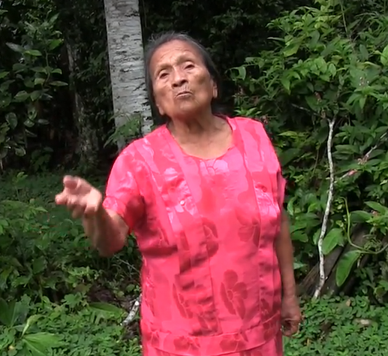
The sound of an armadillo snoring
-Sha verb facilitating action of main verb
A –sha verb can be linked with its main verb in a variety of ways. Sometimes a -sha verb indicates the reason or purpose for the action of the main verb. In the next two sentencse, the -sha verb describes a way of thinking, or an action, which led to the action, or nonaction, of the verb in the main clause:
1.Chita mandzhasha, payguna wagrata mana illapanawrachu.
‘Because they were afraid of it, they didn’t shoot the tapir.’
2.Ukuchata hapishaga churaranchi latay
‘Grabbing a rat we put it in the tin container.’
Another type of –sha linkage may be translated by an if/then or a ‘when’ construction in English:
3.Animalguna pay raykashaga aysan maymandas.
‘If he’s hungry/when he’s hungry, he draws animal (toward himself) from wherever.’
Frequently, more than one -sha verb will be chained together to describe a rather lengthy set of interrelated actions. Consider the following description of a leaf cutter ant’s attempts to pick up and carry off a manioc leaf stem:
4.Lomo pangata pitin; chiwanga urmasha, hatarisha, shayarisha, mana ushashachu, rin.
‘(First) he cuts the manioc leaf. (Then) with that (leaf) falling, rising, standing, (but) not being able to do it, he goes.’
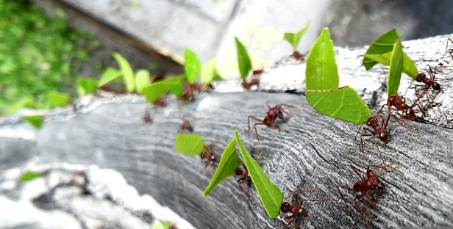
añangu ‘ants’
Practice 1
Practice making -sha verbs by creating sentences with the following word sets. Each sentence should have one -sha verb and one main (finite) verb.
Example:
(paba ‘turkey’, maskana ‘to search’, purina ‘to walk, trek’)
Pabata maskasha purinawn. ‘Searching for turkeys, they trek.’
1. (aswa ‘manioc beer’, machana ‘become intoxicated, urmana ‘to fall’, pamba ‘ground’)
2. (pishku ‘bird’, rikuna ‘to see’, illapana ‘shoot’)
3. (win ‘all’, llatanana ‘undress’, siririna ‘lie down’)
4. (ruya ‘tree’, takana ‘hit’, purina ‘walk/trek’)
5. (supay ‘spirit’, rikuna ‘look at’, mandzharina ‘be afraid’)
6. (urku ‘hill’, sikana ‘climb up’, paktamuna ‘arrive’)
7. (motolo kiru ‘motolo snake’s teeth’, apana ‘take’, rina ‘to go’)
8. (pukuna ‘blow gun’, apana ‘take’, llukshigrina ‘go and leave’)
9. (sindzhita ‘strongly’, tarabana ‘to work’, ashka aswa ‘lots of aswa’, upina ‘to drink’)
10. (ñawpa ‘front’, uyarimuna ‘sound toward’, purina ‘to walk, trek’)
11. (washa ‘back, behind’, uyarimuna ‘sound toward’, purina ‘to walk, trek’)
https://www.youtube.com/watch?v=0BHdmoZZt6A&t=75s
56 to 1:14
Practice 2: Suffix Hunting
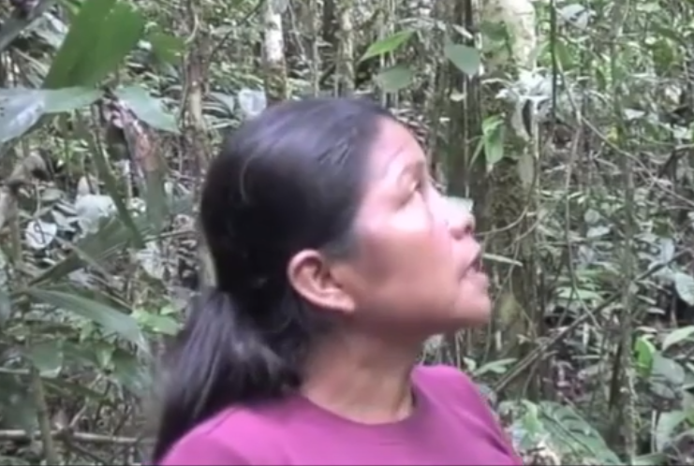
How to harvest tree bark

Go to the following link, where an Upper Napo speaker describes how to harvest tree bark: https://www.youtube.com/watch?v=0BHdmoZZt6A&t=75s
Begin listening at 56 seconds and stop at 1:14, while reading the transcribed words below. See if you can find and circle all of the suffixes in this very long sentence, which makes heavy use of the –sha suffix and then attempt to translate the sentence. Notice how, when such lengthy sentences occur, speakers rely heavily on intonation to set apart the individual –sha marked actions within their verb phrases. At times, a rising intonation may even be used to ask a question:
Payguna rimanawn kasna ambi karara kachama pallanga risha, yura siki paktasha,
may challuwa kaspi, awa amarun kaspi, balsama yura shina paktasha, ñawpa punda shayarisha, payta kwintana nin, rimana.
Negating a –sha verb
Speakers may negate a –sha suffixed verb to create a semantically more complex verb phrase which can communicate an idea of unexpectedness, or some kind of additional, perhaps surprising detail about the way in which the finite verb’s action is carried out. In the example below, the negation surrounds asina ‘to laugh’:
Mana asisha-chu tarabanawn. ‘Not laughing, they work’
Such constructions often lead to inferences which are not overtly stated. If people are not laughing when they work, a possible inference is that they are behaving unnaturally, and may therefore be angry or sad, since good-natured laughter is the norm when engaging in many cooperative tasks.
Practice 2
Practice making negated –sha constructions by going through the following sets of verbs and make only the –sha verb negative. For each example state an inference that a speaker may want to suggest. Please note that if the –sha verb takes a direct object, it is not necessary to add a direct object marker to that object:
Example:
Runa yanapana ‘to ‘people help’, i.e, ‘to help people’, kawsana ‘to live’>
Mana ayllu yanapashachu kawsanawn. ‘Not helping family, they live.’
Likely inference: speaker is being critical of people who don’t help their family.
1. asina ‘to laugh’, baylana ‘to dance’
2. pugllana ‘to play’, tarabana ‘to work’
3. ruya takana ‘to tree hit, i.e., to hit a tree’, purina ‘to walk, trek’
4. uyarikta samana ‘to breathe audibly (literally, ‘to breathe until heard’’, sirina ‘to lie down’
5. rimana ‘to speak’, tiyarina ‘to sit’
6. uyarimuna ‘to be heard’, shamuna ‘to come’
7. rimarina ‘to talk to oneself’, chapana ‘to wait’
8. rikuna ‘to see’, pukuna ‘to blow with a blowgun’
9. supay ‘forest spirit’, gustana ‘to enjoy, like’, mandzharina ‘to be afraid’
10. amarun ‘anaconda, boa’, rikuna ‘to see’, waytana ‘to swim’
Written exercise 1
Choose the most appropriate verb from the word bank below, to put in -sha form for each of the following sentences.
Pukuna tiyarina wakana purina
muskuna asina aparina llukana
1. Ñukanchi __________________ puñunchi.
2. Wawa __________________ sirin.
3. Payguna __________________ tarabanawn.
4. Yaya pawata __________________ paktamun.
5. Kanguna __________________ chapangichi!
6. Pay alimanda __________________ kasan.
7. Palo __________________ purin.
8. Ñuka __________________ kasani.

Written exercise 2
Fill in the following blanks with a correct form of the verb in parentheses. Use either an adverbial -ngaw, -sha, or a finite verb.
1. Ñuka yayaga __________________ (kasana ‘to hunt’) rin, sachama.
2. Kanguna __________________ (aswana ‘to make aswa’) ______________ (chapana ‘to wait) paygunata.
3. Lomota __________________ (yanuna) aswanchi, paygunata (upichina ‘to give to drink’)____________________.
4. Ali aswata __________________ (aswana ‘to make aswa’), ñukanchi ali lomota __________________ (yanuna ‘cook’).
5. Aswata __________________ (tukuchina ‘to finish up, run out’), ñukanchi ______________ (pingarina ‘become embarrassed’).
Practice 3
For each of the sentences in Written Exercise 2 above, transform each finite verb into a past tense form. The point of this practice is to demonstrate how –sha suffixed verbs are independent of tense.
Questioning a –sha verb
In addition to negating a –sha suffixed verb, speakers may also focus on the –sha verb to ask a yes/no question. If the –sha verb has its own direct object, then the question’s scope will include that object:
Yaku hambishachu hapingi?
‘Is treating water with venom (how) you hunt?’( Literally: ‘Water treating with venom do you hunt?’)
Possible response:
Nda. Yaku hambishami hapini.
‘Yup. Treating water with venom is how I hunt.’
Practice 4
Answer the following questions in the affirmative
Example:
Chunlla sirishachu puñungi? ‘Quietly lying do you sleep?’
Nda. Chunlla sirishami puñuni.
1. Kungaylla mikushachu istudiangi?
2. Pukushachu kasangi?
3. Pambay llukashachu puringi?
4. Sindzhi kallpashachu puringi?
5. Aswa upishachu machangi?
6. Chunlla tiyarishachu istudiangi?
7. Sindzhita kantashachu istudiangi?

Nina + -sha
When -sha is suffixed to the verb nina ‘to say’ it can have the effect of transforming its meaning from a verb which simply reports speech, or simply reports the act of speech, to a verb meaning ‘wanting,’ ‘intending,’ ‘thinking,’ or ‘wondering’. For example, the following question is frequently used to ask someone what, in general they might be up to: Imata nisha puriungi? ‘What wanting, are you walking about?’ Or simply: ‘What are you doing walking about?, or What are you up to, walking about?’
Practice 5
Each of the following questions uses a –sha suffixed nina with another verb to ask a question. Answer the questions with the verb in parentheses.
Example:
Imata nisha shamurangi? (yanapana ‘to help) ’What wanting, did you come?’
Yanapanata nisha shamurani ‘Wanting to help I came.’

1. Imata nisha dzas rirangi? (kasana ‘to hunt’)
‘What wanting, did you instantly go?’

2.Imata nisha sacha wagrata illapanrangichichu? (mikuna ‘to eat’)
‘What wanting, did you-all shoot the tapir?’

3. Imata nisha mana dzas shamurangichi? (sakirina ‘to stay’)
‘What wanting did you not come instantly?’

4. Imata nisha nuspa shina muyuriungi sachay? (ala maskana ‘to search for mushrooms’)
‘What wanting are you circling around in the forest like a crazy (person)?’

5. Imata nisha chagray chapangi? (aycha hapina ‘to catch meat’)
‘What wanting do you wait in the chagra?’

6. Imata nisha ruyata kuchungi? (chagrana ‘to make a chagra’)
‘What wanting do you chop a tree?’
In addition to the expression of desires or plans to carry out an action, the verb nisha may express a bodily need or an emotional state. If the bodily or emotional process is not subject to a person’s control, this construction may carry an inceptive ‘about to’ or a ‘need to’ meaning:
Piñarisha nin ‘S/he is about to get angry.’
Wakasha nin She wants to cry
Puñusha nin. S/he wants to sleep.
Imara upisha ningi? ‘What do you want to drink?
Kignasha nin! ‘S/he wants to vomit. S/he is about to throw up.’
Kay wawa ishpasha nin. ‘This child needs to urinate.’
Kay wawa ismasha nin. ‘This child needs to defecate.’

Language and Poetics Focus: -sha suffix in songs
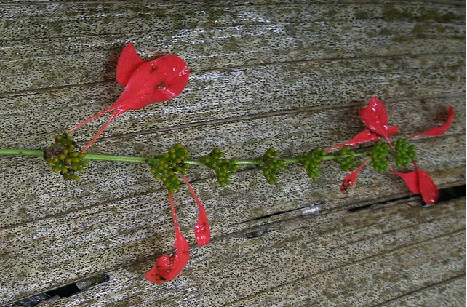
rayu sisa ‘lightening flower’
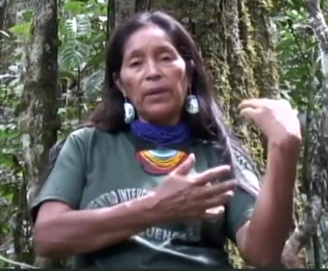
Carrying bunches of rayu sisa

Speaker is demonstrating how people would carry armloads of the rayu sisa for celebrations
Practice 6: Count the –sha suffixes
Listen to the following song which occurs at 2:13 until 3:21:
https://youtu.be/dfNxgrqzHUs
It is a song that causes tender feelings for the singer because it recounts memories of celebrations that took place during the Christian calendrical festivities of Christmas. According to the singer, children were instructed to gather and bring bundles of bright red rayu sisa flowers into a main central plaza, where people would eat, drink aswa, and dance together while men played flutes. Notice how important the –sha suffix is for conveying a general feeling of ongoingness that is evident in various activities. The song does not methodically describe the celebration as a series of discreet events. Instead, the singer evokes various images of ongoing activities that were salient for her as a child.
See if you can find the verbs that have –sha suffixes, underline them, and translate them.

Ñuka paktarikpiga hista paktarikpiga
Sisatalla markasha sisatalla markarisha (gestures closer to her body when she says markarisha)
Intirulla plazata tuta tukay puriunyari
Ruku mama wawaguna markay markay puriunguna
Sisatalla apasha
kushi kushi shunguwan
kushi kushi shunguwan
ashka ashka tandarisha
ashka ashka tandarisha
muru muru mukahata
upi upi riunchiyari
chawpi polazabigaya kiwirisha baylasha
ruku mamagunaga shaya shaya riunguna
shaya shaya riungunaya
ruku yayagunawa gustutalla baylawnguna
aysashaya aysasha piwanota tukusha
piwanota tukashaya
Chasna kantak ara ñuka yaya piwanota tukak ara

