LESSON 16
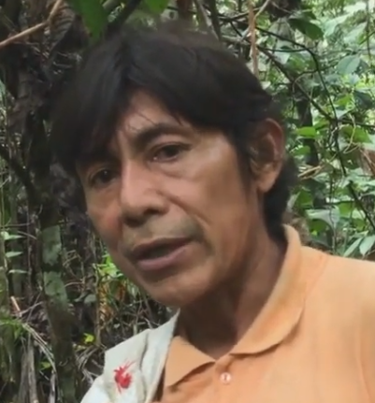
Apasha rin ñukanchi llakiushkata
‘It goes carrying away our sadness.’
The present perfect -shka
The following narrative relates one woman’s personal experience of learning about a small plane that had crashed.
‘A plane crash’
1. Rikungi. Chagray ñuka riurani, lomota apangaw.
‘Look. I was going along in the chagra, to get manioc.’
2. Chiga, avionga, kasna wamburisha riura, riki!
avion “airplane”
wamburina “to float, glide, fly”
‘Then the plane, it was gliding like this, as it was going, look! (gestures¹)’
3. Mana kasnaga rirachu; ña kasnamallaga chupami allpama; pay singaga haway, chupaga allpama. Mana kuskata, mana usharachu.
‘It wasn’t going like this (gestures²); now just like this, the tail toward the ground; its nose (was) toward the ground. It wasn’t able (to go) straight.’
4. Ña chiga yapa kargashkawna: kimsa tanque gasolina; ishkay saco arroz; shuk azucar; chimanda anawra runagunaga.
kargana ‘to load’
tanque Sp. ‘tank’
saco Sp. ‘sack’
azucar Sp. ‘sugar’
‘Now, they’ve loaded it a lot: three tanks of gasoline; two sacks of rice; one of sugar; and then there were the people.’
5. Ñuka shuk ushushillawan mawrani chagray, ichilla wawagunawan. ‘Wawaguna rikuychi avionda!’ nini; ‘mana kuskata rindzhu; siki urmanga rawn!’nirani
‘I was with only one daughter, and some little ones in the chagra’. ‘Children look at the plane!’ I say; ‘It’s not going straight; its rear is going to fall’ I said.’
6. Chiga ña mayta taco tuvyashkata shina uyarani, ñuka, chagramanda!
mayta ‘somewhere, wherever’
‘Then somewhere I heard (what was) like exploded dynamite, from the chagra.’
7. Chiga ‘Huuuuuuuuuuu huu huumi’ chagra ñambimanda kaparimunawn.
kaparina ‘to shout’
‘Then ‘Huuuuuuuuuuu huu huu’ from the chagra path they shout toward me.’
8. ‘Imatashi kaparinawn?’ nishami, uyasha shamuni.
‘Listening and wondering ‘what (on earth) are they shouting (about)?’ I come.’
9.‘Wañuuuuuuushka! Wañuuushka!’ ninawn. ‘Winshi rupashkawna’ ninawra.
rupana “to burn, be hot”
‘Died! They’ve died!’ They say. ‘All of them have burned’ they said.’

The present prefect -shka expresses the present relevance of an already accomplished action which may or may not have been witnessed. It’s most comparable to the English present perfect construction ‘I have gone.’ The present prefect paradigm is reproduced below:
Ñuka rishkani ‘I’ve gone’ Ñukanchi rishkanchi ‘We’ve gone’
Kan rishkangi ‘You’ve gone’ Kanguna rishkangichi ‘You-all have gone’
Pay rishka ‘He, she, it’s gone’ Payguna rishkawna ‘They’ve gone’
Practice 1
Add the complete set of perfect suffixes to the following verbs:
churarina kallpana
gustana kamana
hambina kanina
hapina hapichina
hapichina ichuna
ichuna kachana

As the above paradigm makes clear, there is no formal difference between the third person singular present perfect form, and its adjectival form. And in fact, in many cases, there is very little semantic difference between using a -shka form as an adjective, and using its present perfect form. For example:
Machashkachu angi ‘Are you drunk?’
Machashkangichu? ‘Have you become drunk?’
Written exercise 1
Complete the following sentences with a -shka verb, deciding which verb of the pair is most appropriate. You may want to review Lesson 8 on the semantics of the –ri suffix.
1.(tukuna, tukurina)
Aswa charak mana __________________ chan.
Imata __________________ kamba mamaga?
2.(hapina, hapirina)
Kunan ñuka ushushi __________________ man.
Kunan nina __________________ man.
3.(wiñana, wiñarina)
Payba ushushi __________________ man.
Ñukanchi papagunaga __________________ man.
4.(allsana, allsarina)
Payba chakita __________________ turumanda.
Mushuk killa __________________ maura Sara Yakuma.
Written exercise 2
Fill in the following blank spaces with a correct -shka form of the verb in parentheses.
1. Chita uyasha, payguna dzas __________________ (llukshina + -gri) wasimanda.
2. Kanguna yapami __________________ (kargana) ashangata pallashkagunawan.
3. Kan mukahata __________________ (awana) tayllayashka manga allpawan?
4. Ñukanchi mana __________________ -chu (rikuna) ali mushuk llachapawan churarishkagunata.
5. Ñuka makita __________________ (rupana) mangata shayachisha ninay.
6. Ñuka ñaña __________________ (hapina) man Lobertowa churiwan.
Narrative past -shka
The forms included in the present perfect paradigm outlined in Part 1 have another kind of function in narrative. However, this function is restricted to third person singular and plural forms. When people tell stories they frequently use the third person present perfect verb form instead of the ordinary past tense. –Shka suffixed verbs are not always used throughout the course of a narrative. Speakers will sometimes begin a narrative with –shka verbs, and then switch to the ordinary past tense forms. The -shka suffixed verb may therefore be considered a genre marker for kallari timpu or ‘beginning times’ stories. Such stories often concern mythic, magical, or other-worldly events that are said to have happened too long ago to be remembered by contemporary people.
Practice 1
Practice your command of -shka forms by reading the following narrative, and transforming all of the third person singular and plural past tense verbs (excluding the prologue) into -shka verbs.
Example:
Chiga apashi ara mamaga > Chiga apashi ashka mamaga
‘So once upon a time there was an old woman.’
How people didn’t used to get old
Prologue
Kallariga, ñukanchi rukuyasha, wiwilanda allaranchi. Wiwilan tiyan sachay. Wiwilan nishkata, mana riksirangichu? Shuk angu man. Chiga, allpay, payba, wiñarishka anguga rin. Ichilla panga wawayuk man; ukuymi aparin shuk anguta. Chigama, chigama, chigama, sunigunata aparin. Chitami allasha, wiwilanda takashami armak anawn, runaguna, hasta kunangama armanawn. Jabon shina puskuyan. Napata win anchuchisha armag anawn.
Story
1.Chiga apashi ara mamaga. 2.Chiga churiga: “puñugrishalla mama; kanga tiyawngi” nishashi sakira mamata. 3.‘Ari… muskuk puñugri, ñuka tiyawsha.’ 4.Wiwilanda allara. 5.Kunanga armagrishalla, ismu llachapata llatanagrishalla, nisha ushushita, wasimanda llukshira. 6.Semanata, manashi rikurira. 7.Maytashi mama rin? 8.Churi paktamura. 9.Chiga, mamaga, chita rira. 10.Charak mana rikurindzhu. 11.Imanasha chari? 12.Chagray wiwilanda allara. 13.Ñuka yuyaybi ‘chi ismushka llachapata anchuchingaw, chari, rira’ nirami. 14.‘Ñuka pushagrishalla mamata’ nira chi waglichina runa. 15.Chasna nishaga churiga kallpasha rira. 16.Rikukpi, kaywan pariulla akchayuk shara pay, sultira shina. 17.Ali warmishi ara. 18.Ña mamaga chikan rikurik warmishi ara. 19.Chasnashi ña win wiwilanda armashaga, apangura lluchurishkata rikuk changi? 20.Ña win, llullu shinalla, ima munay rikurig warmi shamura! 21.Chiga, payba churita rikusha, ‘Shamurangichu churi?’ 22.‘Atsatsay! Kanga mana ñuka mamachu angi!’ nirashi. 23.‘Munasha, rikugri ñuka ismushka llachapata, ñuka llatanashkata’, nirashi mamaga. 24.Mana uyarachu churiga. 25.Sira shinashi kipirira mamata, ‘mana ñuka mamachu angi kanga’, nirashi. 26.‘Mana churi, kamba mama mani ñuka; ñuka ismushka llachapatami llatanasha shamuni’ nirashi. 27.‘Imawata kasna kipiriway?’ 28.Puñuy kallarira. 29.Churi chasna rawsha mandzharira. 30.Chimanda, ‘ñukama hapishkangi, ñukama hapishkangi’ nisha, payta aysasha rira. 31.‘Mana churi, ñuka mani kamba mama. 32.Sakiway’, nirashi. 33.Ñuka ismu llachapata rikugri yakuma’, nirashi. 34.Mamaga yaku shinalla wakasha, wasiy paktamura. 35.‘Shamungichu mama?’ nirashi ushushiga. 36.‘Kanga ñuka mama kasna ñawpa rikurig arangi, sultira asha.’ 37.‘Mana ñuka wawa shinachu rawan,’ nirashi mamaga. 38.‘Kunanga yakuma riunimi’ nisha, rira. 39.Ushushi payta apanakura. 40.Rikukpimi, mamaga barawan kumurishashi shamura. 41.Kunan apa mama shina rikurig shara. 42.‘Kunan imaynata rukuyasha wañuni, chasnallata kangunawas wañungichi. 43.Mana llatanangichichu. Kunan ñuka wawa kasna rasha waglichin kayta. 44.Mana llatananata ushangachu rawngichi. 45.Piwas mana llatanangachu. 46.Barata hapirisha, chi aychallanmi wañungichi, nishashi rimasha wakara.’ 47.Chimanda apa wanura.
Grammatical characteristics of –shka
Although the –shka suffix is most at home on verb roots, it may be further suffixed to function in various grammatical capacities. As stated earlier, it is suffixed to a verb root, replacing the infinitive –na:
tukuri-na ‘to finish up, end’ > tukuri-shka ‘finished’
However, a –shka suffixed verb can itself be further suffixed, depending on its grammatical function within a sentence. –Shka is sematically similar to the past tense –ed suffix in English, which can be used in a variety of grammatical constructions:
-ed suffix for verb: He toasted his bread.
-ed suffix as adjective: The toasted food became dried out
-ed suffix as a predicate adjective: The bread was toasted

-shka for verb: Pay mikunata yanushka ‘He cooked the food.’
-shka for adjective: Yanushka mikuna tiyan ‘There is cooked food.’
-shka for predicate adjective: Mikuna yanushka an ‘The food is cooked.’

-Shka suffixed roots may take a variety of other suffixes, such as plural –guna/-una, direct object –ta/ra, and others to be discussed later.
Writen exercise 1
Fill in the following blank spaces with a –shka suffixed form of the verb that is most appropriate:

sambayana chayana ismuna
chunllayana puchuna machana
kushparina llakirina
witayana kumurina
1.Ñuka mana tarabashka chagra __________________________ tukun.
2. Wawagunaga mikushka washa ____________________ tukunawn.
3. Hapishka bagriga _____________________ kanoay.
4..Pundzha chishakta tarabasha chagray ___________________ tukuni ñuka.
5.Paygunawa wawa wanukpi ______________________ tukuranchi.
6.Ña _________________-mi an, lomo.
7. Ñuka _____________________ apa mama alimanda purigmi an.
8. _______________-ta muktingichu?
9.Kay _______________-ta wakaychingi!
10. _________________-guna yapa baylanawn tuta pagarikta
Culture Focus: Forest Resources: Lecythidaceae Grias neuberthii; Quichua: piton
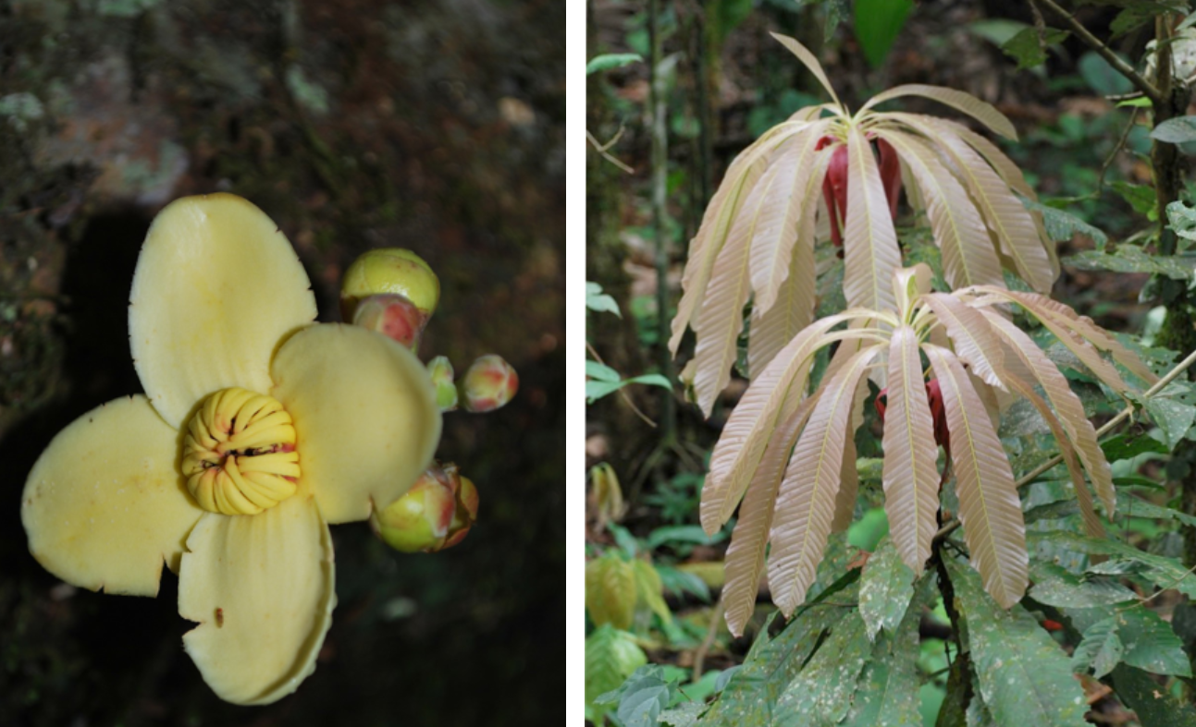
piton sisa ‘piton flower’ piton panga ‘piton leaves’
The piton flower is believed to help shape the tastebuds of a woman’s mouth so that she will be able to make flavorfull aswa, which requires the mastication of cooked manioc tubers, a task traditionally done by women. When the pale yellow piton flowers appear, they might be given to little girls to hold in their mouths, so that the a girl’s saliva can acquire the habitual taste of the flower, which will then be imparted to the aswa when the manioc is chewed. The interesting assumption here is that the girl’s mouth doesn’t just borrow the perfume of the flower momentarily, but actually learns to produce this scent. In other words, the mouth becomes yacharishka ‘accustomed to’ this scent which then becomes part of the girl’s own bodily knowledge. Interestingly, the piton flower’s taste is slightly bitter.
Another traditional practice that makes use of the piton tree is believed to enhance beauty, and involves the long leaves of this tree, which are compared to flowing human hair. Moreover, people have observed that this tree does not shed many of its leaves. The long leaves therefore evoke the desireable characteristic of thick, flowing hair that does not easily shed. For this reason Runa women have traditionally bathed their own hair in pounded leaves from the piton tree.
Promises, threats, and other expressions with –shka
Besides its function as an adjective, predicate adjective, subject, or direct object of a sentence, a verb suffixed with –shka is also used in a number of idiosyncratic expressions. It is often used with evidentially suffixed alimi ‘good (according to speaker)’, and ana ‘to be’, to express a compliment:
Alimi ashka ‘It’s good!; ‘nice’!
The following are just a few contexts where this use has been documented:
- After hearing a good story
- While eating or drinking something tasty
- Upon seeing that something broken has been repaired
- Upon seeing a Swiss army knife completely unfolded
Notice that although –shka was defined earlier as referring to events or processes
that are complete, the above usages are not so restricted. Example 2 above uses a –shka verb to talk about the ongoing experience of enjoying food or drink.
-Shka also forms part of an exclamation used to express amazement, surprise, or awe, particularly when looking at something very nice, such as well-made, finely painted pottery:
Ushashka! < ushana ‘to be able’
This expression is not easy to translate. English exclamatives like ‘wow!’ come close. It is also interesting to point out that there is a semantics of ‘unpreparedness’ that goes along with this expression, and has been reported by linguists as a function of perfect grammatical markers in other languages. This semantics of unpreparedness is sometimes labelled ‘mirativity’.
Yet another type of –shka usage is found when speakers want to make promises or threats. In such usages, a speaker is saying to someone that something is so certain to happen or not to happen to or for them, that it is as good as accomplished. This is expressed by taking the –shka suffixed verb root and adding angi ‘you are’ or angichi ‘you all are’. In the narrative ‘How people didn’t use to get old’, this construction occurs in line 30, reproduced below:
30. Chimanda, ‘ñukama hapishkangi, ñukama hapishkangi’ nisha, payta aysasha rira.
‘And then “You are mine, you are mine! (lit: to me you are caught)”, saying, pulling her, he went.’
For another example, again from a narrative context, consider the following threat that someone once made to someone else:
wañuchi ‘kill’ + -shka = wañuchishka ‘killed + angi = wañuchishkangi ‘you are killed’
This sentence does not mean that the speaker is addressing a corpse. It means, rather, that the speaker is making a prediction, which in this case is interpretable as a threat. A more figurative translation would be: ‘you are as good as dead’.
-Shkangi constructions are not only used for threats. In the following example, it is used to tell someone that they will receive harvested fruit from the speaker:
Chunda muyuta pallakpiga ashkata kushkangi
‘If/when (someone) harvests a lot of chunda fruit, you are given a lot of them.
And:
Masnata wakakpiwas, mana aparishkangichu
‘No matter how much (you) cry, you are not going to be carried.’
Listening Exercise: the promise/threat –shkangi and the mirative –shka
Examples of both a promise or threat –shkangi construction as well as a surprising observation with –shka are found in the following video clip featuring a speaker describing a practice used to determine a baby’s gender. This is accomplished with a flower called the papangu sisa. The speaker repeatedly taps the flower against her abdomen while asking which of the two names she has picked for either a boy or a girl, will end up being used. She then stops, saying that she’s going to cut it open, using the ideophone chyuw as well as the promise –shkangi construction. After seeing what is inside she exclaims ‘It’s a girl!’ Watch the following link, from 12 seconds until 25 seconds, to see both constructions:
https://www.youtube.com/watch?v=YVqqwvUdPJM&t=8s
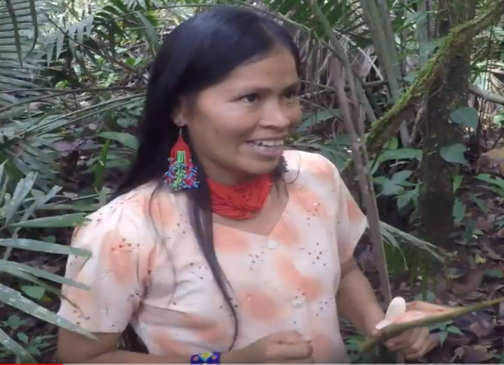
Warmi mashka! ‘It’s a girl!’

Kunan amo rimarimun, kungata chyuw pitishkangi
‘Now the owner (of the flower) speaks: “Your neck is going to be cut apart chyuw!”’ (opens flower)
Warmi mashka!
‘It’s a girl!’
Practice 2
Fill in the following blank spaces with a correct, –shka form of the verb in parentheses.
Example:
Aswata upichik shamwi! Mana _____________ (tukurina) -chu an >

Aswata upichik shamwi! Mana tukurishkachu an.

- Ñuka ______________ (wañuna) mikya Theresa mana ali tarabakchu ara.

- Mikukchu angi paygunawa _______________ (pallana)
- Kay mana ali _______________ (yacharina) gringo turuyasha purikmi an.
- Chi ali ___________________ (churarina +plural + acc) rikurangichichu?
- Ñukata aychata apamukpiga ____________________ (llakina).

- Paparaw aswa pukukpiga, wayra shina ________________ (upichina)
- Kan, kay llaktamanda rikpiwas, mana ____________________ (kungarina)
- Kan ñukata kayakpiwas mana _______________________ (yanapana)
- Supay _________________ (uyarimuna) kanda kwintawni.
- Ñuka ali, mana _____________________ (ismuna) hachata aparirani, ruyata kuchungawa.
- Chi __________________ runata rikuranchi _____________ (turuyana) sacha ñambiy

Culture Focus: The Healing power of river foam
Lesson 11 mentioned the importance of rivers in Runa lives, for basic spatial orientation. In Lesson 12, we saw the shape of a river’s movements painted on the inside of a drinking bowl. In the following brief narrative, a man explains how the foam from river water is believed to have curative powers for lovesickness.
Hatun yaku puskuwan armana ‘to bath with foam from big rivers’

Grammar awareness prompt

Go to the following link and listen to a man named Luis briefly explain to another man named Pedro, as well as to Tod Swanson, about the curative power of foam from large rivers, which is said to be helpful when a person is saddened because of love. Listen to the section that begins at 34 seconds, until the video ends.
https://youtu.be/UDEHzLOTtcE
Notice how the speaker uses the –shka suffix. Which of the functions of –shka do you see being used below?
T: Ima rasha apan llakira?
‘How does it take the sadness?’
1.Chi pusku, no cie(rto), yaku kayta rin kakurishka washa,
That foam, right?, the water goes this way, after it was rubbed,
2.Yakuy armana, chiwan kakurisha, yakuy arman pichasha, pusku na rin urayta (uray)llata.
One has to bathe in the water, and with that (foam) rubbing, in the water one bathes, sweeping (it), and the foam then goes dowriver, just downriver.’’
3.Chay apasha rin payga na ñukanchi llakiushkata.
That’s how it goes then, taking what has made us sad.’
4.Chaybi ñukanchita ña llaki kalmarin na pasarin.
‘And then the sadness passes us, it calms down.’
5.Ña kuti llakiushas, chasna chasna kimsa kutin chasna armana.
‘Again becoming sad, like that, like that, three (more) times one is to bathe.’
Chibi ña pasarin llaki.
‘With this the sadness passes.’

