LESSON 7
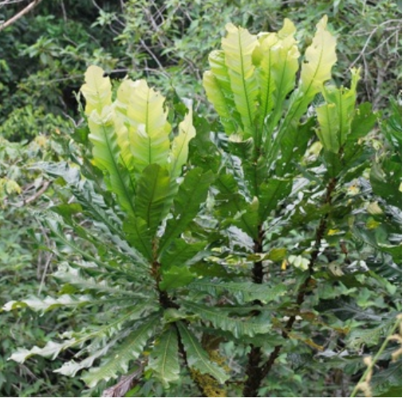
amarun kaspi ruya‘anaconda stick tree’

Human and nonhuman bodies
Dialogue 1
1. Antoñia: Shamungichu kumpari? ‘Have you come kumpari’?
2. Leopoldo: Nda. Shamunimi. ‘Yes. I’ve come’.
3. Leopoldo: Ima rayguta kasna amangay siringi? ‘Why do you lie in the hammock
like this?’
4. Antoñia: Wiksami yapa nanawan; chaki ‘My stomach hurts a lot (and my)
tak pungiwan feet are completely swollen tak’!
wiksa ‘stomach’
yapa ‘a lot’
nanana ‘to hurt, be painful’
tak (ideophonic adverb) ‘completely swollen’
pungina ‘to swell’
-wa- (first person direct object) ‘to me’

5. Leopoldo: Chuchawasata upingi. Chimanda ‘Drink some chuchawasa (broth).
ali tukungi! Then you’ll get well’.
chuchawasa ‘type of tree bark with
medicinal value’
tukuna ‘to become, to happen’
6. Antoñia: Apamupangi kumpari! ‘Please bring some, kumpari’!
-pa- ‘politifying suffix’
7. Leopoldo: Ari. ‘O.K’.

The foregoing dialogue reveals some of the ways in which the body is talked about, especially when it is not well. This chapter concerns some of the ways in which Quichua conceptions of the body differ from European conceptions. When people become ill, for example, they often seek treatments from plants in their surroundings. This is possibly related to the observation that Quichua speakers do not see a fundamental difference between their own bodies, and those of the living species that surround them. Perhaps the first thing to notice is that Quichua uses many of the same words for human and animal body parts:
kiru ‘teeth, beak’
(w)illma ‘feathers, fur or human body hair’
maki ‘hand, paw’
chaki ‘foot or hoof’
rigra ‘arm of a human, wing of an animal’
sillu ‘fingernail or claws’
shimi ‘the mouth, voice or language of any living thing’

This may seem strange to speakers of European languages who take it for granted that their bodies differ qualitatively from those of plants and animals. The reasons for this are complex, but may be understood as, in part, related to the European split between culture and nature. Human bodies are different because they are believed to express a moral and cultural personality which is traditionally understood in Judeo-Christianity as made in the image of God. By contrast plants and animals are pure nature.
Consider, for example, how the following expressions and usages create a different set of associations for human vs nonhuman bodies: hands pray and create art while paws and claws carry out instinctive acts; humans speak but animals bark, howl, or chirp; humans kiss, caress, and make love while animals mate; humans shed tears while trees drip sap. In English the attribution of animal bodies to humans is most commonly in the form of insult such as: ‘He fell into her claws’ or ‘Don’t put your paws on me.’
By contrast Quichua culture does not make a split between culture and nature, and comparing human and animal bodies is common in compliments. Therefore, unlike English or Spanish, Quichua often uses the same terms for the human body as it does for the bodies of plants or animals. For example the roots of a tree are its angu (tendons or veins). The stem is its tullu or bones. The smaller stem of a leaf is its “hand” or maki. The nodes of its stem are its knuckles or muku. The base of a tree is its siki (buttocks). If its kara (skin/bark) is cut, the sap that it sheds is its wiki or tears.
This interchangeability of terms reflects differences in the way Quichua people speak about plants and animals. In Quichua the human body is frequently used to speak analogically about plant and animal experience. Consider the following brief narrative by Clara Santi, one of our linguistic consultants.
"This is a fig tree. When we are about to cut any tree, the tree gets harder. Why does it tense up? Because it is a living being… It stands there tightening up because it does not want to be cut. When we cut it tak with a knife, do tears (wiki) not come out? It cries then. Those tears/sap (wiki) are crying. To sing (to trees) you have to know this”
Clara Santi’s comparison works, in part, because the Quichua word wiki means both sap and tears. In English such a narrative might be understood to be merely poetic but this feature of the Quichua language reflects a deeper confidence that plant experience can be known by analogy to human feelings. Furthermore it expresses a belief that the boundaries between human and nonhumanbodies are porous and that bodily qualities are transmutable across the species barriers.
The following is a very basic list of the body part terms you will most likely need to use. The list is generally organized by a top down logic beginning with the upper parts of the body and working its way downward.

akcha ‘hair, ’
uma ‘head’
urinti ‘forehead’
ñuktu ‘brain’
zigas ‘eyebrows’
rigri ‘ear’
rigri uktu uyana ‘ear drum’
lipinshi ‘eyelash’
ñawi ‘face’
ñawi lulun ‘eye’
singa ‘nose’
singa uktu ‘nostril’
ñawi muku tullu cheekbones
munglus ‘cheeks’
shimi willma ‘beard’
kara ‘skin, bark’
rigri aycha ‘earlobe’
shimi ‘lips, mouth’
kiru ‘teeth’
mama kiru ‘molars’
kallu ‘tongue’
tunguri ‘larynx’
tunguri tutu ‘uvula’’
wapu ‘adam’s apple area’
kunga ‘neck, throat’
kunga tullu ‘neck bone’
pusku shungu ‘lungs’
bigas ‘collar bones’
rigra ‘upper arm (down to the elbow), wing’
rigra muku ‘shoulder’
talon ‘elbow’
maki ‘hand, paw, forearm (area up to elbow)’
maki muku ‘wrist’
luki maki ‘left hand’
ali maki ‘right hand’
maki pamba ‘palm of hand’
maki angu ‘hand vein’
maki riru ‘finger’
maki riru muku ‘finger joints’
shillu ‘nail (of finger or toe), claw’
kustillas ‘rib bones’
hatun shungu ‘heart’
pusku shungu ‘lung’ (literally: ‘foam heart’)
chuchu ‘breast’
chundzhuli ‘intestines’
raway, yawar ‘blood’
kangana muyu ‘lymph glands in groin’
wawa muyu ‘egg sacs, ovaries’
yana shungu liver
pupu ‘navel’
ullu ‘penis’
kari lulun ‘testicles’
pingay ‘genital area’, used for females
churus colloquial for pingay, for females
raka ‘colloquial for pingay’, for females
payna charishka ‘what a person has, i.e., private parts’
siki ‘buttocks’
siki uktu = sikuktu ‘bottom hole’
washa tullu ‘back bone’
kangik ‘hips’
changa ‘upper leg, thigh’
kunguri ‘knee’
piruru ‘kneecap’
pingullu ‘lower leg’
chaki muku ‘ankle’
pingullu ipish ‘calf’
chaki ‘foot’
chaki pamba ‘sole (literally: ‘foot ground’)’
chaki riru ‘toe’
chaki shillu ‘toe nails’
kara ‘skin’
tullu ‘bone, beak of a bird’
siki tullu ‘sit bones’
wira ‘fat’
ichilla chuchu ‘men’s breasts’
chuchu muyu ‘nipple’
chuchu punda ‘nipple’
tintili ‘side’
llawsa ‘saliva’
tsugni ‘sleep in the eyes’
rigri isma ‘earwax’
maska ‘runny stuff coming out of nose’
Practice 1
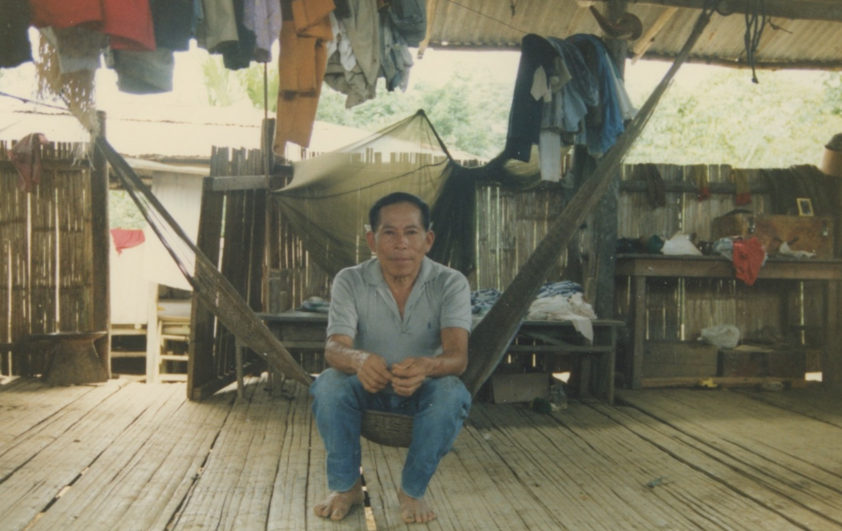
Hamangay tiyarin ‘In a hammock he sits.’

Describe what you see in this picture.
What is this man doing?
How many parts of his body can you name?

Practice 2
Using the following model, point to 5 different parts of your body, using Quichua words.
Example:
Kaymi an maki ‘This is (my) hand’.

Quichua body part terms are rarely modified by possessive pronouns when a speaker refers to his or her own body part. Moreover, it is not necessary to pluralize body part terms because they can refer either to one member of a set of body parts, such as one finger, eye, etc., or to the collective members of fingers, eyes, etc. This is exemplified in the dialogue in line 4. The speaker uses the singular form chaki even though both of her feet hurt.

Ideophones for bodily movements and configurations
There are many expressive adverbs called ‘ideophones’ that depict visually observable movements and configurations of the body as well as other kinds of sensory perceptions. Ideophones are words that are difficult to define within a traditional dictionary format. They occur in many languages and language families throughout the world, although European languages such as English do not have nearly as many as are found in Asian and African languages. They may also be referred to as ‘mimetics’, and ‘expressives’ by linguists who study them. Whatever term is used, they have a lot in common with each other, no matter which language they are part of.
They are most often used as adverbs, although they may take over the role of the verb they are supposed to be modifying. They tend to be performatively foregrounded with an intonational emphasis that marks them off as distinctive from their surrounding utterances. They often use sounds, syllable structures, or stress patterns that are atypical for their language. They are frequently accompanied by their own gestures which cause the rest of the utterance’s syntax to just ‘stop what it’s doing’, in a sense, so that the ideophonic performance may take center stage.
The cultural significance of ideophones is enormous. Quichua speakers use ideophones in a way that enhances their own animistic view of the world. Ideophones are a way of letting nonhuman forms of life speak for themselves. When someone moves through thick underbrush and describes the sound of that rustling movement with the ideophone taras, that person is not simply adding a vivid detail. The ideophone is, in a sense, a depiction of the voice of the bushes reacting to the presence of human movement. The ideophone, then, allows nature to speak from its own perspective.
Allowing nature to speak is significant aesthetically and cosmologically.
Quichua narrative traditions do not have a genre of fiction consisting of stories that are made up for entertainment or diversion. Speakers do not seem to value the elaboration of an imagined setting that goes beyond what can be perspectivized either from one’s own or someone else’s experience. Quichua narrative style is therefore spare---tending toward minimalist in terms of figurative usages such as metaphor. The goal of narrative skill seems to be to evoke for a listener the event itself in a kind of cinematic ‘you-are-there’ experience. The tendency to use ideophones may be motivated by the same urge we all have to share photographs and videos of our experiences. Ideophones are tools for pointing the imagination to the polysensory world of experience.
Mastering ideophones will help you achieve a much greater authenticity when yoy speak Quichua. We introduce one of them here. The ideophone ang describes a mouth that is widely and completely opened. It combines with the following verbs:
ang paskana ‘to open the mouth as widely as possible, e.g. to yawn, to nurse (of a baby); to open the mouth of an animal, e.g., a baby bird, to feed it.’
ang chapana ‘to wait with mouth wide open, e.g., baby birds waiting to be fed.’
ang sirina ‘to lie with mouth wide open, e.g., an anaconda trying to disgorge what it has swallowed, a person trying to drink an entire pond (myth).’
ang puñuna ‘to sleep with mouth wide open, e.g., several types of fish’
ang rikuna ‘to stare with mouth wide open, e.g., an alligator menacing someone.’
ang sambayana ‘to become so tired that one’s mouth hangs wide open’
As is apparent from the definitions, most of the time, ang is part of an adverbial phrase that is best translated as ‘with mouth wide open.’ The pronunciation of ang is sometimes extended, its pitch is sometimes raised, and it is often followed by a pause, all of which serves to dramatize and foreground the image being described. An audiovisual example of ang may be viewed at the following link, where the speaker explains how a tortoise that had become lodged in a jaguar’s teeth became dislodged by a man who was able to remove it from the animal because of its wide open mouth:
http://quechuarealwords.byu.edu/?ideophone=ang
Ang tiyawn ‘it has its mouth wide open ang!
Written Exercise 1
Complete the following sentences with the correct form of the verb that occurs with ang.
1.Llulluku wawa shimita ang _______________ (paskana ‘to open’)
2. Bagri shina ang ________________ (puñuna ‘to sleep’)
3.Ñuka ang ___________________ (sambayana ‘to become tired’)
4.Lagarto ñukanchita ang _______________ (rikuna ‘to look at, stare’)
5.Amarun ang _______________ (sirina ‘to lie’) chagra ñambiy
6.Pishku wawaguna ang ang kiruta _________________ (paskana ‘to open’)

Impersonal verbs
This section introduces impersonal verbs. These are verbs that mostly concern bodily functions which are described as happening to a speaker, as if the speaker has relinquished control over his or her own body. They include: nanana ‘to hurt’, pungina ‘to swell’, raykanayana ‘to hunger’, upinayana ‘to thirst, and shikshina ‘to itch’. One frequently used impersonal verb that does not involve bodily functions is illana ‘to be lacking’.
Impersonal verbs are easy to use because they only occur in the third person singular form. Impersonal verbs that refer to bodily functions and processes often take a special direct object suffix -wa that is reserved for the first person. This suffix may be translated with the word ‘me’ because its function is analogous to that word’s function in English. In English, ‘me’ is a special, direct object pronominal form, as are ‘him’, and ‘her’.
First person object suffix -wa
In Quichua, the first person ‘me’ form is the only person to have its own special direct object suffix form. No other pronoun has such a special form. As stated above, this suffix is used with impersonal verbs. It may also, however, be used with other kinds of verbs as in some of the following examples.
kuna ‘to give’

kuwangi ‘ you give me’
kuwan ‘s/he gives me’
kuwangichi ‘you-all give me’

rimawangi ‘you speak to me’
rimawan ‘he/she speaks to me’
rimawangichi ‘you (plural) speak to me’

shikshiwan ‘it itches me’
shikshichiwan ‘it makes me itch’

puñuy wañuchiwan ‘sleep is killing me’. (I am dying of sleepiness.)
raykay wañuchiwan ‘hunger is killing me’
chiri ima shina wanuchiwan! ‘how the cold is killing me!’

Transcription Exercise
Listen to the following segment from a personal experience narrative told by Senora Luisa Cadena. She mentions various llakichina love songs that were taught to her by a friend, using yachachina ‘to teach’, with the first person object marker –wa.(1:19-1:30). She also uses a past tense form of yachachina that will not be discussed until Lesson 12. Listen and transcribe the sentences as best you can. She mentions titles of 5 songs, each of which is named after plants, birds, or forest spirits.
https://www.youtube.com/watch?v=FJg2pXNb55Y
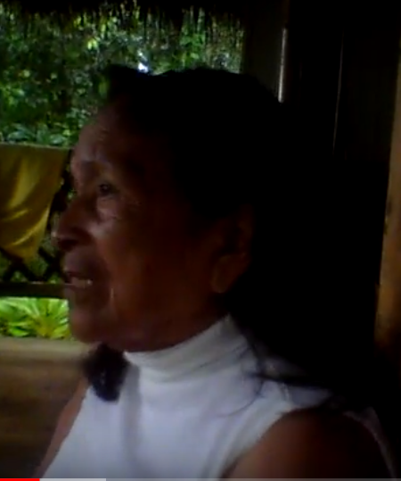
Kantota yachachina ‘to teach songs’
1.____________________________________
2.____________________________________
3.____________________________________
4.___________________________________
5.___________________________________

Written exercise 1
Translate the following forms of the verb:

tapuna ‘to ask’
tapuwangi _______________
tapuwan ________________
tapuwangichi _____________

tupana ‘to meet’
tupawangi ________________
tupawan __________________
tupawangichi _________________

killkana ‘to write’
killkawangi _________________
killkawan___________________
killkawangichi _________________
killkawanawn __________________

Practice 2
Use the following impersonal verbs, along with –wa, to tell about some physical problem you may have.
Example: nanana ‘to hurt’, wiksa ‘stomach’: Wiksa nanawan. ‘My stomach hurts’.
- chaki, nanana
- maki pungina
- ñawi pungina
- maki muku, nanana
- kallu, pungina
- kara, shikshina
- upinayana
- raykanayana
- sawli, illana
- ashanga, illana
Culture Focus: Forest Resources: bitter trees
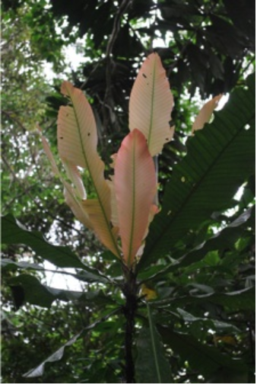
Cespedesia spathulata (Ochnaceae); Quichua: amarun kaspi female tree (left) and male tree (right)

In the Ecuadorian Amazon the bark of Cespedesia spathulata tree is widely used as a remedy for stomach problems as well as for aches and pains. Runa believe that their ancestors lived longer and had more endurance than people have now because they drank daily doses of tinctures made from Cespedezia spathula and other bitter trees. This practice is called ayakta upina ‘to drink bitters’ because of the bitter alkaloids contained in the bark. Drinking bitters is believed to impart the long life and strength of the hardwoods to the drinker. The tree is also said to be a person who heals in a cross gender fashion. Female patients drink medicine taken from the male tree, recognized by the reddish color of its new leaves (above right). By contrast, male patients drink medicine taken from the female tree, recognized by the pale green color of its new leaves (above left). The night after the patient drinks the bitter tea the tree may appear in a dream as a human medicine woman or man to sweep away the sickness of the patient.
Practice 3
Pain, swelling, and itching are the most common physical complaints one hears people discussing. Answer each of the following yes/no questions in the affirmative, using the impersonal verbs nanana ‘to hurt’, pungina ‘to swell’, and shikshina ‘to itch’. Assume that someone is asking each question about your own anatomy, which will make use of the –wa suffix necessary.
Example:
Kungurichu pungin? ‘Is (your) knee swollen?’
Ari. kungurimi pungiwan. ‘yes. (My) knee is swollen.’
1. Makichu pungin?
2. Ñawichu pungin.
3. Chakichu tak nanan?
4. Karachu shiksin?
5. Kungurichu pungin?
6. Kungurichu shikshin?
7. Rigrichu pungin?
8. Kiru yapachu nanan?
9. Changa yapa nananchu?
10. Ñawi yapa punginchu.
11. Kara yapa shikshinchu?
12. Ñawi lulun yapa punginchu?

Written exercise 2
Answer each of the following questions in the negative, and then supply whatever correct information is called for. If the question concerns a body part, assume that it concerns your own anatomy.
1. Umachu shikshin? ______________________________________________
2. Ñawi lulunchu pungin? _________________________________________
3. Makichu tak nanan? ________________________________________________
4. Pupuchu shikshin? ______________________________________________
5. Maki mukuchu nanan? _______________________________________________
6. Maki pambachu tak pungin? ____________________________________________
7. Chaki mukuchu shikshin?______________________________________________
8. Kungurichu nanan?___________________________________________________
9. Kamba hachi Cervantes kayutuy sirinchu? _________________________________
10. Payba wawa puñunchu? ___________________________________________
11. Ringichu kumari Estella? ____________________________________________
12. Chuchawasatachu upingi? __________________________________________

Possessive markers
Dialogue 2
1. Asevero: Shamungi kumari! Wawata puñuch- ‘Come comadre! Put the
ingi! Kanba llulluku yapa wakawan. Baby to sleep! Your infant

llulluku “newborn baby” is crying(at me) so much.’
puñuchina ‘to cause, put to sleep’
2. Valenciana: Ciertomi ningi kumpari. Wakaysiki ‘You’re right compadre. He’s a
man payga. Kangunawa wawagunaga? crybaby. What about your-all’s

cierto ‘certainly’ children?”
kangunawa ‘your-all’s’
3. Asevero: Mana wakanawnchu. Ali wawaguna ‘They don’t cry. They’re
manawn. good children’.

4. Valenciana: Atsatsay! Yanga ningi! ‘I don’t believe you. You’re
atsatsay (exclamative) meaning roughly, talking nonsense!’
‘I don’t believe you.’
yanga ‘useless, for nothing, without value’
5. Asevero: Mana llullanichu. Chasna manawn ‘I’m not lying, that’s the
ñukanchi wawaguna. way our children are’.
chasna ‘like that’
ñukanchi ‘we, our’
6. Valenciana: Kirumi nanan. Chi raygumi ‘His teeth hurt. That’s why
wakawn. he’s crying’.
chi raygu ‘that’s why’
7. Asevero: Kiru yapa nanachik man. “Their teeth cause them a lot
nanachina ‘to cause pain’ of pain (literally: their teeth are such pain causers)’.
Possessive pronouns in Quichua are slightly irregular. The paradigm follows:
First person ñuka ‘mine’ ñukanchi ‘ours’
Second person kan-ba ‘yours’ kangunawa ‘your-all’s’
Third person pay-ba ‘his, hers, its’ paygunawa ‘theirs’
The only irregularity occurs in the third person singular form. Whenever any object, entity or person is used in a plural possessive form, it will be suffixed with –wa rather than –ba, if it ends in a vowel. Note that the –y sound is treated as a consonant:
For example:
pay ‘he/she/it’ > payba ‘his/hers/its’
Camilla ‘Camilla’ > Camillawa ‘Camilla’s’

When a construction consists of more than one term that is capable of taking a possessive suffix, speakers only mark with a possessive, the terms immediately modifying the word that is possessed.
For example, one would say
payba hachi ‘his/her uncle’
but not:
*payba hachiwa ushushi ‘his/her uncle’s daughter’
Instead, speakers leave the possessive marker off of pay because it does not immediately precede the word ushushi. They would say instead:
pay hachiwa ushushi ‘his/her uncle’s daughter’
Practice 4
Modify each of the following nouns with the correct possessive form of the word in parentheses.
Example:
(pay) wawa > payba wawa
1. (Antonia) sawli ‘machete’
2. (Fernando) chagra ‘garden, agricultural field’
3. (ñuka) ushushiguna ‘daughters’
4. (kanguna) wawkiguna ‘brothers of a male or males’
5. (payguna) mikya Lola ‘Aunt Lola’
6. (ñukanchi) lyakta ‘place, nucleated settlement such as village or town’
7. (ñuka hachi Fernando) kanoa ‘canoe’
8. (kan) hamanga ‘hammock’
9. (ñuka mikya) churiguna ‘sons’
10. (kanguna ñaña) mukahaguna ‘drinking bowls’
11. (kanguna) yaku aycha ‘fish’
12. (pay yaya) wawki ‘brother of male’
13. (ñuka turi) churiguna ‘sons’
14. (payguna) minga ‘work party’
15. (ñukanchi masha Leopoldo) chagra ñambi ‘garden path’
16. (kan) apa mama ‘grandmother’
Practice 5
Go back and make each of the above phrases into any statement that would make sense. A good way to do this would be to turn the possessive phrase into a direct object, and use verbs such as mikuna ‘to eat’, rikuna ‘to see’, llakina ‘to love’, gustana ‘to enjoy’, or uyana ‘to hear’
Example:
Kangunawa yaku aycha ‘your-all’s fish’> kangunawa yaku aychata mikuni. ‘I eat your-all’s fish’.

Written exercise 3
Fill in each of the following blank spaces with any possessively marked pronoun or noun that makes sense.
1. pani man Irmilinda.
2. turi shamun.
3. lyaktama riunchi.
4. wawkiguna hapinawn wanganata.
5. yayaguna purinawn Kwankiri yakuma.
6. chagray tarabangichichu?
7. pani mana kawsanchu.
8. yaya llaktay tiyawn.
9. chagra ñambita apanakunchi.
10. ashangata mana apamunichu.

Written exercise 4
Modify each of the following nouns with the correct possessive form of the word in parentheses, then use the phrase in a complete sentence.
Example:
(pay) hachi Cervantes > payba hachi Cervantes > Payba hachi Cervantes paktamun.
1. (ñukanchi) apayaya ___________________________________________________
2. (payguna ñaña) churi _________________________________________________
3. (kanguna turi Cezar) masha _____________________________________________
4. (kan) wasi __________________________________________________________
5. (ñuka) ushushi ________________________________________________________
6. (pay) hatun chagra ___________________________________________________
7. (payguna mikya Lucinda) sawli __________________________________________
8. (kanguna ) ali aswa __________________________________________________
9. (kan) wawaguna _____________________________________________________
10. (pay) hachiguna ______________________________________________________

