Lesson 10
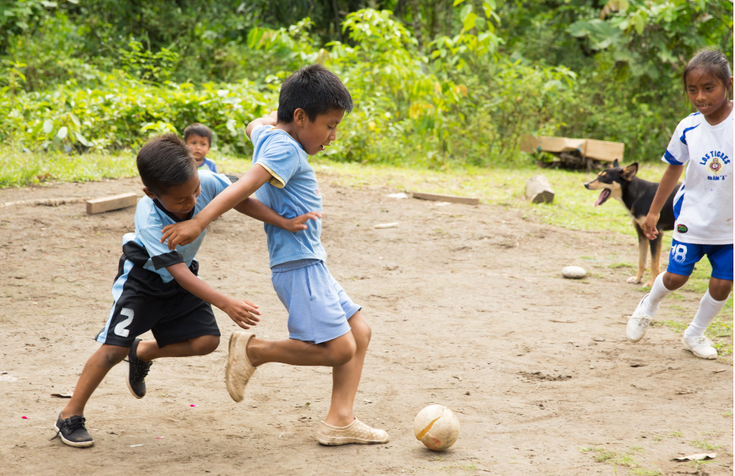
pugllana ‘to play’
Suffixes of togetherness, separateness, and exclusivity
The reciprocal suffix –naku
Narrative: To catch a killpundu
1. Ñuka yaku wawata hambini; Hambini ñuka, sapalla.
‘I was treating a small pond; I was treating (it) alone.’
2. Chiga ñuka rikuni killpundugunata; hrrrr hrrrrr hrrrr kantanawn.
hrrrrrr ‘sound of birds chirping’
killpundu ‘a small bird with a large beak’
‘Well then I notice some killpundus; they are singing hrrrr hrrrr hrrrrrr.”
3. Ñuka tay (pause) ruya sapiy mitikuni.
mitikuna ‘to hide’
tay ‘a complete absence of motion’
‘So then I hide tay (not moving) behind the tree trunk’
4. Chiwan pariul pururururururu pawan, kiruy amulin.
pururururururur ‘sound of bird flying’
pawana ‘to fly’
amulina ‘to hold in the mouth’
‘And at that moment, flying pururururururu it comes, holding (food) in its beak.’
5. Chiga garararararara gararararara gararararararara. Mikunata mitsanakunawn. Chasna uyarin.
gararararara ‘sound of birds fighting’
mitsana ‘to be stingy’
-naku- reciprocal morpheme
‘And so then (I hear) gararararara garararararar garararararara. They are being stingy with each other over food. That’s how it sounds’.
6. Chusku wawata rikuni!
‘(Upon looking), I see four baby (birds).’

Language and Culture Focus: Ideophones and their gestures
The preceding narrative features several ideophones: gara, the sound of birds fighting with each other over food; puru, the sound of birds flying, and tay, a complete absence of motion. When Quichua speakers use ideophones, they will often deploy a gesture for that ideophone, especially if the ideophone is depictive of some kind of motion. However, one of the ideophones featured in the opening narrative of this chapter tay, is somewhat unusual in that it depicts a complete lack of movement. Nevertheless, even a lack of movement can be gestured. While uttering tay speakers may gesture its meaning with the entire upper body, in a way that indicates stasis, often by bringing the hands and arms into a position of stillness that is then held for a moment. Go to the link http://quechuarealwords.byu.edu/?ideophone=tay and watch videos 1 and 3. Listen to the short fragments of speech and watch the speakers bring their bodily postures into a stillness that occurs simultaneously with their pronunciation of tay. You will also notice a slight intonational emphasis on tay followed by a brief pause before the rest of the utterance is resumed:
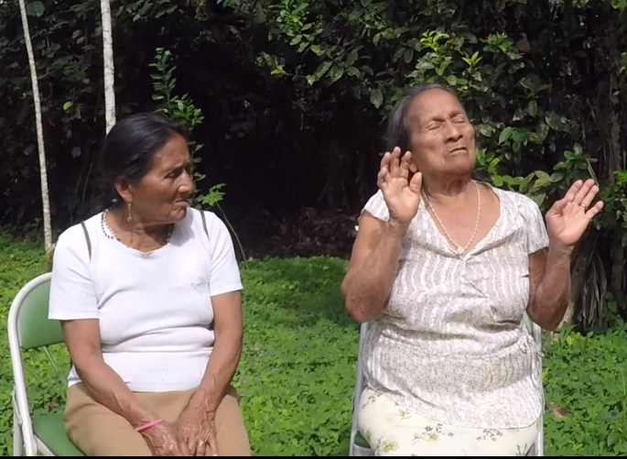
Image from video 1 for tay

Image from video 3 for tay

The reciprocal suffix -naku
The reciprocal suffix –naku is used to describe actions performed by two agents upon each other, or with their mutual cooperation. Not every verb can take this suffix. It tends to occur when actions are performed by agents inhabiting the same spatial arena. Verbs such as shuwana ‘to steal’ and muskuna ‘to dream’ are not good candidates for this suffix, therefore. This suffix is also different from the causative –chi suffix because the causative suffix can be used when only one entity is responsible for an action, event, or process. People do, for example, talk about being caused to dream with the verb muskuchina. For the suffix –naku, however, it is necessary for there to be actions, events, or processes that are mutually brought about. –Naku is added to a root before any tense or aspect morphemes:
makana ‘to hit’
maka-naku-na ‘to fight/hit together’
payguna maka-naku-nawn/nun ‘They fight with each other’.
Verbs suffixed with –naku are only used in the plural persons, because –naku requires joint action brought about by two or more agents:
First person plural: Ñukanchi makanakunchi ‘We hit each other’

Second person plural: Kanguna makanakungichi ‘You-all hit each other’
Third person plural: Payguna makanakunawn ‘They hit each other’
Besides these examples, the following verbs are among the most likely to take the –naku suffix:
kwintana ‘to talk, recount’ > kwintanakuna ‘to talk, recount together’
rimana ‘to speak’ > rimanakuna ‘to speak together’
llullana ‘to lie’ > llullanakuna ‘to lie to each other’

yanuna ‘to cook food by boiling’ > yanunakuna ‘to cook together’
piñana ‘to speak angrily with/at someone’ > piñanakuna ‘to speak angrily together, to argue’
kipina ‘to make into a bundle’ > kipinakuna ‘to hug together’
tupana ‘to find, encounter’ > tupanakuna ‘to meet up with someone’
apana ‘to take’ > apanakuna ‘to follow’
purina ‘to walk’ > purinakuna ‘to walk together’
hapina ‘to catch, hunt, become romantically attached to’ > hapinakuna ‘to be in a romantic relationship together’
puñuna ‘to sleep’ > puñunakuna ‘to engage in sex’

Dialect Alert: Napo suffix -ria
The upper Napo dialect does not use –naku for reciprocal actions. Instead, Napo speakers use –ria. For example, upichina ‘to give to drink’ would become upichirianun ‘they give each other to drink’​. However, there are some differences in verb usage as well. For example, rather than saying apanakuna ‘to follow’, they would use the verb katina ‘to follow’, which would become katirianun ‘they follow each other’.

Practice 1
Make simple sentences with each of the following –naku verbs, using the given pronoun.
Example:
Ñukanchi/asinakuna ‘to laugh’ > Ñukanchi asinakunchi ‘We laugh together’
1.payguna/ apanakuna ‘to follow (literally: to take together)’
2. kanguna/asinakuna ‘to laugh together’
3. payguna/aspinakuna ‘to scratch each other’
4. payguna/ichunakuna ‘to mutually abandon, break up with each other’
5. kanguna/kipinakuna ‘to hug each other’
6. payguna/llakinakuna ‘to love, feel affection for each other’
7. ñukanchi/makanakuna ‘to hit each other’
8.payguna/mitsanakuna ‘to be stingy with each other’
9.payguna/muktinakuna ‘to sniff each other’
10. payguna /piñanakuna ‘to speak angrily with each other’
11 payguna/.rimanakuna ‘to speak with each other’
12. kanguna /tandarinakuna ‘to gather together’
13. ñukanchi/tanganakuna ‘to shove each other’
14.kanguna/.tapunakuna ‘to ask each other’
15. ñukanchi/tupanakuna ‘to meet up with, run into someone; literally: to find each other’
16.kanguna/yanapanakuna ‘to help each other’
Practice Exercise 2
Using the following set of –naku-suffixed verbs verbs, study each of the images below and decide which verb would be most appropriate to describe the main activity that you see in each image. You may need to use one verb for more than one picture. Then write 3 sentences which tell a mini-story about why the individuals in each set of pictures is engaged in the main activity of whatever they are doing. Finally, share your sentences with your classmates or instructor.
Verb list:
pugllanakuna ‘to play with each other’
apanakuna ‘to follow each other’
kipinakuna ‘to hug each other’
upichinakuna ‘to give each other to drink’
samanakuna ‘to rest together’
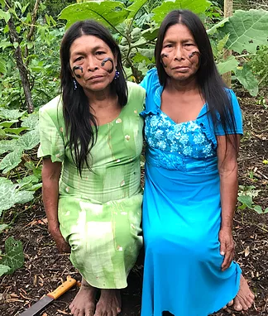
A ñañaguna

1.
2.
3.

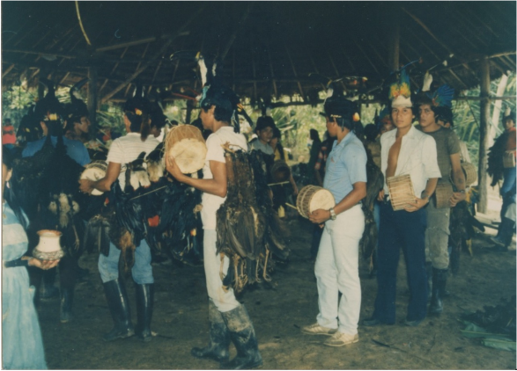
B kariguna
1.
2.
3.
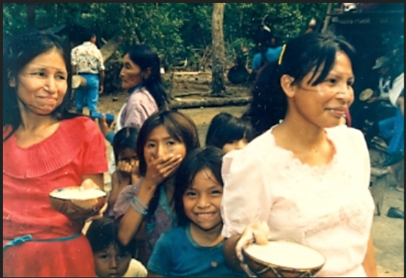
C warmiguna
1.
2.
3.
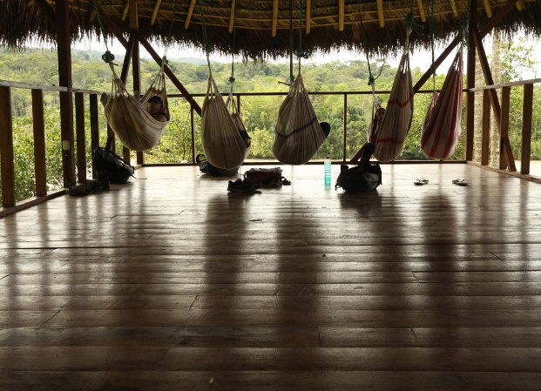
D istudianteguna
1.
2.
3.
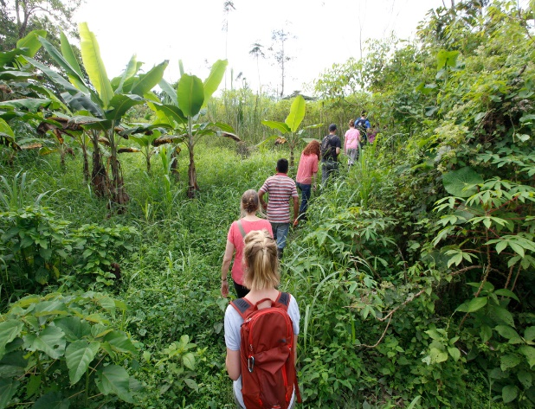
E istudianteguna
1.
2.
3.
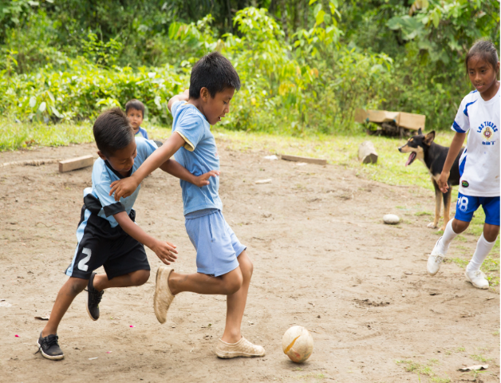
F wawaguna
1.
2.
3.
The conjunctive suffix –ndi
The suffix –ndi, which is added to nouns, works in many ways like the conjunction “and” in English but the fit is not perfect. The most common use is to express the idea of natural pairs such as husband and wife, mother and child, etc. The Highland dialects’ suffix -ntin and its variants -ndi/-ndin have been used by anthropologists to argue that the cosmology of Quichwa speakers has a distinctive view of wholeness or pairedness. In his book “Mountain of the Condor” Bastien (1978) wrote, “Andeans understand their body as a gestalt, and the suffix -ntin of uqhuntin expresses this completeness. When Andeans add -ntin to a word it means that two separate entities have been transformed into something complete and whole.
Tawantinsuyu was the Andean name for the Inca empire. It meant the four places tawa-ntin-suyu (literally:four-united-place) that were distinct yet united. Many native languages have technical terms for this complementarity. Ruth Moya saw in -ntin the notion of that which is paired in a complementary fashion. Complementary foods are joined with this suffix:
lumu aychandi ‘manioc and meat’
lumundi uchundi ‘manioc and hot pepper’
When –ndi is appended to kinship terms it may express the completion that a couple achieves as a pair:
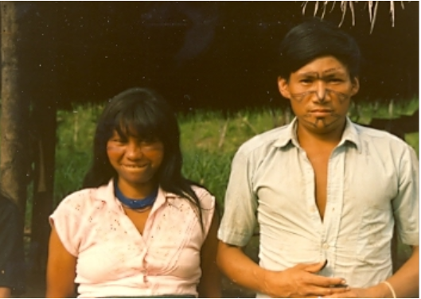
kari warmindi

or a parent with a child:
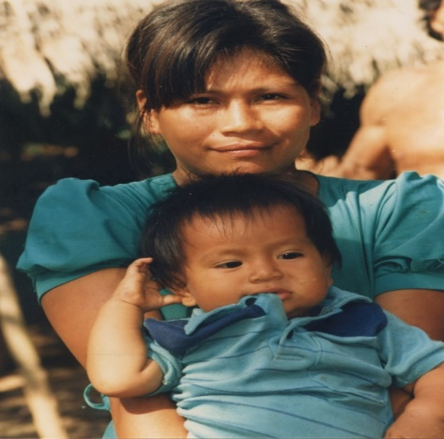
mama churindi

When there is a series of nouns, the suffix -ndi can be appended to the end of each noun:
Yayandi mamandi wawandi sachama purinawn.
‘Father, mother, and children walked to the forest’.
When appended to the number two, ishki (UN) or ishkay (PQ), -ndi has the meaning of ‘both’:
Ishkandi shamun ‘They both have come.’
When added to other numbers, it means something like ‘the _______ of them:
Chuskundi rin ‘The four of them have gone.’
The opposite of -ntin is chulla which expresses the idea of a broken pair. Ruth Moya, Simbolismo y ritual en el Ecuador andino, (Otavalo: Instituto Otavaleno de Antropologia, 1981:72). A type of fish which has an asymmetrically shaped mouth, consisting of the top half as much larger than the bottom half is called chulla shimi which means ‘uneven mouth’.

The exclusive suffix -pura
The suffix –pura, which is another nominal suffix, is used to indicate action that occurs among an exclusive group. The difference between –pura and –ndi is that when the suffix –pura is used, there is an implication of exclusivity, while with –ndi, the implication is that there are parts making up a whole.
Examples:
Wawapura pugllanaku-nun/nawn. ‘The children are playing among themselves.’
Warmipura kwinta-nun/nawn. ‘The women talk among themselves.’
Karipura tandari-nun/nawn. ‘The men are meeting among themselves.’
Warmipuralla yakuma taksa-nawn/-nun. ‘Only the women wash clothes together’.
Karipura sachama ri-nawn/-nun. ‘The men go to the forest together’.
Writing Exercise 1
Choose the best suffix, -ndi or -pura for each of the following sentences:
- Kachi uchu-_______ mikunchi aychata.
- Warmi-_________ aswanawn.
- Kari warmi-_______ kawsanawn.
- Wawa-________ pugllanawn.
- Kari-_________ aychata kasanawn.
- Ayllu-________ chagray tarabanawn.
- Mama wawa-_________ chagrama purinawan.
- Warmi-_______ mukahata awanawn.
- Yaya mama-______ kiwata allmanawn.
- Kari wawki-_____ wasita wasinawn

Karipura kahanawn

The limitative suffix –lla
The –lla suffix has an essential meaning that can be compared with English words ‘only’, ‘just’, and ‘very’. The appropriate interpretation depends on the contexts of its use. It is also a flexible suffix that can be added to different categories of words, including nouns, adjectives, adverbs, and verbs.
-lla + nouns
The limitative suffix is added to nouns before any case marking suffixes:
Aychallata mikuni ‘I eat only meat.’
Sawlillawan tarabani ‘I work only with a machete.’
Ñañallawan shamuni ‘I come just with my sister’.
-lla + adjectives
Although Quichua does not have a large class of adjectives, -lla combines easily with them:
Pay kushillami an. ‘He/she is very happy.’
Napalla tukunimi ‘I’ve become very dirty.’
Ñawi pukallami an ‘(My) face is just red.’
-lla + adverbs
-Lla is frequently used with adverbs:
Alilla tarabangichi ‘You-all work really well.’
Uktalla shamunawn ‘They come very quickly.’
Bagri tsapaklla urman ‘The catfish falls just tsapak (sound of hitting a surface).’
Nanay amsalla samarin ‘The pain subsides just a little’.
-lla + verbs
-Lla does not occur very often with verbs. Probably the most commonly occurring use of –lla with verbs is the first person future form used to announce a departure:
Ri-sha-lla kumari ‘I will just go, kumari’

Practice 2
For each of the following sentences, use the suffix –lla on one its words to change its meaning to ‘just’, ‘only’, or ‘very’.
Example:
Pay kullkita shuwan ‘He/she steals money’ >
pay kullkillata shuwan ‘He/she steals only money.’
1. Wawa wakan
2. Kan shamungi
3. Pay shuwan
4. Ñuka apa yaya taraban
5. Leopoldo bagrita hapin.
6. Kanoa yakuy shayarin.
7. Pay aychata mana kasanchu
8. Ñuka turi pugllan
9. Ñuka masha shamun.
10. Payba mikya paktamun.
Practice 3
Make each of the following verbs an immediate imperative, adding any arguments listed below it. Then add the –lla suffix to give the command greater emphasis.
Example:
Shamuna ‘to come’/ukta ‘fast’ > uktalla shamui! ‘Come really fast!’

shamuna mañachina (+ -wa-)

ukta llachapa
wayra shina kamba ali sawli
kunan paygunawa kullki
dzas ñuka masha yayawa hacha

yuyana apagrina

payba wawa wasima
ñukanchi yaku aycha chagrama
pita lala llaktama
puma kuchama

randigrina pallana

ashka waska muyu
mushuk llachapa panga
ali sawli sisa
aspirina chunda

rikuchina (+ -wa) tandarina

llulluku lomo kaspi
kamba chagra aylluguna
payba mushuk mukaha wawaguna
kanba mushuk kiru llachapa

tapuna puñuna

shuti ukta
gasta chun
masha Cervantes wayra shina
apa mama kunan

Culture Focus: Forest Resources: Fish poisons
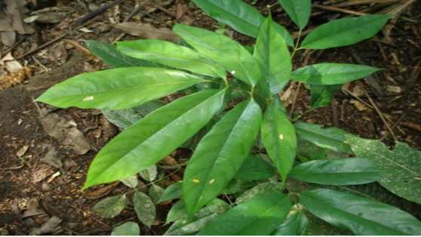
Loncho carpus nicou, or sapi barbasco (strong fish poison)
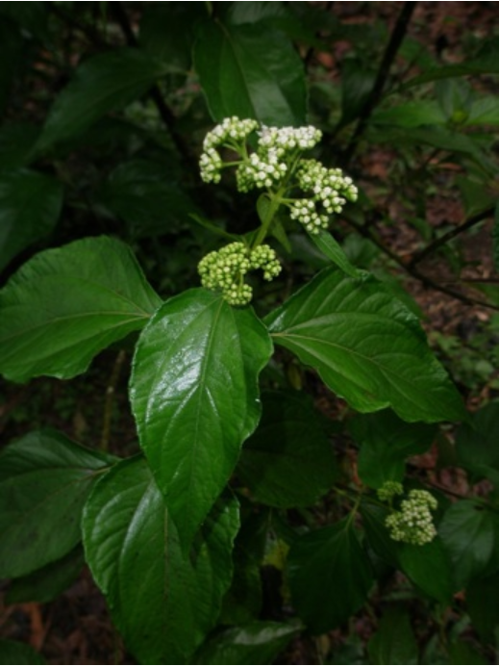
Clibadium surinamense or panga barbasco (weak fish poison)

The verb hambina used in this chapter’s opening narrative describes an important method for catching fish by means of plant substances. The leaves of the two plants pictured above are grown in gardens. These plants’ roots are pulled out of the ground and pounded so that a milky white sap may emerge. When rivers’ levels are low during the dry season, people will often combine their efforts and ‘treat’ an entire expanse of a river by swishing their pounded barbasco roots into the water. This sap acts upon the fish by stunning them temporarily, causing them to rise to the surface, which then makes them easy to catch them by scooping them up into a basket. Barbasco plants, in their strong and weak forms are both significant for mythic thinking about masculine sexual energy, and also form the backdrop for an origin story about anacondas: http://andesandamazonfieldschool.com/Andes_and_Amazon_Field_School/Lonchocarpus_nicou.html

